Contents
This guide contains information for users from schools and Tertiary Education Organisations (TEOs) who may appeal moderation reports. It contains steps on how to:
- Prepare Appeal
- Submit Appeal
- Notes: Materials for an Appeal

For a full list of guides to the External Moderation Application see: Related Guides

Why appeal?
An appeal may be appropriate if you disagree with moderation decisions and/or comments. Before creating an appeal, you should discuss it with the Principals’ Nominee or Moderation Liaison for your organisation.
If you just want more information or clarification about something in the report then submitting a query may be more appropriate.
Note: An appeal must be submitted within 20 working days of the ‘provisional’ moderation report being published. After this time, the report becomes final

Quick Steps
- Log in to the application and select Moderation.
- Select the required standard.
  - The status must be: Report – Provisional.
- Right-click on the standard.
- Select View Report from the menu.
- Select Appeal report.
- Enter appeal details and attach evidence (if relevant).
- Select Ready to Submit.
- Submit the appeal (Management Authoriser only).

Prepare Appeal
Prepare an appeal
Role required: Moderation Processer or Moderation Authoriser (High Security User)
Only reports in the following status can be appealed:
- Report-Provisional
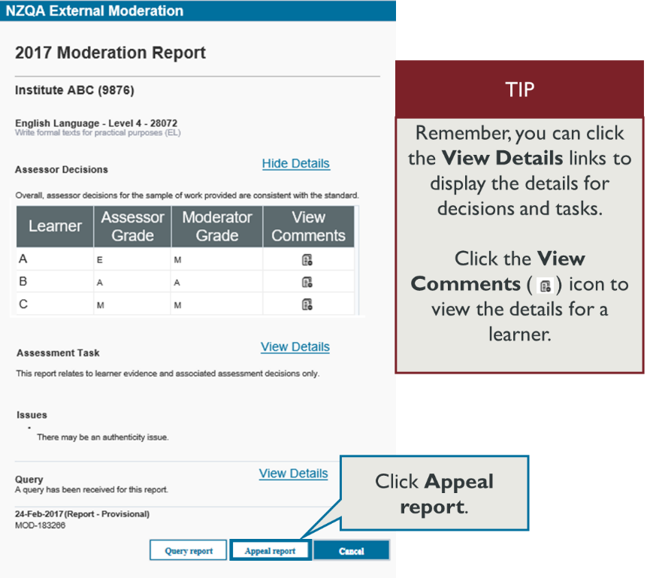
- Select View Report for the relevant standard from the moderation plan.

- Select Appeal report.

Prepare an appeal, continued
- Select Add Issue.
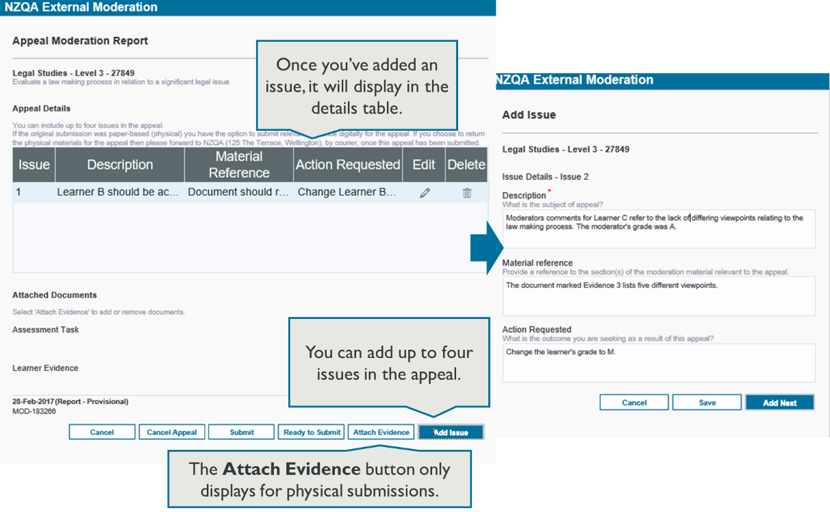
- For each issue, include:
  - Description: the issue you’ve identified within the report (up to 1000 characters)
  - Material reference: location of the evidence to support the appeal within the assessment materials (up to 500 characters)
  - Action requested: what outcome you are seeking (up to 500 characters).
  - Save the issue.
- Create additional issues, as required, (maximum of four), click the Add next button, and return to step 3.
- Note: If the original moderation submission was a physical submission, you can upload digital files of the material.
- Select Attach Evidence.
    - In either the Assessment Task or Learner Evidence sections, select the Browse button.
    - Find the file you want to upload, select it then select Open.
    - Repeat as required, and Save.
- Once you have added all the issues and evidence, select Ready to Submit.
  - You can still edit an appeal with status ‘Ready to Submit’.

Submit Appeal
Submit an appeal to NZQA
Role required: Moderation Authoriser (High Security User)
- Select View Report for the relevant standard on the moderation plan.
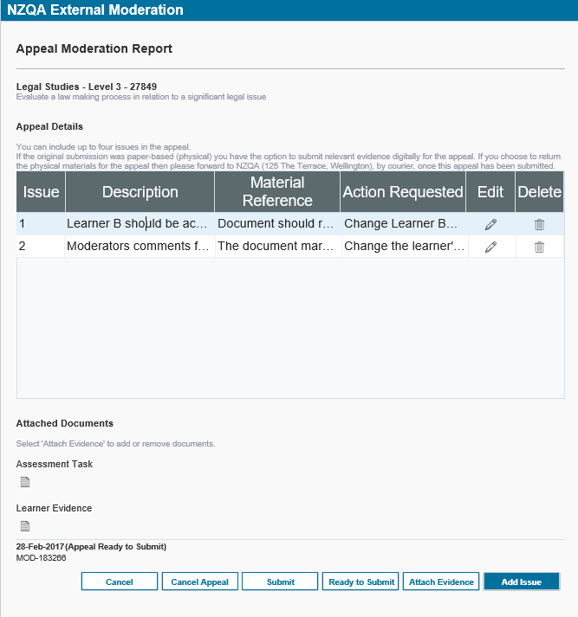
  - Note: the status should be ‘Appeal Ready to Submit’
- Select Appeal report.
- Review the appeal details. Ensure that:
  - the issue Description and Action Requested sections contain sufficient detail
  - only originally submitted material is included. Any additional material will not be considered for the appeal.
- Save any updated details, as required.
- Select Submit.
  - A confirmation message showing the standard number displays.
- Select Yes to submit the appeal to NZQA.
  - The status of the standard changes to ‘Appeal submitted’.
  - Once you submit an appeal, you will no longer be able to edit it.
What Next?
When the appeal is received, NZQA checks that it meets the appeal criteria:
- If it doesn’t, you’ll receive a notification that the appeal was declined.
- If it does, we’ll start processing the appeal.
The appeal outcome is recorded in the moderation report. The outcome of the appeal is final.
The Principals’ nominee or Moderation Liaison is notified when the final report is available.

Notes: Materials for an Appeal
Digital submission | If the original submission was digital the appeal moderator will have access to the original materials, they do not need to be re-loaded.
Physical submission | If you are appealing a report where the original submission was physical, and you do not wish to attach the documents to the appeal, then these will need to be couriered back to NZQA,
Submitting ‘new’ material | Only material orignially submitted for moderation should be included with an appeal. Any additional material will not be considered for the appeal.

Related Guides
The following guides provide further information on using the external moderation application:
Guide | For how to:
Access the External Moderation Application | Access and navigate the application.
Submit an Assessment Plan | Select standards and submit an assessment plan.
View, Print & Customise Moderation Plan or History Views | View, customise or print/export assessment plan, moderation plan or moderation history views
Submit Material for Moderation | Create a moderation submission and submit to NZQA.
Digital Submission Tips | Additional tips relating to digital submissions including, submitting cloud-based files, video files, file types accepted and size limits.
View and Query a Moderation Report | View or print a moderation report. Submit a query.
Appeal a Moderation Report | Appeal a moderation outcome.
Browser & Application Issues | Resolve browser issues and oracle errors

The guides can be found at: http://www.nzqa.govt.nz/providers-partners/assessment-and-moderation/moderation-online/qrgs-and-faqs/

Note: Browsers
The External Moderation is supported across a range of browsers, however not all browsers behave in the same way. If you are experiencing issues with functionality described in this guide with a browser please try a different one. We have found Mozilla Firefox provides the best experience when using the application.
For specific advice on browser issues see: Browser & Application Issues.

