Appendix 1: Guidelines to assist schools to update their contact information with NZQA online

High Security ESL users can update their school’s key contact details in their provider login page. The contact details are used by NZQA to send important messages to schools, so it is important to keep them up-to-date to ensure your school keeps well informed. Please review your key contacts’ details in High Security on a regular basis and amend the information online as soon as changes occur.

How to access your school’s profile page

You can access the Profile page through your secure provider login. You will need to log into the NZQA website using your ESL High Security account. If you do not have a High Security ESL account, contact your school’s ESL Authoriser.

Under High Security Features there is a link to the School’s Administration page:

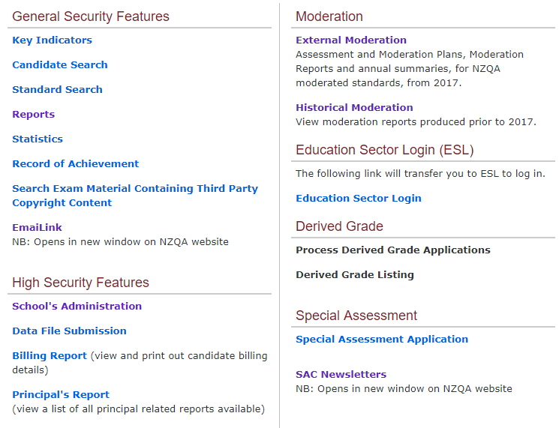

There you will find the link to the Profile page.

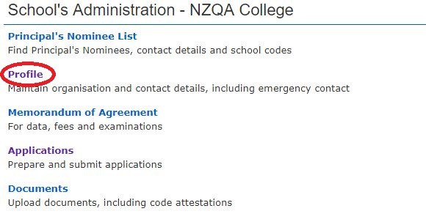

How to add a new contact

New contacts can be added through the Profile page. This page displays a range of information on your school:
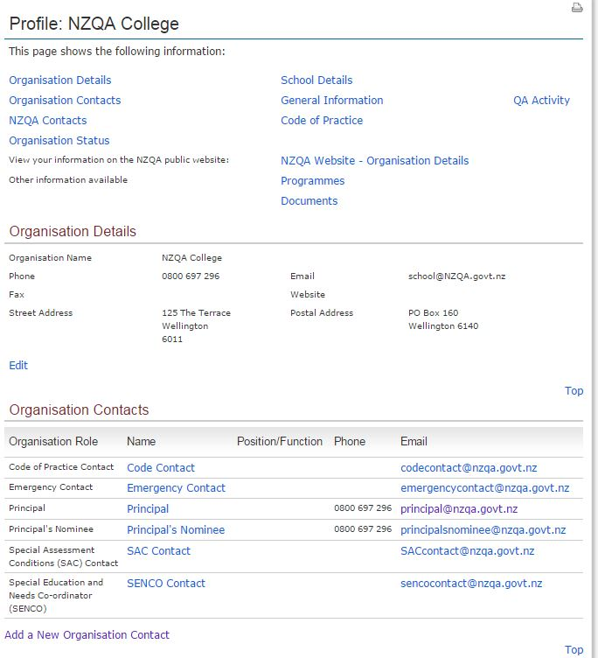

You can add a new contact to your school through the Add a New Organisation Contact link.

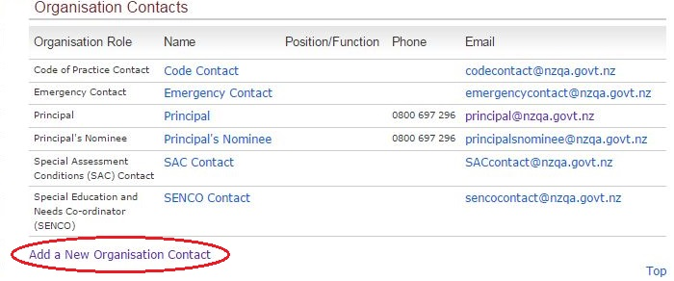

This link will take you to the Add Contact Details page, where new contacts can be added to NZQA roles.

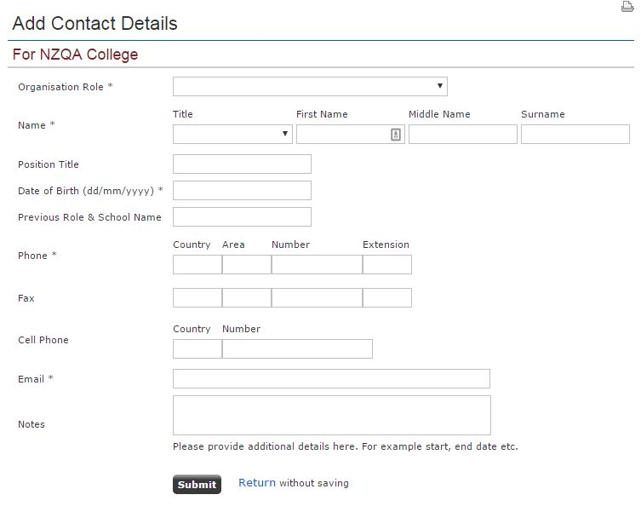
Users may be assigned the following roles:

- Principal
- Principal’s Nominee
- Data Manager
- Code of Practice Contact
- Code of Practice Contact (Other)
- Emergency Contact
- Special Assessment Conditions (SAC) Contact
- Special Education and Special Needs Co-ordinator (SENCO)
Schools may only assign one contact to the Principal, Principal’s Nominee and Data Manager roles at a time. A contact assigned to the Principal’s Nominee role cannot also be assigned the Data Manager role. All other roles may have multiple users assigned to them.

To add a new contact simply enter the information into the appropriate fields, check the accuracy of the information and click Submit. When you submit this information, NZQA will add the new user within three working days.

How to edit/update an existing contact

If a contact has recently changed any of their contact details, such as their email address, you can edit that information by clicking on the name of the contact you wish to edit:
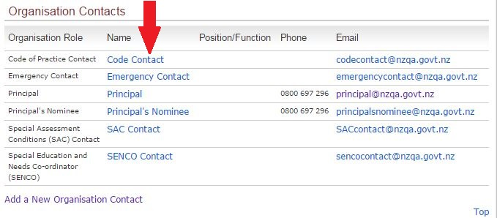
You will be taken to the Edit Contact Details page, where you can enter any new information into the appropriate fields or edit existing information. Please note that the cellphone field will not be visible on the public website, only to NZQA and staff within your school with a ESL High Security account.
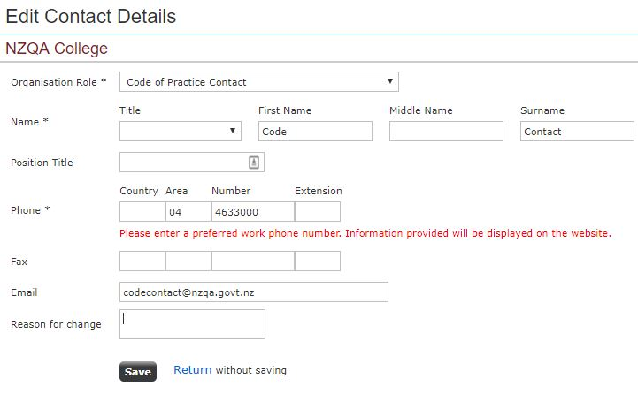

You can change any of these details except for the name of the contact. Currently if you need to make changes to the name of the contact (e.g. if that user changes their surname) then you can put that request in the Reason for Change field and click Save, or email the Schools Liaison team at schoolsliaison@nzqa.govt.nz with your request.

