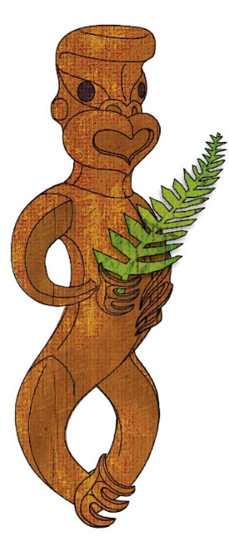

Tīkarohia te Marama – Realise Your Potential
Field Māori Assessment Support Material

TOURISM MĀORI

UNIT STANDARD 17387 (version 5)

Discuss ngā hekenga mai and iwi settlement, and compare Māori customs with those of another Polynesian people

(Level 5, Credits 15)

ĀKONGA BOOKLET

Name
Organisation
Kaiako/Assessor
NSN Number

© New Zealand Qualifications Authority 2017
Tēnā koe
This is your assessment booklet for Tourism Māori unit standard 17387 Discuss ngā hekenga mai and iwi settlement, and compare Māori customs with those of another Polynesian people.

Assessment criteria
Paetae/Achievement
People credited with this unit standard are able to: discuss and trace ngā hekenga mai across Polynesia; discuss an iwi settlement in Aotearoa; and compare and contrast Māori customs, traditions, and values to those of another Polynesian culture.

There are four (4) assessment tasks for this standard that you must correctly complete.
The tasks are:
- Research the rationale for ngā hekenga mai across Polynesia.
- Provide evidence of settlement and chronological patterns that took place during migration across Polynesia to Aotearoa.
- Discuss and give referenced evidence of the effect of settlement on the local environment.
- Compare and contrast Māori customs, traditions, and values in terms of welcome and hospitality with another Polynesian culture.

Your kaiako will discuss the length of time you have to complete this. PLEASE remember to reference where you get your information from for all tasks. Your kaiako will discuss this with you.

Authenticity
As per NZQA requirements:
- all work submitted for assessment must be produced by you
- the assessor will consider (and manage) the potential for work to have been copied, borrowed from another ākonga, photocopied from a book, or downloaded from the internet.
You may work with and learn from others to gather information from a variety of sources. However, the assessor must be clear that the work to be assessed has been processed and produced by you. To help manage authenticity of your work, where you are asked to complete any written tasks, you will be asked to use your own words as well as provide reference/s for your information.
If you have any pātai, or are unsure about anything, kōrero ki tō kaiako.
For further information, please refer to the following link:
http://www.nzqa.govt.nz/providers-partners/assessment-and-moderation/assessment-of-standards/generic-resources/authenticity/.

ĀKONGA ASSESSMENT TASK SHEET

Name |  | NSN #

Outcome 1 | Discuss and trace ngā hekenga mai across Polynesia

Assessment Task 1
Research the rational for ngā hekenga mai across Polynesia focusing on the socio-economic conditions and how these conditions influenced the migration from Hawaiki to Aotearoa. Present you information in one of the following forms;
- 500-600 word written response, and/or
- PowerPoint presentation (15 mins) and/or
- Performance i.e. roleplay/mōteatea/waiata
Please include the following: disputes, overcrowding, warfare, human sacrifice, and mana in your discussion.
This task assesses the performance criteria of 1.1.
You must present information in your own words, and references must be provided.

Assessment Task 2
Provide evidence of settlement and chronological patterns that took place during the migration across Polynesia to Aotearoa.

Please include at least three of the following settlement patterns: fishing, hunting, gathering, gardening, language, kai, symbols, construction and establishing communities in your response.
Also include at least three of the following chronological settlements: Hawaii, Lapita pottery, Rapanui, Thor Heyerdahl. You need to demonstrate SIX forms.
This task assesses the performance criteria of 1.2.
You must present information in your own words, and references must be provided.

Assessment Task 3a
Using an aerial view of iwi settlement within Aotearoa that shows the diversity of settlement areas, discuss and give referenced evidence of the effect of settlement on the local environment.
Please include at least four of the following: hunting, fishing, landscape, land use, water, air, climate, sustainability, people, and coastal in your response

Assessment Task 3b
i Discuss the different media used to establish the history of iwi settlement within your local rohe in accordance with whānau, hapū and iwi accounts and provide evidence.
Include and explain at least two of the following Iwi accounts: karakia, mōteatea, pakiwaitara, pūrākau, whakapapa.
ii Economic trade and social benefits of iwi settlement in terms of the positive or negative outcomes for the whānau, hapū/ and or iwi:
Evidence of two positive and two negative outcomes is required
These tasks assess the performance criteria of 2.1 and 2.2

Assessment Task 4
Compare and contrast Māori customs, traditions, and values in terms of welcome and hospitality with another Polynesian culture.
Customs and traditions may include but are not limited to – atua, haka, kai, kākahu, kupu, poroporoaki, pōwhiri, toi, waiata, whakairo, whaikōrero, whare.
Select four customs and traditions.
Values may include but are not limited to – manaakitanga, tapu, aroha, aroha ki te tangata, tiakitanga, whanaungatanga, and kotahitanga.

Select four values.
These tasks assess the performance criteria of 3.1, 3.2

