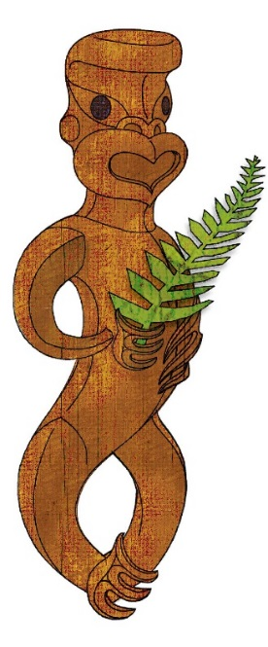
Tīkarohia te Marama – Realise Your Potential
Field Māori Assessment Support Material

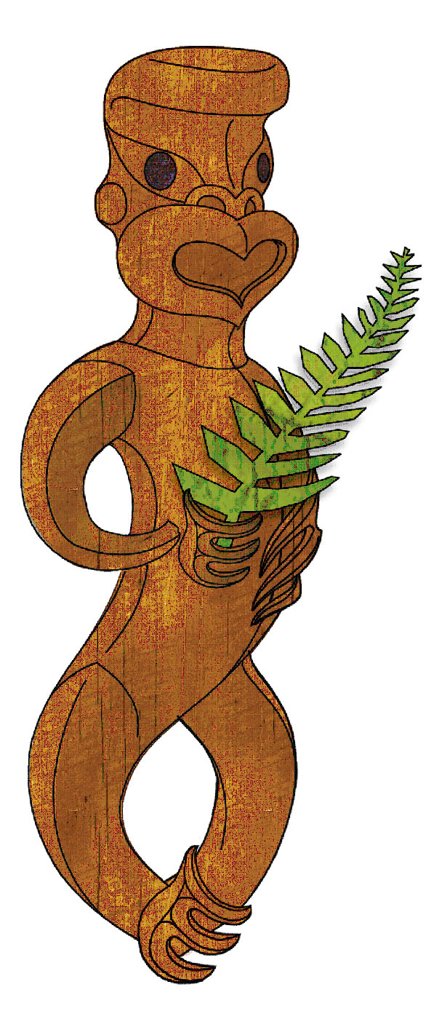TOURISM MĀORI

UNIT STANDARD 17387 (version 5)

Discuss ngā hekenga mai and iwi settlement, and compare Māori customs with those of another Polynesian people

(Level 5, Credits 15)

ASSESSOR BOOKLET
© New Zealand Qualifications Authority 2017

Assessor Information

Assessment criteria
Paetae/Achievement
People credited with this unit standard are able to: discuss and trace ngā hekenga mai across Polynesia; discuss an iwi settlement in Aotearoa; and compare and contrast Māori customs, traditions, and values to those of another Polynesian culture.

There are FOUR (4) assessment tasks that the ākonga must correctly complete to gain credits for this standard. Once the ākonga has correctly completed the tasks, the assessor must complete the assessment schedule for each ākonga.

Ākonga assessment booklet
The ākonga receives this. It outlines important information for the ākonga including:
- assessment and other information
- assessment tasks.

Ākonga assessment tasks
These sheets and any other evidence should be collected by the assessor and retained for assessment and moderation purposes.
Where ākonga choose to provide oral description/evidence for Task 2 and/or Task 4b, this must be recorded (ie recorded onto DVD or USB flash drive). Where ākonga work has been selected for moderation, the DVD or USB flash drive must be included with the materials.
Where a recording of the demonstration is submitted for moderation, the ākonga identification sheet (refer following link: http://www.nzqa.govt.nz/assets/Providers-and-partners/Assessment-and-moderation/mod-visevidence-cvr.doc) must be included.
You will need to discuss with the ākonga the length of time they have to complete the assessment. He ture-a-kōnui: one credit equates to 10 notional hours of teaching, practice and/or study, and assessment.

Authenticity
As per NZQA requirements:
- you must verify that the work submitted for assessment has been produced by the ākonga
- you must consider (and manage) the potential for work to have been copied, borrowed from another ākonga, photocopied from a book or downloaded from the internet.
Ākonga may work with and learn from others to gather information from a variety of sources. However, you must be clear that the work to be assessed has been processed and produced by the ākonga.
To help manage authenticity of ākonga work, where the ākonga is asked to complete any written tasks, the ākonga is asked to use their own words as well as provide reference/s for their information. Please ensure you discuss this with your ākonga.
For further information, please refer to the following link:
http://www.nzqa.govt.nz/providers-partners/assessment-and-moderation/assessment-of-standards/generic-resources/authenticity/.

Referencing
This assessment requires the ākonga to reference his/her information. For the purposes of this assessment, the following are examples of reference styles.

Examples of referencing
1 | Book with one author
 | King, M. (2000). Wrestling with the angel: A life of Janet Frame. Auckland, New Zealand: Viking.
2 | Course handout/Lecture notes (electronic version)
 | Archard, S., Merry, R., & Nicholson, C. (2011). Karakia and waiata [PowerPoint slides]. Retrieved from TEPS757-11B (NET): Communities of Learners website: http://elearn.waikato.ac.nz/mod/resource/view.php?id=174650.
3 | Film
 | Māori Television (Producer). (2016). Iwi Anthems, Series 2 Episode 5 [video file]. Retrieved from: http://www.maoritelevision.com/tv/shows/iwi-anthems/S02E005/iwi-anthems-series-2-episode-5.
4 | Magazine/Newspaper article – popular/trade/general interest
 | Fox, D. (2015, 15 September). Viewpoint: Not one more acre. Mana. Retrieved from: http://www.mana.co.nz/heritage/viewpoint.html.
5 | Personal Communication - letters, telephone conversations, emails, interviews, private social networking
 | Smith, J. (2016, 19 October) Personal communication.
6 | Webpage
 | New Zealand Trade and Enterprise. (n.d.). Agribusiness. Retrieved from https://www.nzte.govt.nz/en/export/market-research/agribusiness/.

Preparation for moderation
It is no longer necessary to complete a Moderation Cover Sheet as this information is entered online. If physical materials are sent for moderation, please ensure name of school and standard are included.
Digital submissions can be made directly through the application at any time.
Using the online External Moderation Application, schools and providers must include:
- a copy of the task and any key supporting resources
- a copy of the assessment schedule
- up to 8 samples of student work consisting of the key materials that the assessor has used to make an assessment judgement. (ungraded unit standards: schools – 4 learner samples; providers – 3 learner samples).
For moderation to occur:
- all files must be viewable online
- URLs, e.g. for student created websites, will need to be submitted as links within a document.
For more information on the digital moderation process, please contact your Principal Nominee or Moderation Liaison (ML).

If you have any issues with preparing materials for moderation OR do not have materials to submit (ie you didn’t assess this standard), SPEAK to your Principal Nominee (PN) or Moderation Liaison (ML).
ASSESSOR INFORMATION – ASSESSMENT TASKS

Outcome 1 | Discuss and trace ngā hekenga mai across Polynesia

Assessment Task 1
Research the rational for ngā hekenga mai across Polynesia focusing on the socio-economic conditions and how these conditions influenced the migration from Hawaiki to Aotearoa. Present you information in one of the following forms;
- 500-600 word written response, and/or
- PowerPoint presentation (15 mins) and/or
- Performance i.e. roleplay/mōteatea/waiata
Please include the following: disputes, overcrowding, warfare, human sacrifice, and mana in your discussion.
This task assesses the performance criteria of 1.1.

Assessment Task 2
Provide evidence of settlement and chronological patterns that took place during the migration across Polynesia to Aotearoa.

Please include at least three of the following settlement patterns: fishing, hunting, gathering, gardening, language, kai, symbols, construction and establishing communities in your response.
Also include at least three of the following chronological settlements: Hawaii, Lapita pottery, Rapanui, Thor Heyerdahl. You need to demonstrate SIX forms.

This task assesses the performance criteria of 1.2.

Assessment Task 3a
Using an aerial view of iwi settlement within Aotearoa that shows the diversity of settlement areas, discuss and give referenced evidence of the effect of settlement on the local environment.

Please include at least four of the following: hunting, fishing, landscape, land use, water, air, climate, sustainability, people, and coastal in your response

Assessment Task 3b
i Discuss the different media used to establish the history of iwi settlement within your local rohe in accordance with whānau, hapū and iwi accounts and provide evidence.

Include and explain at least two of the following Iwi accounts: karakia, mōteatea, pakiwaitara, pūrākau, whakapapa.

ii Economic trade and social benefits of iwi settlement in terms of the positive or negative outcomes for the whānau, hapū/ and or iwi:

Evidence of two positive and two negative outcomes is required

These tasks assess the performance criteria of 2.1 and 2.2

Assessment Task 4
Compare and contrast Māori customs, traditions, and values in terms of welcome and hospitality with another Polynesian culture.

Customs and traditions may include but are not limited to – atua, haka, kai, kākahu, kupu, poroporoaki, pōwhiri, toi, waiata, whakairo, whaikōrero, whare.

Select four customs and traditions.

Values may include but are not limited to – manaakitanga, tapu, aroha, aroha ki te tangata, tiakitanga, whanaungatanga, and kotahitanga.

Select four values.
These tasks assess the performance criteria of 3.1, 3.2

Comments on this support material
Please contact Māori Qualifications Services mqs@nzqa.govt.nz if you wish to suggest changes to the content of this resource.

Assessment Schedule

Assessment Task 1 | Evidence for Achieved | Grades
Research the rationale for ngā hekenga mai across Polynesia focusing on the socio-economic conditions and how these conditions influenced the migration from Hawaiki to Aotearoa.  Please include all of the following: disputes, overcrowding, warfare, human sacrifice and mana in your discussion. | Oral, written or visual research on reasons for ngā hekenga mai. To include the following – disputes, overcrowding, warfare, human sacrifice and mana in the discussion.  Please note: the following is an example of tauira response as tauira responses may vary.  Example: Ariki or Rangatira such as Uenuku who had mana (power authority and supremacy), controlled the distribution of land, food and even women causing dissatisfaction, jealousies, resentment and bitterness leading to hostility, feuding and warfare.  In some areas overcrowding led to shortages of food and other resources and in others cultural/religious practices included human sacrifice. Combinations of these factors motivated groups to seek new lands. | N  A
 | Judgement for Achieved
Response includes:
- disputes
- overcrowding
- warfare
- human sacrifice
- mana

Responses are supported by APA references

Assessment Task 2 | Evidence for Achieved | Grades
Provide evidence of settlement and chronological patterns that took place during the migration across Polynesia to Aotearoa.  Please include at least three of the following settlement patterns: fishing, hunting, gathering, gardening, language, kai, symbols, construction and establishing communities in your response.  Also include at least three of the following chronological settlements: Hawaii, Lapita pottery, Rapanui, Thor Heyerdahl. | Oral, written or visual evidence on settlement and chronological patterns of ngā hekenga mai across Polynesia to Aotearoa.  Please note: the following are examples of tauira responses as the tauira responses may vary.  Example:  Settlement pattern: The landfall of the first settlers seems to have been along the East Coast of the North Island – the Coromandel Peninsula and the Bay of Plenty. Evidence seems to indicate that although the schoolbook stories of a Great Fleet is probably mythical (and invented by early European anthropologists), the migrations did happen in phases which included fleets of several waka. They brought with them their traditions of whakairo (carving), raranga, (weaving), tā moko (tattooing) and their traditional waiata (songs) and karakia (prayers). They also brought the kūmara, and the kiore (Polynesian rat) which proceeded to decimate the native (and unprotected) bird population.  Chronological pattern: The Lapita Pottery theory suggests, through the discovery of clay artefacts throughout Western Polynesia that the Polynesian culture evolved from the Santa Cruz group of islands, south-east of the Solomon Islands around 3000BC spreading throughout the Pacific some 1500 years later forming the peoples of Polynesia. 600 A.D First settlers to Hawaii, 700 A.D First settlers in Rapa Nui 750 A.D Kupe discovers Aotearoa, 1250 – 1300 Toi and Whātonga, arrive in Aotearoa to discover it is inhabited by Moriori. | N  A
 | Judgement for Achieved
 | - Responses are supported by APA references

Assessment Task 3 | Evidence for Achieved | Grades
3a (2.1)  Using an aerial view of iwi settlement within Aotearoa that shows the diversity of settlement areas, discuss and give referenced evidence of the effect of settlement on the local environment.  Please include at least four of the following: hunting, fishing, landscape, land use, water, air, climate, sustainability, people and coastal in your response.  3b (2.2)  i Discuss the different media used to establish the history of settlement and provide evidence in accordance with whānau, hapū and iwi accounts.  Include and explain at least two of the following Iwi accounts: karakia, mōteatea, pakiwaitara, pūrākau, whakapapa.  ii Economic trade and social benefits of iwi settlement in terms of the positive or negative outcomes for the whānau, hapū/ and or iwi: Evidence of two positive and two negative outcomes is required. | Visual evidence on iwi settlement in Aotearoa showing the diversity of settlement areas, and the effect on the local environment.  Please note: the following are examples of tauira responses as the tauira responses may vary.  Example: 3a  Geographical map outlining iwi settlement with a description of the effects on the local environment.  3b  i  Te Rauparaha was a fearless rangatira of the Ngāti Toa tribe who descends back to Hoturoa, captain of the Tainui waka. He was the son of Werawera the chief of Ngāti Toarangatira. His wife was killed by the people of Waikato which lead to his retaliation to kill a Waikato chief. The battle took place and from here he and his tribe left Kāwhia migrating southwards controlling the southern end of the north island in particular Ōtaki, Kāpiti Island and its surrounding areas.  ii  He encouraged pākeha to set up whaling stations establishing a lucrative trade of supplies for muskets, increasing his mana. He was feared throughout the land for his skill in warfare and it was he who composed the famous haka “Ka mate ka mate ka ora! ka ora!”. (Pūrākau provided)  At the time Te Rauparaha composed this haka, he was nearly caught by his enemies. Fleeing for his life he asked the local chief Te Whareangi for protection. The chief permitted Te Rauparaha to be hidden in his kūmara pit and Te Wharehangi’s wife Te Rangikoaea then sat over the kūmara pit. Te Rauparaha performed his Haka of joy before Te Whareangi and Te Rangikoeaea as he climbed out of the kūmara pit. However, his mana would have been trampled when he hid under the skirts of a woman and whare tangata. | N  A

 | Judgement for Achieved
Response includes any four of the following:
hunting fishing,
landscape land use
water air
climate sustainability
people coastal

Response includes:

- two positive responses

- two negative responses

http://history-nz.org/rauparaha.html

Responses are supported by APA references
Assessment Task 4 | Evidence for Achieved | Grades
Compare and contrast Māori customs, traditions and values in terms of welcome and hospitality with another Polynesian culture.  Customs and traditions may include but are not limited to – atua, haka, kai, kākahu, kupu, poroporoaki, pōwhiri, toi, waiata, whakairo, whaikōrero, whare.  Select four customs and traditions.  Values may include but are not limited to – manaakitanga, tapu, aroha, aroha ki te tangata, tiakitanga, whanaungatanga, and Kotahitanga.  Select four values. | Oral, written or visual evidence comparing Māori customs, traditions and value with those of another Polynesian people.  Please note: the following are examples of tauira responses as the tauira responses may vary.  Examples: Comparison of Pōwhiri and Kava Ceremony  Pōwhiri  What to wear to a pōwhiri  Females - a long dark coloured skirt or dress, males to wear long dark trousers (no jeans). Manuhiri can change if necessary after the pōwhiri  The pōwhiri  The pōwhiri is the ritual ceremony of encounter.  Traditionally the process served to discover whether the visiting party were friend or foe, and so its origins lay partly in military necessity. As the ceremony progressed, and after friendly intent was established, it became a formal welcoming of guests (manuhiri) by the hosts (tangata whenua or home people). As the ceremony progresses also, the tapu or sacredness surrounding manuhiri is removed, and they become one with the tangata whenua.  Kava  What to wear at a kava ceremony  Casual clothes like jeans, t-shirt. NO hats or scanty clothing - bikinis or scanty dress above the knee or partially exposing the breasts are inappropriate. Fijian culture is based on respect and conservative Christian values so dress conservatively.  The kava ceremony  The kava ceremony is one of the central Fijian traditions. If you go to a village expect to participate in a kava ceremony of some form. It is highly informal yet highly formal in its end result. Remember to bring kava to the village- as a sign of your respect for the community. It is also a central symbol of the Fijian culture so behave yourself at the kava ceremony or you will most definitely upset your hosts. | N  A
 | Judgement for Achieved
Response includes:

- four Māori customs or traditional values are compared and/or contrasted with another Polynesian culture

http://maaori.com/misc/powhiri.htm

http://www.fijibure.com/kava.htm

Responses are supported by APA references

Overall grade (please circle) | N (Not Achieved) | A (Paetae/Achieved)

Ākonga name |  | Assessor name
Ākonga signature |  | Assessor signature
Completion date

