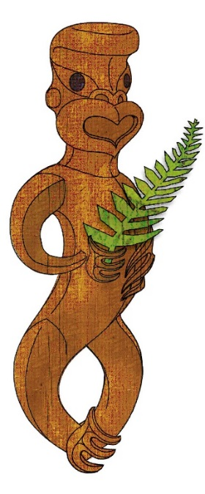

Tīkarohia te Marama – Realise Your Potential
Field Māori Assessment Support Material

TOURISM MĀORI

UNIT STANDARD 17391 (version 7)

Demonstrate knowledge of key forms of Māori communication, and the significance of Māori identity in tourism

(Level 3, Credits 5)

ĀKONGA BOOKLET

Name
Organisation
Kaiako/Assessor
NSN Number

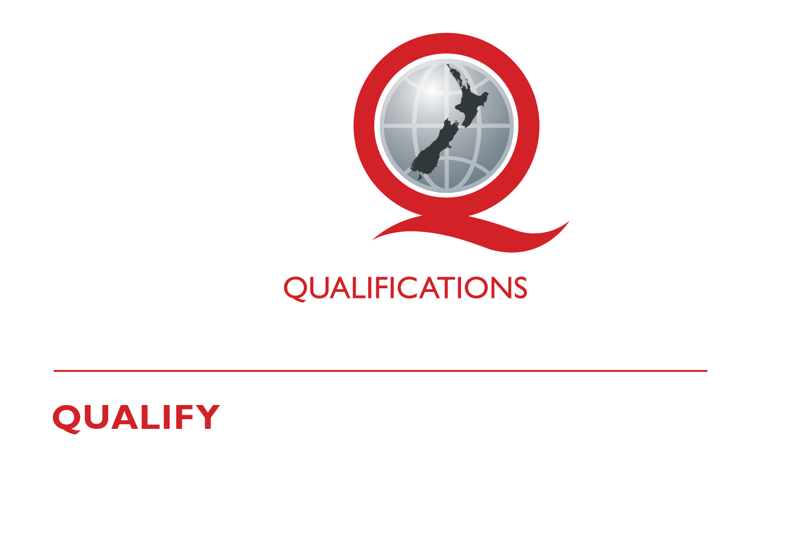
© New Zealand Qualifications Authority 2017
Tēnā koe
This is your assessment booklet for Tourism Māori unit standard 17391, Demonstrate knowledge of key forms of Māori communication, and the significance of Māori identity in tourism.

Assessment criteria
Paetae/Achievement
Demonstrate knowledge of key forms of Māori communication, and the significance of Māori identity in tourism.

There are four (4) assessment tasks for this standard that you must correctly complete.
The tasks are:
- Describe the significance of te reo Māori in tourism
- Listed below are verbal, non-verbal and artistic forms of communication used within te ao Māori.
3 Identify three key forms of artistic means of communication from Ngā mahi a Toi and Te Whare Pora:
- List the category of each form
- Describe each form
4 Explain the meaning of whakapapa and why it is so important to Māori. Include in your explanation the significance of whakapapa in relation to Ranginui and Papatūānuku and the relevance to tourism Māori.
Recite your whakapapa that includes at least three of the following: awa, hapū, maunga, iwi, whānau or any other relevant concepts.

Your kaiako will discuss the length of time you have to complete this. PLEASE remember to reference where you get your information from for Tasks 3 and 4a. Your kaiako will discuss this with you.

Authenticity
As per NZQA requirements:
- all work submitted for assessment must be produced by you
- the assessor will consider (and manage) the potential for work to have been copied, borrowed from another ākonga, photocopied from a book, or downloaded from the internet.
You may work with and learn from others to gather information from a variety of sources. However, the assessor must be clear that the work to be assessed has been processed and produced by you. To help manage authenticity of your work, where you are asked to complete any written tasks, you will be asked to use your own words as well as provide reference/s for your information.
If you have any pātai, or are unsure about anything, kōrero ki tō kaiako.
For further information, please refer to the following link:
http://www.nzqa.govt.nz/providers-partners/assessment-and-moderation/assessment-of-standards/generic-resources/authenticity/.

ĀKONGA ASSESSMENT TASK SHEET

Name |  | NSN #

Outcome 1 | Demonstrate knowledge of key forms of Māori communication and their significance in tourism.

Assessment Task 1
Describe the significance of te reo Māori in tourism.

This task assesses the performance criteria of 1.1.

Assessment Task 2
Listed below are a number of verbal, non-verbal and artistic forms of communication used within te ao Māori.
From the list below select THREE forms of verbal communication and THREE forms of non-verbal communication and give a demonstration to show your understanding of them.
- whakatauki  - whakairo  - hongi  - wero  - waha  - kākahu  - raranga | - pepeha  - kōwhaiwhai  - waiata ā ringa  - kupu  - tā moko  - kete  - pakiwaitara | - whaikōrero  - haka  - pūkana  - mau rakau  - waiata  - tauparapara  - pūrakau | - tukutuku  - whētero  - karanga  - poi  - mihi  - harirū  - korowai
You need to demonstrate SIX forms.
Demonstration may include computer, whakaari, tuhituhi, roleplay, poster, waiata, artwork, kapahaka, pakiwaitara, pūrākau, drama, dance, video, oral, photo images, social media etc.
This task assesses the performance criteria of 1.2, 1.3
You may use the attached sheet to record your answers and/or use a range of other techniques to present your descriptions – e.g. PowerPoint, mind maps, posters, drawings etc.
You must present information in your own words, and references must be provided.
Your assessor will observe your performance and record the result on the following checklist.

Observation Sheet – Communication
ĀKONGA:
ASSESSOR:
DATE:
Verbal communication | Criteria: Performance accords with tikanga and kawa. Shows correct pronunciation, wording, phrasing, intonation etc.
1

2

3

Non- verbal communication | Criteria: Performance accords with tikanga and kawa. Shows correct facial expressions, gestures, stance etc.
1

2

3

Assessment Task 3
Identify THREE key forms of artistic means of communication from Ngā mahi a Toi and THREE from Te Whare Pora.
- List the category of each forum
- Describe each form
NGĀ MAHI A TOA
Category 1
Category 2
Category 3
TE WHARE PORA
Category 1
Category 2
Category 3

Assessment Task 4a
Explain the meaning of whakapapa and why it is so important to Māori. Include in your explanation the significance of whakapapa in relation to Ranginui and Papatūānuku and the relevance to tourism Maori.

Assessment Task 4b
Recite your whakapapa that includes at least three of the following: awa, hapū, maunga, iwi, whānau or any other relevant concepts.

Observation Sheet – Whakapapa
TAUIRA
ASSESSOR
DATE:
Whakapapa concept  hapū, maunga, awa whānau, iwi | Performance accords with tikanga and kawa  - correct pronunciation  - appropriate wording  - phrasing  - intonation etc.
 | Observer comments
1
2
3

Observer signature: _____________________________________________

Reference/s:

