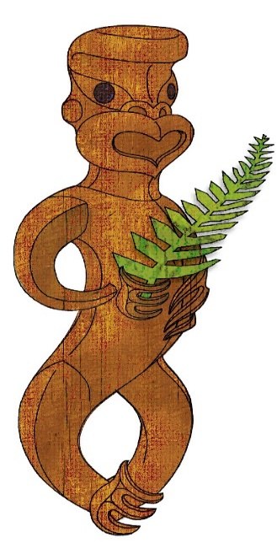

Tīkarohia te Marama – Realise Your Potential
Field Māori Assessment Support Material

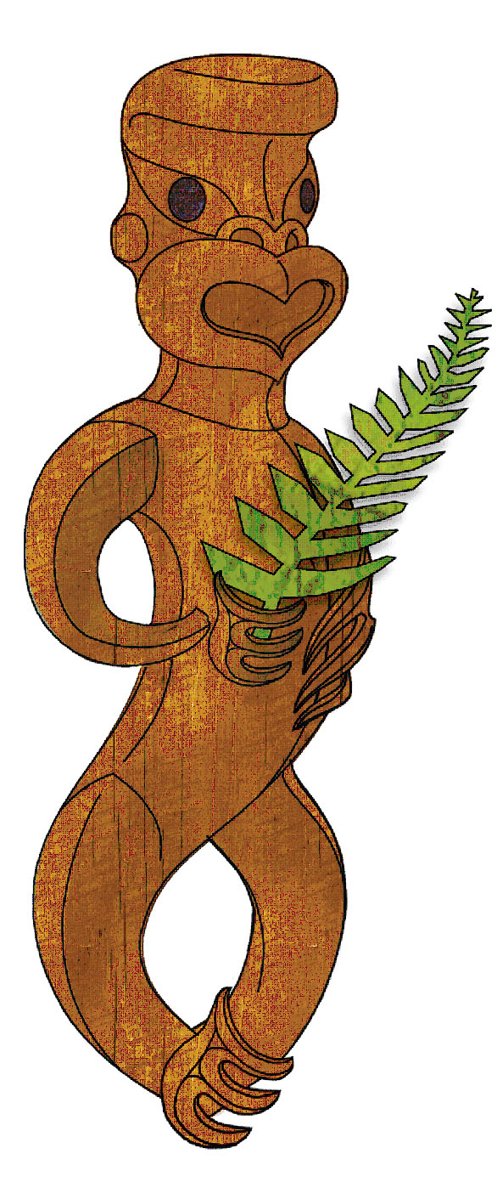

TOURISM MĀORI

UNIT STANDARD 17391 (version 7)

Demonstrate knowledge of key forms of Māori communication, and the significance of Māori identity in tourism

(Level 3, Credits 5)

ASSESSOR BOOKLET
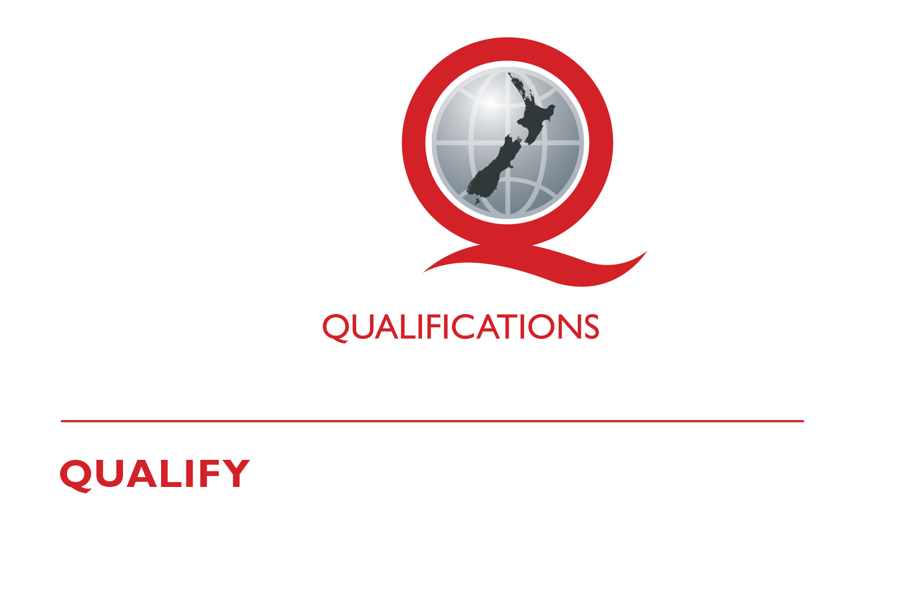
© New Zealand Qualifications Authority 2017

Assessor Information

Assessment criteria
Paetae/Achievement
People credited with this unit standard are able to demonstrate knowledge of key forms of Māori communication, and the significance of Māori identity in tourism

There are FOUR (4) assessment tasks that the ākonga must correctly complete to gain credits for this standard. Once the ākonga has correctly completed the tasks, the assessor must complete the assessment schedule for each ākonga.

Ākonga assessment booklet
The ākonga receives this. It outlines important information for the ākonga including:
- assessment and other information
- assessment tasks.

Ākonga assessment tasks
These sheets and any other evidence should be collected by the assessor and retained for assessment and moderation purposes.
Where ākonga choose to provide oral description/evidence for Task 2 and/or Task 4b, this must be recorded (i.e. recorded onto DVD or USB flash drive). Where ākonga work has been selected for moderation, the DVD or USB flash drive must be included with the materials.
Where a recording of the demonstration is submitted for moderation, the ākonga identification sheet (refer following link: http://www.nzqa.govt.nz/assets/Providers-and-partners/Assessment-and-moderation/mod-visevidence-cvr.doc) must be included.
You will need to discuss with the ākonga the length of time they have to complete the assessment. He ture-a-kōnui: one credit equates to 10 notional hours of teaching, practice and/or study, and assessment.

Authenticity
As per NZQA requirements:
- you must verify that the work submitted for assessment has been produced by the ākonga
- you must consider (and manage) the potential for work to have been copied, borrowed from another ākonga, photocopied from a book or downloaded from the internet.
Ākonga may work with and learn from others to gather information from a variety of sources. However, you must be clear that the work to be assessed has been processed and produced by the ākonga.
To help manage authenticity of ākonga work, where the ākonga is asked to complete any written tasks, the ākonga is asked to use their own words as well as provide reference/s for their information. Please ensure you discuss this with your ākonga.
For further information, please refer to the following link:
http://www.nzqa.govt.nz/providers-partners/assessment-and-moderation/assessment-of-standards/generic-resources/authenticity/.

Referencing
This assessment requires the ākonga to reference his/her information. For the purposes of this assessment, the following are examples of reference styles.

Examples of referencing
1 | Book with one author
 | King, M. (2000). Wrestling with the angel: A life of Janet Frame. Auckland, New Zealand: Viking.
2 | Course handout/Lecture notes (electronic version)
 | Archard, S., Merry, R., & Nicholson, C. (2011). Karakia and waiata [PowerPoint slides]. Retrieved from TEPS757-11B (NET): Communities of Learners website: http://elearn.waikato.ac.nz/mod/resource/view.php?id=174650.
3 | Film
 | Māori Television (Producer). (2016). Iwi Anthems, Series 2 Episode 5 [video file]. Retrieved from: http://www.maoritelevision.com/tv/shows/iwi-anthems/S02E005/iwi-anthems-series-2-episode-5.
4 | Magazine/Newspaper article – popular/trade/general interest
 | Fox, D. (2015, 15 September). Viewpoint: Not one more acre. Mana. Retrieved from: http://www.mana.co.nz/heritage/viewpoint.html.
5 | Personal Communication - letters, telephone conversations, emails, interviews, private social networking
 | Smith, J. (2016, 19 October) Personal communication.
6 | Webpage
 | New Zealand Trade and Enterprise. (n.d.). Agribusiness. Retrieved from https://www.nzte.govt.nz/en/export/market-research/agribusiness/.

Preparation for moderation
It is no longer necessary to complete a Moderation Cover Sheet as this information is entered online. If physical materials are sent for moderation, please ensure name of school and standard are included.
Digital submissions can be made directly through the application at any time.
Using the online External Moderation Application, schools and providers must include:
- a copy of the task and any key supporting resources
- a copy of the assessment schedule
- up to 8 samples of student work consisting of the key materials that the assessor has used to make an assessment judgement. (ungraded unit standards: schools – 4 learner samples; providers – 3 learner samples).
For moderation to occur:
- all files must be viewable online
- URLs, e.g. for student created websites, will need to be submitted as links within a document.
For more information on the digital moderation process, please contact your Principal Nominee or Moderation Liaison (ML).

If you have any issues with preparing materials for moderation OR do not have materials to submit (i.e. you didn’t assess this standard), SPEAK to your Principal Nominee (PN) or Moderation Liaison (ML).
ASSESSOR INFORMATION – ASSESSMENT TASKS

Outcome 1 | Demonstrate knowledge of key forms of Māori communication and their significance in tourism.

Assessment Task 1
Describe the significance of te reo Māori in tourism.
This task assesses the performance criteria of 1.1.

Assessment Task 2
Listed below are a number of verbal, non-verbal and artistic forms of communication used within te ao Māori.
From the list below select THREE forms of verbal communication and THREE forms of non-verbal communication and give a demonstration to show your understanding of them.
- whakataukī  - whakairo  - hongi  - wero  - waha  - kākahu  - raranga | - pepeha  - kōwhaiwhai  - waiata ā ringa  - kupu  - tā moko  - kete  - pakiwaitara | - whaikōrero  - haka  - pūkana  - mau rākau  - waiata  - tauparapara  - pūrakau | - tukutuku  - whētero  - karanga  - poi  - mihi  - harirū  - korowai
You need to demonstrate SIX forms.
Demonstration may include computer, whakaari, tuhituhi, roleplay, poster, waiata, artwork, kapahaka, pakiwaitara, pūrākau, drama, dance, video, oral, photo images, social media etc.
This task assesses the performance criteria of 1.2, 1.3
Ākonga may use the attached sheet to record their answers and/or use a range of other techniques to present your descriptions – e.g. PowerPoint, mind maps, posters, drawings etc.
ĀĀkonga must present information in their own words, and references must be provided.
You will observe ākonga performance and record the result on the following checklist.

Observation Sheet – Communication
ĀKONGA:
ASSESSOR:
DATE:
Verbal communication | Criteria: Performance accords with tikanga and kawa. Shows correct pronunciation, wording, phrasing, intonation etc.
1

2

3

Non- verbal communication | Criteria: Performance accords with tikanga and kawa. Shows correct facial expressions, gestures, stance etc.
1

2

3

Assessment Task 3
Identify THREE key forms of artistic means of communication from Ngā mahi a Toi and THREE from Te Whare Pora.

- List the category of each form
- Describe each form

NGĀ MAHI A TOI
Category 1
Category 2
Category 3
TE WHARE PORA
Category 1
Category 2
Category 3

Assessment Task 4a
Explain the meaning of whakapapa and why it is so important to Māori. Include in your explanation the significance of whakapapa in relation to Ranginui and Papatūānuku and the relevance to tourism Māori.

Assessment Task 4b
Recite your whakapapa that includes at least three of the following: awa, hapū, maunga, iwi, whānau or any other relevant concepts.

Observation Sheet - Whakapapa
TAUIRA:
ASSESSOR:
DATE:
Whakapapa concept  hapū, maunga, awa whānau, iwi | Performance accords with tikanga and kawa  - correct pronunciation  - appropriate wording  - phrasing  - intonation etc.
 | Observer comments
1
2
3

Observer signature: _____________________________________________
Comments on this support material
Please contact Māori Qualifications Services mqs@nzqa.govt.nz if you wish to suggest changes to the content of this resource.

Assessment Schedule

Assessment Task 1 | Evidence for Achieved | Grades
Describe the significance of te reo Māori in tourism Māori. | Oral, written or visual description of the significance of te reo Māori in tourism Māori.  The following is an example of tauira response.  Waiata tawhito/or mōteatea are ancient songs and poetry of the Māori. Referred to as laments mōteatea have been the vehicle used to transmit history and whakapapa from the past to the present as well as into the future. When used in tourism Māori it connects tangata whenua with the environment, whenua and relates to kaitiakitanga… | N  A
 | Judgement for Achieved
Response includes reasons for using te reo Māori in tourism.

Responses are correct and relevant

Response links te reo Maori to communication forms for the transmission of culture and history from the past to the present day.

Assessment Task 2 | Evidence for Achieved | Grades
Select three forms of verbal communication and three forms of non-verbal communication and demonstrate your understanding of them. | Tauira demonstrates their understanding of, and explaining the use for, verbal and non-verbal communication in te reo Māori.  The following is an example of tauira response.  Non-verbal - the hongi is the pressing of noses and symbolises the joining of the hā (breath of life) from one person to another.  Completed observation form signed off by tauira and assessor:  Observation form to be completed. | N  A
 | Judgement for Achieved
Response includes:
  - three verbal and
  - three non-verbal
forms of communication

Demonstration in accordance with relevant tikanga and kawa
Verbal - Correct pronunciation, wording, phrasing, intonation
Non-verbal - Appropriate facial expressions, gestures, stance
Observation form completed, comments made and signed by observer.
Assessment Task 3 | Evidence for Achieved | Grades
a Identify three key forms of artistic means of communication from Ngā mahi a Toi.  - List the category of each form  - Describe each form  b Identify three key forms of artistic means of communication from Te Whare Pora.  - List the category of each form  - Describe each form | Tauira identifies three key forms of artistic communication from Ngā mahi a Toi and Te Whare Pora.  The following is an example of tauira response:  Whakairo (carving) is an artistic form of communication (visual art) that displays figurines of prominent ancestors and kōrero pertaining to whakapapa. | N  A
 | Judgement for Achieved
Response categorises and describes:
- Three key forms of artistic communication from Ngā mahi a Toi
- Three key forms of artistic communication from Te Whare Pora

Assessment Task 4 | Evidence for Achieved | Grades
a Explain the meaning of whakapapa and why it is so important to Māori. Include in your explanation the significance of whakapapa in relation to Ranginui and Papatūānuku and the relevance to tourism Maori.  b Recite your whakapapa that includes at least three of the following: awa, hapū, maunga, iwi, whānau or any other relevant concepts. | Tauira explains what whakapapa is and why it is important to Māori. Included in the explanation is the significance of Ranginui and Papatūānuku and the relevance to Tourism Māori.  The following is an example of tauira response:  a in te ao Māori whakapapa is an important factor in establishing one’s identity. It provides an in-depth connection to the whenua (land) and the roots of one’s ancestry linking everyone back to Ranginui (Sky father), Papatūānuku (earth mother) and the outer creations to the beginning of time. Its relevance to tourism Māori is an awareness of kaitiakitanga and tangata whenua relationship with the land.  b Whakapapa is recited.  Observation Sheets – Whakapapa is completed and signed by Assessor. | N  A
 | Judgement for Achieved
a Response includes the connection between Ranginui and Papatūānuku in relation:
- Kaitiakitanga
- Manaakitanga
- Whakapapa

b Whakapapa is recited with at least three concepts:
awa/moana/repo, maunga, iwi, hapū, tangata, whānau, mātua, tamariki, ingoa.

Observation checklist completed, comments made and signed by observer.

UNIT STANDARD 17391 (version 7)

Demonstrate knowledge of key forms of Māori communication, and the significance of Māori identity in tourism

Overall grade (please circle) | N (Not Achieved) | A (Paetae/Achieved)

Ākonga name |  | Assessor name
Ākonga signature |  | Assessor signature
Completion date

