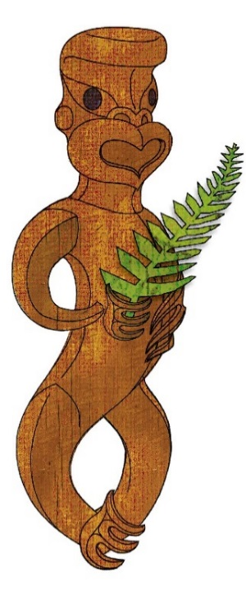
Tīkarohia te Marama – Realise Your Potential
Field Māori Assessment Support Material

TOURISM MĀORI

UNIT STANDARD 17578 (version 8)

Explain the value and benefits of whānau in tourism Māori

(Level 3, Credits 4)

ĀKONGA BOOKLET

Name
Organisation
Kaiako/Assessor
NSN Number

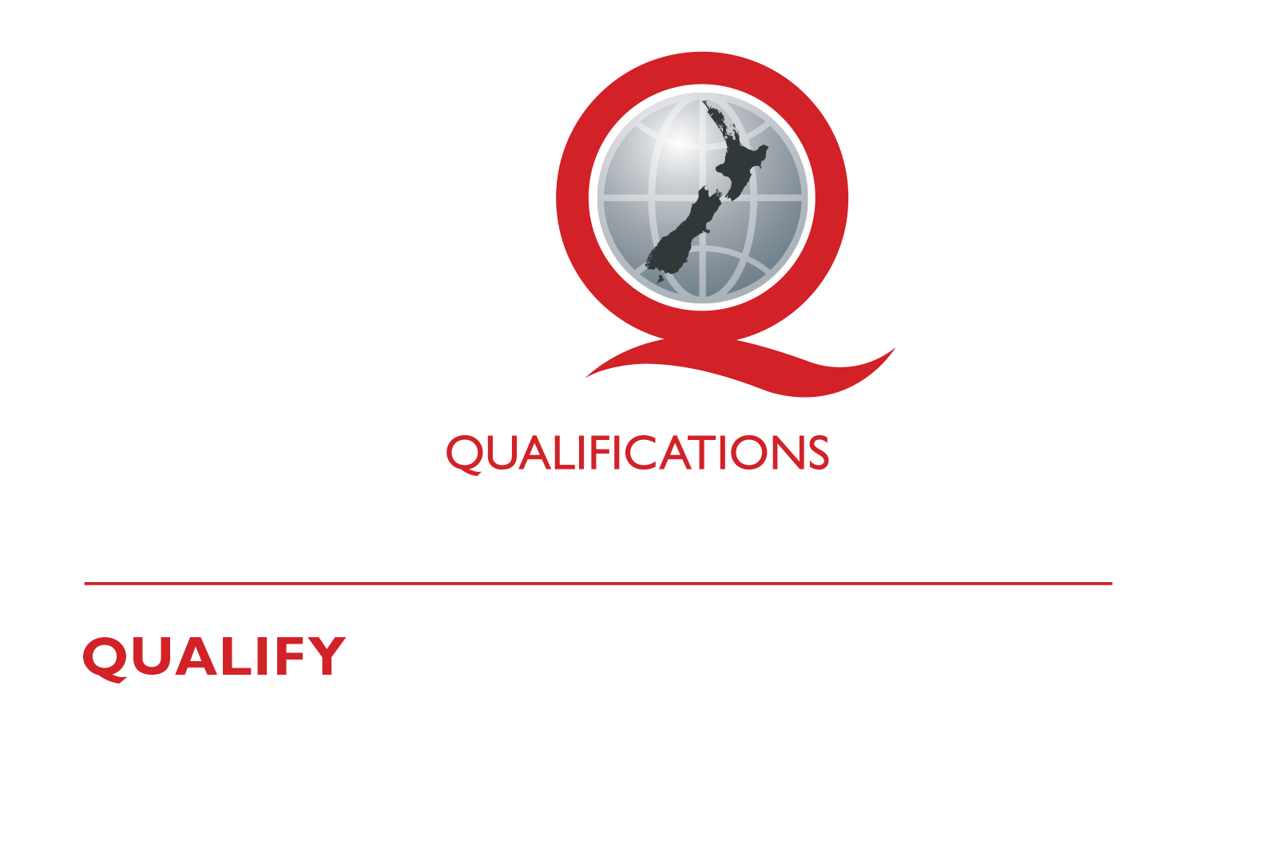
© New Zealand Qualifications Authority 2017
Tēnā koe
This is your assessment booklet for Tourism Māori unit standard 17378, Explain the value and benefits of whānau in tourism Māori.

Assessment criteria
Paetae/Achievement
Explain the value and benefits of whānau in tourism Māori.

There are THREE (3) assessment tasks for this standard that you must correctly complete.
The tasks are:
1 Write about the value the listed roles bring to any tourism Māori event or service. Explain the value of mana whenua plus any other five roles.
2 In the mind map there are seven potential areas of benefit for whānau, hapū and iwi from using a whānau approach to tourism Māori. Explain the best outcomes that could be achieved in each of the remaining six areas.
3 From the list of contemporary whānau activities, explain how these activities contribute to Tourism Māori. Select two activities and explain how each can contribute to tourism Māori.

Your kaiako will discuss the length of time you have to complete this. PLEASE remember to reference where you get your information from for Tasks 1 and 2. Your kaiako will discuss this with you.

Authenticity
As per NZQA requirements:
- all work submitted for assessment must be produced by you
- the assessor will consider (and manage) the potential for work to have been copied, borrowed from another ākonga, photocopied from a book, or downloaded from the internet.
You may work with and learn from others to gather information from a variety of sources. However, the assessor must be clear that the work to be assessed has been processed and produced by you. To help manage authenticity of your work, where you are asked to complete any written tasks, you will be asked to use your own words as well as provide reference/s for your information.
If you have any pātai, or are unsure about anything, kōrero ki tō kaiako.
For further information, please refer to the following link:
http://www.nzqa.govt.nz/providers-partners/assessment-and-moderation/assessment-of-standards/generic-resources/authenticity/.

ĀKONGA ASSESSMENT TASK SHEET

Name |  | NSN #

Outcome 1 | Explain the value and benefits of whānau in tourism Māori.

Assessment Task 1
Here is a list of whānau roles within possible tourism Māori events/services.
mana whenua | taura here | ringawera | kaihautū | kaiwhakahaere
kaimahi | tuakana | teina | kuia | Koroua
In the table provided below, write about the value these roles bring to any tourism Māori event or service. An example for ringa wera has been given. Your task is to explain the value of mana whenua plus any other five roles.

Roles | Value of the role in a tourism Māori event/service
ringa wera | Ringawera showcase Māori hospitality of manaakitanga at its very best, by providing kai (food). In the first instance, they cook and prepare kai for the noa process whereby the tapu placed on manuhiri during a pōwhiri is neutralised through eating of food.
Mana whenua
1
2
3
4
5

Assessment Task 2
Task.2 (1.2)
In the mind map below there are seven potential areas of benefit for whānau, hapū and iwi from using a whānau approach to tourism Māori. An example of best outcomes of using this approach for strengths has been provided as a model. Explain the best outcomes that could be achieved in the remaining six areas.
Collective Actions
Strengths
Whanaungatanga
Building relationships within the community and industry leading to jobs and other benefits
Social Activities
Economic Development
Self-Management
Collective Esteem
Identity
Iwi
Hapū
Iwi

Additional space for ākonga to key in answer

Assessment Task 3
Task 3 (1.3)
3a Below is a list of some traditional whānau activities that may take place during a tourism Māori event. In the table provided, explain how two of these activities can contribute to Tourism Māori. An explanation for poukai has been given as an example.
 | hura kōhatu | Matariki | wānanga whakapapa | poukai | wānanga mōteatea | Ratana Day

Traditional whānau activities: | Explanation of how the activity contributes to tourism Māori
POUKAI | Was originally started by Kīngi Tāwhiao to feed the widowed, the bereaved and the destitute. It was a way of looking after and feeding people driven from their homeland after the New Zealand wars in 1863. Nowadays it is a way for iwi to feast together, grieve together for those recently passed, disseminate news of relevance to the iwi, bring people’s concerns to the attention of the Kīngitanga leadership and collect financial contributions to the Kīngitanga and the host marae.
3b Below is a list of contemporary whānau activities. An explanation for kapa haka has been provided as an example. Select another two activities and explain how each can contribute to tourism Māori.
Pā wars | Reunions | Matariki | Waka ama | Māori golf | Te Matatini

Contemporary whānau activities: | Explanation of how the activity contributes to tourism Māori
Kapa haka events | Kapa haka have a significant contribution to tourism Māori as it is not only used to embrace te reo Māori, but it is also a way of sharing and expressing stories and conveying messages through song and dance.  There are yearly competitions held in local kapa haka regions and biennially a national competition is held.

References

