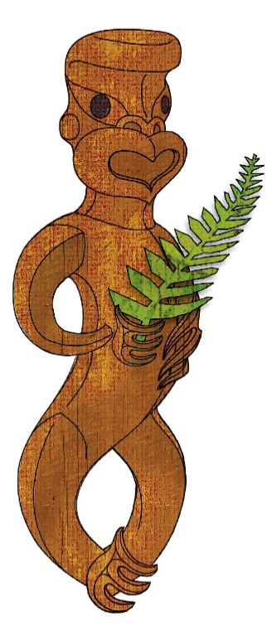
Tīkarohia te Marama – Realise Your Potential
Field Māori Assessment Support Material

TOURISM MĀORI

UNIT STANDARD 17784 (version 7)

Examine and recite appropriate karakia in tourism

(Level 3, Credits 5)

ĀKONGA BOOKLET

Name
Organisation
Kaiako/Assessor
NSN Number

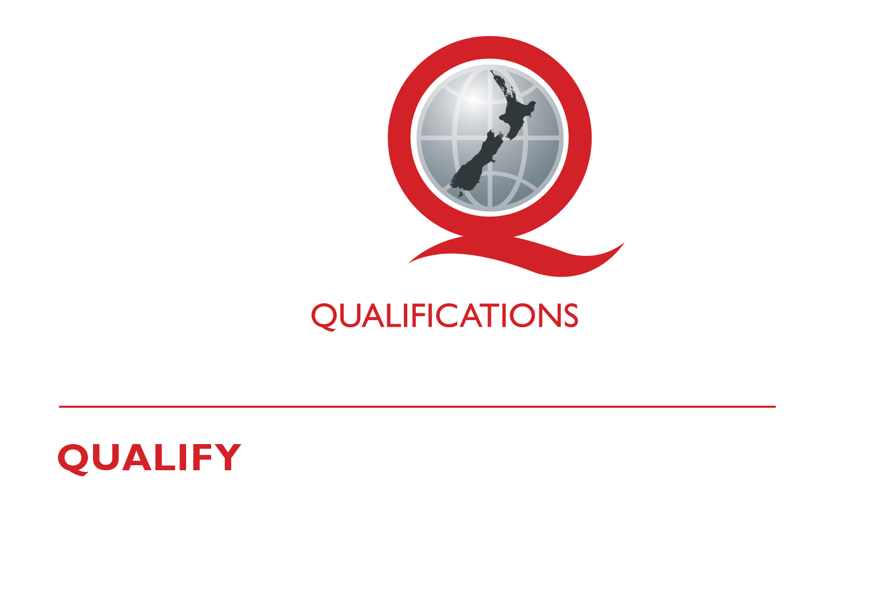
© New Zealand Qualifications Authority 2017
Tēnā koe
This is your assessment booklet for Tourism Māori unit standard 17784, Examine and recite appropriate karakia in tourism.

Assessment criteria
Paetae/Achievement
People credited with this unit standard are able to discuss karakia tawhito and examine contemporary karakia as they apply to a tourism Māori event, and recite a karakia appropriate to a tourism Māori event.

There are TWO (2) assessment tasks for this standard that you must correctly complete.
The tasks are:
1 Select two karakia tawhito, and two contemporary karakia, which could be used during a tourism event, and provide the following information in the table below
2 Select one karakia tawhito, OR one contemporary karakia from Task 1. Recite the karakia demonstrating appropriate behaviour and/or demeanour and with correct pronunciation of kupu

Your kaiako will discuss the length of time you have to complete this. PLEASE remember to reference where you get your information from for Tasks 1 and 2. Your kaiako will discuss this with you.

Authenticity
As per NZQA requirements:
- all work submitted for assessment must be produced by you.
- the assessor will consider (and manage) the potential for work to have been copied, borrowed from another ākonga, photocopied from a book, or downloaded from the internet.
You may work with and learn from others to gather information from a variety of sources. However, the assessor must be clear that the work to be assessed has been processed and produced by you. To help manage authenticity of your work, where you are asked to complete any written tasks, you will be asked to use your own words as well as provide reference/s for your information.
If you have any pātai, or are unsure about anything, kōrero ki tō kaiako.
For further information, please refer to the following link:
http://www.nzqa.govt.nz/providers-partners/assessment-and-moderation/assessment-of-standards/generic-resources/authenticity/.

ĀKONGA ASSESSMENT TASK SHEET

Name |  | NSN #
You may use the attached sheet to record your answers and/or use a range of other techniques to present your descriptions – e.g. artwork, computer, dance, drama, kapahaka, oral, poster, pakiwaitara, pūrākau, photo images, roleplay, social media, tuhituhi, video, waiata, whakaari.
You must present information in your own words, and references must be provided.
Outcome 1 | Discuss karakia tawhito as it applies to a tourism Māori event.

Outcome 2 | Examine contemporary karakia as it applies to a tourism Māori event.

Assessment Task 1
Here are some karakia themes - tīmatanga hui, karakia mo te kai, sickness, canoe building, protection against mākutu, tapu, unite factions, to cure injuries, to ward off ill luck, Ngā atua Māori.
Select two karakia tawhito, and two contemporary karakia, which could be used during a tourism event, and provide the following information in the table below. An example is given in the table below.

Karakia tawhito  Whakataka te hau | Whakamārama (explanation) | Purpose and appropriateness to a tourism event
Whakataka te hau ki te uru  Whakataka te hau ki te tonga  Kia mākinakina ki uta  Kia mātaratara ki tai  E hī ake ana te atākura  He tio, he huka, he hauhu  Haumi e! Hui e! Tāiki e! | Let the west wind fall  And the south wind be silent  The land bristles in the chill  And the ocean has goose bumps  The first rays of a red dawn pierce the night  Revealing snow, ice, and frost  I will grasp it; I will bind myself to it. | A karakia saying “my god, I’m part of this!! - this extraordinary beauty. I bind myself to it”  Asking for nothing except to bind oneself to ‘this’  Justice Joe Williams (Key Note speaker, Ngā Pae o te Maramatanga 15 November 2016)
Karakia tawhito
1.___________________________________
 | Whakamārama (explanation) | Purpose and appropriateness to a tourism event:
Karakia tawhito
2.___________________________________
 | Whakamārama (explanation) | Purpose and appropriateness to a tourism event:

Contemporary karakia
1.___________________________________
 | Whakamārama (explanation) | Purpose and appropriateness to a tourism event:
Contemporary karakia
2.___________________________________
 | Whakamārama (explanation) | Purpose and appropriateness to a tourism event:

Outcome 3 | Recite a karakia appropriate to a tourism Māori event.

Assessment Task 2
Select one karakia tawhito, OR one contemporary karakia from Task 1. Recite the karakia demonstrating appropriate behaviour and/or demeanour and with correct pronunciation of kupu.
Observation Sheet – recite karakia
ĀKONGA:

ASSESSOR:

DATE:

Recitation of karakia is in accordance with tikanga and kawa | Assessor comments
- te reo kia tika
- te reo kia rere
- te reo kia Māori
- Appropriate behaviour and/or demeanour in accordance with tikanga and kawa e.g. removal of hats/hoodies during karakia:
  - respectful manner
  - facial expressions
  - gestures
  - stance
  - acknowledgements

Reference/s:

