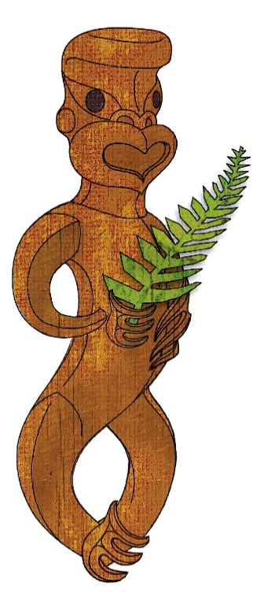
Tīkarohia te Marama – Realise Your Potential
Field Māori Assessment Support Material

TOURISM MĀORI

UNIT STANDARD 17786 (version 7)

Explain tikanga in tourism Māori

(Level 3, Credits 5)

ĀKONGA BOOKLET

Name
Organisation
Kaiako/Assessor
NSN Number

© New Zealand Qualifications Authority 2017
Tēnā koe

This is your assessment booklet for Tourism Māori unit standard 17786, Explain tikanga in tourism Māori

Assessment criteria
Paetae/Achievement
People credited with this unit standard are able to explain tikanga in tourism Māori

There is ONE (1) assessment task for this standard that you must correctly complete.
The task is:
- Explain at least four tikanga that relate to each tour and to each of the sites the tour will visit.

Your kaiako will discuss the length of time you have to complete this. PLEASE remember to reference where you get your information from for Tours1 and 2. Your kaiako will discuss this with you.

Authenticity
As per NZQA requirements:
- all work submitted for assessment must be produced by you
- the assessor will consider (and manage) the potential for work to have been copied, borrowed from another ākonga, photocopied from a book, or downloaded from the internet.
You may work with and learn from others to gather information from a variety of sources. However, the assessor must be clear that the work to be assessed has been processed and produced by you. To help manage authenticity of your work, where you are asked to complete any written tasks, you will be asked to use your own words as well as provide reference/s for your information.
If you have any pātai, or are unsure about anything, kōrero ki tō kaiako.
For further information, please refer to the following link:
http://www.nzqa.govt.nz/providers-partners/assessment-and-moderation/assessment-of-standards/generic-resources/authenticity/.

ĀKONGA ASSESSMENT TASK SHEET

Name |  | NSN #

Outcome 1 | Explain tikanga Māori in tourism Māori.  Range Tikanga Māori may include but is not limited to – rāhui, tapu, noa, muru, utu, pouwhenua, aukati;  evidence of four is required.

Assessment Task 1
Instructions
To complete this unit standard successfully the candidate is expected to complete the following task as set out on the following pages.
Tikanga must always be explained to visitors. This is so that protocols and procedures are carried out in the right way making the experience safe for all. For example, when being welcomed onto a marae it is important for the visitors to know what the kai wero is doing and why, the same for the kaikaranga and kaikōrero.
Scenario: You are taking groups of tourists on two different tours.
The tours can be:
- A cultural heritage trail;
- A marae visit;
- A hard adventure.
Each tour will visit two particular sites, these sites may be:
- Awa;
- māra kai;
- mātaitai reserves;
- maunga;
- moana;
- pā;
- taiapure;
- archaeological sites;
- historical sites;
- marae;
- wāhi tapu.
Chose the two tours and the sites each tour will visit and find out from local whānau/hapū or iwi the Māori customs and practices that are appropriate to the tours and sites.
Here is a sample of useful information to gather:
- Māori name and the history behind it;
- significance of site;
- customs regarding tapu and noa;
- procedures to entering and exiting site;
- roles and responsibilities of tangata whenua and visitors (i.e. kaumātua, kuia etc, poua, taua);
- safety measures;
- time factors.

List below the two different tours you have chosen and the two sites each tour will visit.
Explain at least four tikanga that relate to each tour and to each of the sites the tour will visit.
Tikanga can include: rāhui, tapu, noa, muru, utu, pouwhenua, aukati and any others the local whānau/hapū or iwi see as appropriate practices for the sites to be visited. You may use the attached sheet to record your answers and/or use a range of other techniques to present your descriptions – e.g. artwork, computer, dance, drama, kapahaka, oral, poster, pakiwaitara, pūrākau, photo images, roleplay, social media, tuhituhi, video, waiata, whakaari

Tour #1 | Sites | Tikanga – explanation
Tour #1 | 1 | 1
 |  | 2
 | 2 | 3
 |  | 4
Tour #2 | Sites | Tikanga - explanation
Tour #2 | 1 | 1
 |  | 2
 | 2 | 3
 |  | 4

Reference/s:

