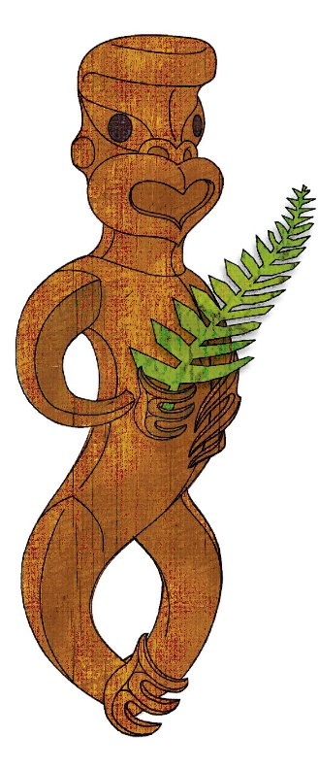
Tīkarohia te Marama – Realise Your Potential
Field Māori Assessment Support Material

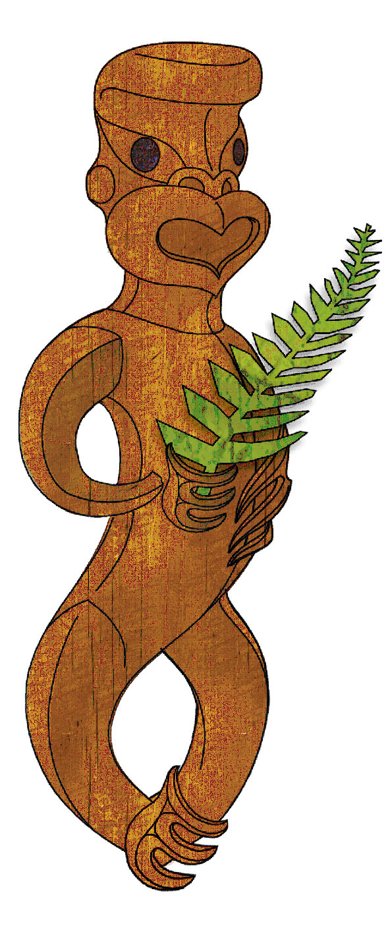

TOURISM MĀORI

UNIT STANDARD 17786 (version 7)

Explain tikanga in tourism Māori

(Level 3, Credits 5)

ASSESSOR BOOKLET
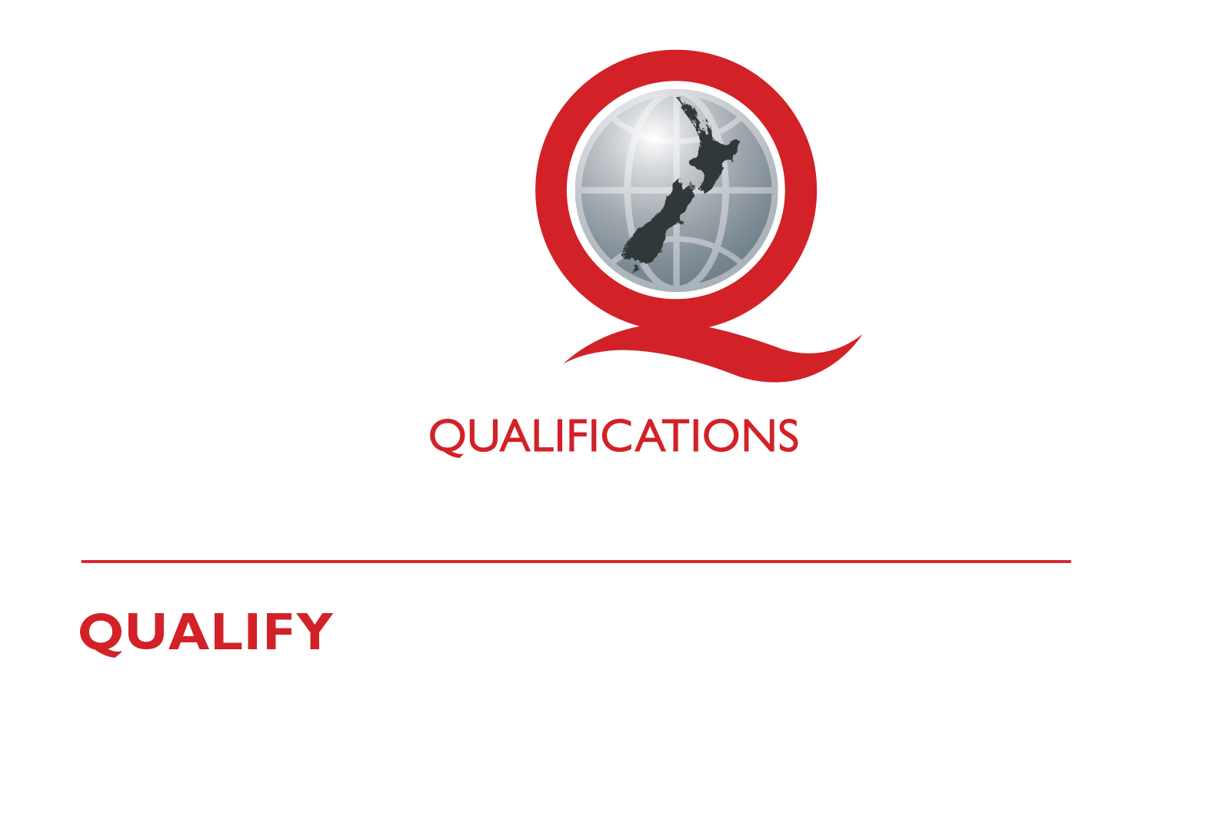
© New Zealand Qualifications Authority 2017

Assessor Information

Assessment criteria
Paetae/Achievement
People credited with this unit standard are able to explain tikanga in tourism Māori.

There is ONE (1) assessment task that the ākonga must correctly complete to gain credits for this standard. Once the ākonga has correctly completed the task, the assessor must complete the assessment schedule for each ākonga.

Ākonga assessment booklet
The ākonga receives this. It outlines important information for the ākonga including:
- assessment and other information
- assessment tasks.

Ākonga assessment tasks
These sheets and any other evidence should be collected by the assessor and retained for assessment and moderation purposes.
Where ākonga choose to provide oral description/evidence, this must be recorded (i.e. recorded onto DVD or USB flash drive). Where ākonga work has been selected for moderation, the DVD or USB flash drive must be included with the materials.
Where a recording of the demonstration is submitted for moderation, the ākonga identification sheet (refer following link: http://www.nzqa.govt.nz/assets/Providers-and-partners/Assessment-and-moderation/mod-visevidence-cvr.doc) must be included.
You will need to discuss with the ākonga the length of time they have to complete the assessment. He ture-a-kōnui: one credit equates to 10 notional hours of teaching, practice and/or study, and assessment.

Authenticity
As per NZQA requirements:
- you must verify that the work submitted for assessment has been produced by the ākonga
- you must consider (and manage) the potential for work to have been copied, borrowed from another ākonga, photocopied from a book or downloaded from the internet.
Ākonga may work with and learn from others to gather information from a variety of sources. However, you must be clear that the work to be assessed has been processed and produced by the ākonga.
To help manage authenticity of ākonga work, where the ākonga is asked to complete any written tasks, the ākonga is asked to use their own words as well as provide reference/s for their information. Please ensure you discuss this with your ākonga.
For further information, please refer to the following link:
http://www.nzqa.govt.nz/providers-partners/assessment-and-moderation/assessment-of-standards/generic-resources/authenticity/.

Referencing
This assessment requires the ākonga to reference his/her information. For the purposes of this assessment, the following are examples of reference styles.

Examples of referencing
1 | Book with one author
 | King, M. (2000). Wrestling with the angel: A life of Janet Frame. Auckland, New Zealand: Viking.
2 | Course handout/Lecture notes (electronic version)
 | Archard, S., Merry, R., & Nicholson, C. (2011). Karakia and waiata [PowerPoint slides]. Retrieved from TEPS757-11B (NET): Communities of Learners website: http://elearn.waikato.ac.nz/mod/resource/view.php?id=174650.
3 | Film
 | Māori Television (Producer). (2016). Iwi Anthems, Series 2 Episode 5 [video file]. Retrieved from: http://www.maoritelevision.com/tv/shows/iwi-anthems/S02E005/iwi-anthems-series-2-episode-5.
4 | Magazine/Newspaper article – popular/trade/general interest
 | Fox, D. (2015, 15 September). Viewpoint: Not one more acre. Mana. Retrieved from: http://www.mana.co.nz/heritage/viewpoint.html.
5 | Personal Communication - letters, telephone conversations, emails, interviews, private social networking
 | Smith, J. (2016, 19 October) Personal communication.
6 | Webpage
 | New Zealand Trade and Enterprise. (n.d.). Agribusiness. Retrieved from https://www.nzte.govt.nz/en/export/market-research/agribusiness/.

Preparation for moderation
It is no longer necessary to complete a Moderation Cover Sheet as this information is entered online. If physical materials are sent for moderation, please ensure name of school and standard are included.
Digital submissions can be made directly through the application at any time.
Using the online External Moderation Application, schools and providers must include:
- a copy of the task and any key supporting resources
- a copy of the assessment schedule
- up to 8 samples of student work consisting of the key materials that the assessor has used to make an assessment judgement. (ungraded unit standards: schools – 4 learner samples; providers – 3 learner samples).
For moderation to occur:
- all files must be viewable online
- URLs, e.g. for student created websites, will need to be submitted as links within a document.
For more information on the digital moderation process, please contact your Principal Nominee or Moderation Liaison (ML).

If you have any issues with preparing materials for moderation OR do not have materials to submit (ie you didn’t assess this standard), SPEAK to your Principal Nominee (PN) or Moderation Liaison (ML).

ASSESSOR INFORMATION – ASSESSMENT TASKS

Outcome 1 | Explain tikanga Māori in tourism Māori.  Range Tikanga Māori may include but is not limited to – rāhui, tapu, noa, muru, utu, pouwhenua, aukati;  evidence of four is required

Assessment Task 1
This task assesses the performance criteria of 1.1 and 1.2.
1.1 Tikanga relevant to a specific tour are explained in accordance with local hapū and iwi tikanga.
1.2 Tikanga relevant to a site are explained in accordance with local hapū and iwi tikanga

Instructions
To complete this unit standard successfully the candidate is expected to complete the following task as set out on the following pages.
Tikanga must always be explained to visitors. This is so that protocols and procedures are carried out in the right way making the experience safe for all. For example, when being welcomed onto a marae it is important for the visitors to know what the kai wero is doing and why, the same for the kaikaranga and kaikōrero.
Scenario: You are taking groups of tourists on two different tours.
The tours can be:
- A cultural heritage trail;
- A marae visit;
- A hard adventure.
Each tour will visit two particular sites, these sites may be:
- Awa;
- māra kai;
- mātaitai reserves;
- maunga;
- moana;
- pā;
- taiapure;
- archaeological sites;
- historical sites;
- marae;
- wāhi tapu.
Chose the two tours and the sites each tour will visit and find out from local whānau/hapū or iwi the tikanga that are appropriate to the tours and sites.
Here is a sample of useful information to gather:
- Māori name and the history behind it;
- significance of site;
- customs regarding tapu and noa;
- procedures to entering and exiting site;
- roles and responsibilities of tangata whenua and visitors (i.e. kaumātua, kuia etc);
- safety measures;
- time factors.

List below the two different tours you have chosen and the two sites each tour will visit.
Explain at least four tikanga that relate to each tour and to each of the sites the tour will visit.
Tikanga can include: rāhui, tapu, noa, muru, utu, pouwhenua, aukati and any others the local whānau/hapū or iwi see as appropriate practices for the sites to be visited.

Tour #1 | Sites | Tikanga – explanation
Tour #1 | 1 | 1
 |  | 2
 | 2 | 3
 |  | 4
Tour #2 | Sites | Tikanga - explanation
Tour #2 | 1 | 1
 |  | 2
 | 2 | 3
 |  | 4

Comments on this support material
Please contact Māori Qualifications Services mqs@nzqa.govt.nz if you wish to suggest changes to the content of this resource.
Assessment Schedule
Assessment Task 1 | Evidence for Achieved | Grades
Explain four tikanga that relate to each tour and to each of the sites the tour will visit. | The following are examples of tauira responses:  Marae Visit:  ‘state of’ Tapu i.e.: tapu is one of the strongest forces in Māori life and means sacred. You are about to embark on a sacred ritual of the Māori people  Wero (mātātaki), means “challenge” and was performed by a male warrior of ranking. It is a process at the beginning of a welcome ceremony to ascertain whether the visitor has come with peaceful intentions.  Kaikaranga – performed by women. Calls of welcome from the tangata whenua and response calls of gratitude and acknowledgement from the manuhiri (visitors)  Kaikōrero – speech maker or orator, who are knowledgeable in tribal whakapapa, and the spiritual, political, social and economic realities of the hapū.  Waiata – performed directly after a speech by groups belonging to the speaker to show that they support his speech  Hongi – is the pressing of noses and symbolizes joining of hā (the breath of life)  Kai – food  Noa – similar to a blessing and returns all to a neutral state. This is done by partaking of food.  Visit to wāhi tapu:  Local iwi authorities informed and consent given  Local kaumātua and kuia to accompany the group.  Historical kōrero to be given prior to entering site  Ngā ture (rules) explained  Karakia performed before entering wāhi tapu.  Karanga performed by kuia on entering the site to acknowledge ngā tīpuna.  Enter site.  Completion: Karakia performed and waiata sung  Noa process: Return to venue for refreshments to neutralise the process of tapu. | N  A
 | Judgement for Achieved
Responses include:
- two different tours
- two different sites for each tour
- four Māori customs and practices for each site
- Explanations in accord with local hapū and iwi tikanga.
- References provided.

UNIT STANDARD 17786 (version 6)

Explain tikanga in tourism Māori

(Level 3, Credits 5)

Overall grade (please circle) | N (Not Achieved) | A (Paetae/Achieved)
Ākonga name |  |  | Assessor name
Ākonga signature |  |  | Assessor signature
Completion date

