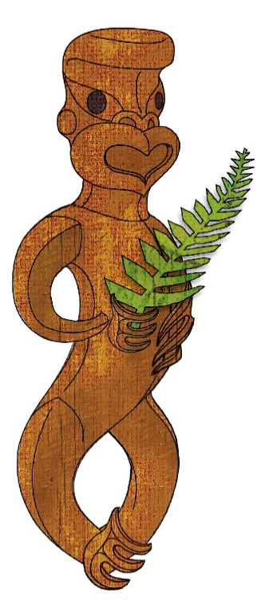
Tīkarohia te Marama – Realise Your Potential
Field Māori Assessment Support Material

TOURISM MĀORI

UNIT STANDARD 17791 (version 7)

Explain kaitiaki practices in a tourism Māori context

Level 3, Credits 5

ĀKONGA BOOKLET

Name
Organisation
Kaiako/Assessor
NSN Number

© New Zealand Qualifications Authority 2017
Tēnā koe

This is your assessment booklet for Tourism Māori unit standard 17791 Explain kaitiaki practices in a tourism Māori context

Assessment criteria
Paetae/Achievement
People credited with this unit standard are able to explain kaitiaki practices in a tourism Māori context.

There are THREE (3) assessment tasks for this standard that you must correctly complete.
The tasks are:
1 a Find out what is meant by kaitiaki practices and how they pertain to Ranginui (sky father) and Papatūānuku (earth mother)
b Explain two different kaitiaki practices and how they are applied in tourism Māori
2 Research THREE kāwai tīpuna/atua – Tāne, Tangaroa and one other and identify TWO kaitiaki practices for each, that are appropriate to tourism Māori.
3 Interview tourism industry practioners from your local rohe and discuss kaitiaki practices and how they relate to three different tourism events/activities.
Your kaiako will discuss the length of time you have to complete this. PLEASE remember to reference where you get your information from. Your kaiako will discuss this with you.

Authenticity
As per NZQA requirements:
- all work submitted for assessment must be produced by you
- the assessor will consider (and manage) the potential for work to have been copied, borrowed from another ākonga, photocopied from a book, or downloaded from the internet.
You may work with and learn from others to gather information from a variety of sources. However, the assessor must be clear that the work to be assessed has been processed and produced by you. To help manage authenticity of your work, where you are asked to complete any written tasks, you will be asked to use your own words as well as provide reference/s for your information.
If you have any pātai, or are unsure about anything, kōrero ki tō kaiako.
For further information, please refer to the following link:
http://www.nzqa.govt.nz/providers-partners/assessment-and-moderation/assessment-of-standards/generic-resources/authenticity/.

ĀKONGA ASSESSMENT TASK SHEET

Name |  | NSN #
You may use the attached sheet to record your answers and/or use a range of other techniques to present your descriptions – e.g. PowerPoint, mind maps, posters, drawings etc.
You must present information in your own words, and references must be provided.

Assessment Task 1a
- Find out what is meant by kaitiaki practices and how they pertain to Ranginui (sky father) and Papatūānuku (earth mother).
- Record TWO kaitiaki practices (ONE from Ranginui and ONE from Papatūānuku) below and give a brief explanation (one paragraph) about each one.
1
2
Additional space for ākonga to complete assessment

Assessment Task 1b
From your findings above in Task 1a, explain two different kaitiaki practices and how they are applied in tourism Māori.
Kaitiaki Practice 1
Kaitiaki Practice 2

Additional space for ākonga to complete assessment

Assessment Task 2
Research THREE kāwai tīpuna/atua – Tāne, Tangaroa and one other and identify TWO kaitiaki practices for each, that are appropriate to tourism Māori, that ensure the relationship between people and their environments are protected and kept in a healthy state. When writing up your research, include the domain or realm they are kaitiaki of.
Tane
1 |  | kaitiaki practice
2 |  | kaitiaki practice
Tangaroa
1 |  | kaitiaki practice
2 |  | kaitiaki practice
One other kāwai tīpuna
1 | kaitiaki practice
2 | kaitiaki practice
Additional space for ākonga to key in answer

Assessment Task 3
Task 3 (1.3)
Interview kaumātua, pakeke, tāua, poua, or iwi authority from your local rohe and discuss kaitiaki practices and how they relate to three different tourism events/activities.
The events/activities may be:
tramping, fishing, Matariki/Puanga/Puaka celebrations, swimming, hunting, waka, awa, roto, moana, maunga, ngahere, iwi commemorations, Te Matatini, ANZAC, Waitangi celebrations.
Name the three events/activities below and explain the kaitiaki practices the local rohe applied to each event/activity.

Event/Activity | Kaitiaki practice
1
Event/Activity | Kaitiaki practice
2
3

Reference/s:

