Tīkarohia te Marama – Realise Your Potential
Field Māori Assessment Support Material

TOURISM MĀORI

UNIT STANDARD 25954 (version 3)

Plan, conduct, and evaluate a tour on a marae in a tourism Māori context

(Level 4, Credits 15)

ĀKONGA BOOKLET
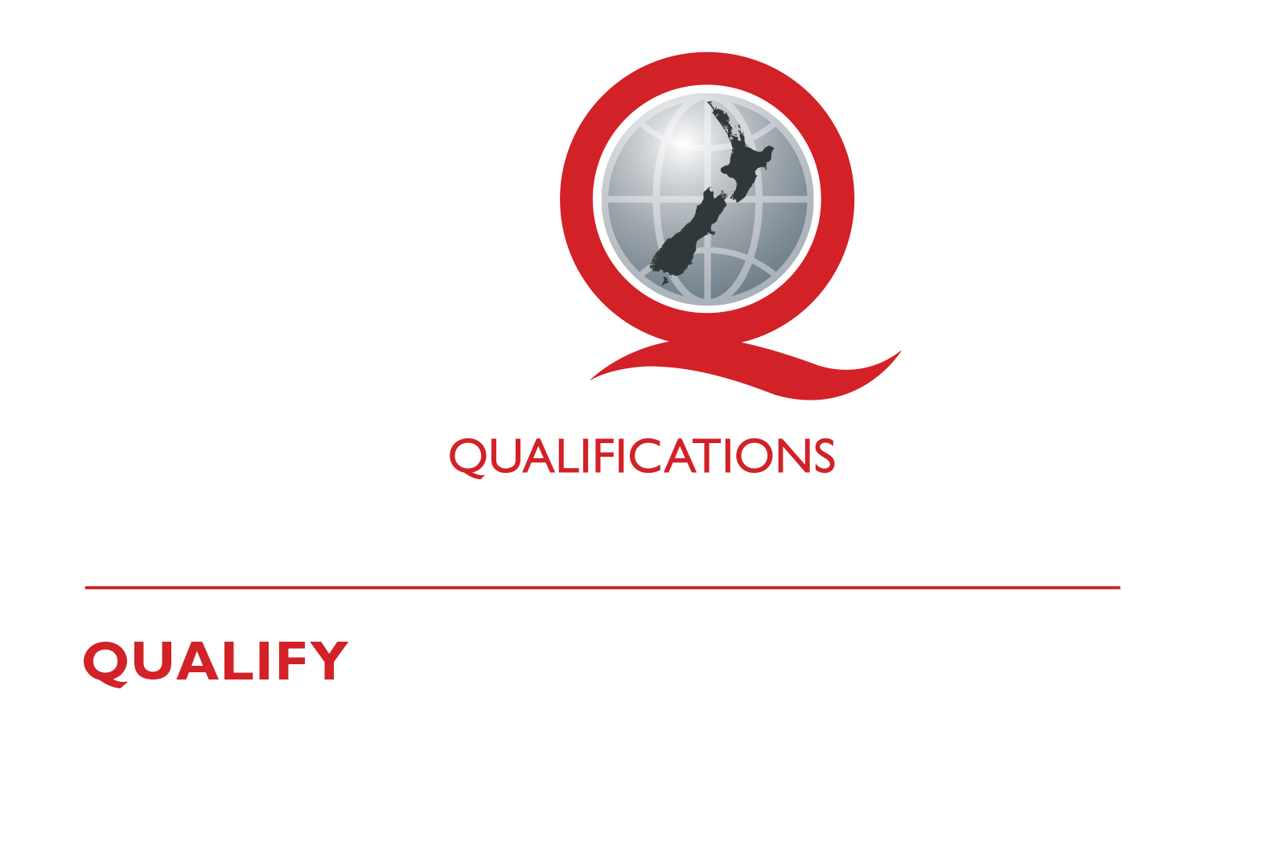
© New Zealand Qualifications Authority 2017
Name
Organisation
Kaiako/Assessor
NSN Number
Tēnā koe
This is your assessment booklet for Tourism Māori unit standard 25954 (version 3), Plan, conduct, and evaluate a tour on a marae in a tourism Māori context.

Assessment criteria
Paetae/Achievement
Explain procedures for conducting a tour on a marae. To include planning and evaluation.

There are four (4) assessment tasks for this standard that you must correctly complete.
The tasks are:
- Explain the procedures for conducting a tour on the marae. Include what must be done before, during and after the tour List here the task
- Plan the tour
- Conduct the tour
- Using the feedback from the tour guests, the run sheet and the observation sheet as a guide, evaluate how things went.

Your kaiako will discuss the length of time you have to complete this. PLEASE remember to reference where you get your information from. Your kaiako will discuss this with you.

Authenticity
As per NZQA requirements:
- all work submitted for assessment must be produced by you
- the assessor will consider (and manage) the potential for work to have been copied, borrowed from another ākonga, photocopied from a book, or downloaded from the internet.
You may work with and learn from others to gather information from a variety of sources. However, the assessor must be clear that the work to be assessed has been processed and produced by you. To help manage authenticity of your work, where you are asked to complete any written tasks, you will be asked to use your own words as well as provide reference/s for your information.
If you have any pātai, or are unsure about anything, kōrero ki tō kaiako.
For further information, please refer to the following link:
http://www.nzqa.govt.nz/providers-partners/assessment-and-moderation/assessment-of-standards/generic-resources/authenticity/.

ĀKONGA ASSESSMENT TASK SHEET

Name |  | NSN #

Outcome 1 | Explain procedures for conducting tours on a marae in a tourism Māori context.

Pre-Assessment Task
Organise a hui with your local marae committee and gain appropriate information regarding the following:
- Procedures for conducting a tour on the marae.
- Roles and responsibilities as well as the responsibilities of the manuhiri (tikanga or marae kawa).
Procedures that need to be followed to ensure very thing goes well. Make sure to record the minutes of your meeting and have them signed off by the marae committee or appointed representative.

Hui held at
Date |  | Time
Present
Discussion

Assessment Task 1
Using information from the hu.

Explain the procedures for conducting a tour on the marae. Include what must be done before, during and after the tour
Before
During
After

Reference/s:

Assessment Task 2
You may use the attached sheet to record your answers and/or use a range of other techniques to present your descriptions – e.g. PowerPoint, mind maps, posters, drawings etc.
You must present information in your own words, and references must be provided.
Plan the tour.

Having consulted regarding the tour and gathered all the relevant information you must now plan the tour. To do this you must complete a RUN SHEET, a draft template has been provided on the following page, you will need to modify it to include all the relevant information.

Ensure that you include ALL the following details in your run sheet or attached additional documents to it to cover them all:

- Dates and timing
- Marae booking and confirmation
- Numbers on tour
- Catering requirements
- Koha
- Names of kaumātua, kuia and hau kāinga where relevant
- Resources needed
- Budget
Programme - (karakia tīmatanga, pōwhiri, mihimihi, housekeeping duties, mihi whakamutunga, karakia whakamutunga)
You must build into your plan contingencies to cope with extraordinary occurrences these could include:
- Unavailability of a marae
- Tangihanga
- Marae over booked
- Change of circumstance
- Environmental conditions.
Your contingencies must cover tangihanga and one other possible extraordinary occurrence.

RUN SHEET – TOUR PLAN
ĀKONGA: |  | NAME OF TOUR:
DATE: |  | VENUE:
Time | Content | Who is responsible | Check

Reference/s:

Assessment Task 3
Conduct the tour
- Following your planning you must conduct the tour.
- Ensure that you follow your plan and comply with all aspects of marae tikanga.
Your trainer or a senior marae representative will observe you conducting the tour and note its progress on the following Observation sheet:

OBSERVATION SHEET
ĀKONGA:  ASSESSOR  DATE |  | TYPE OF TOUR:  VENUE:
Criteria | Assessor comments
Tour plan has been provided for observer
Tour has been well planned
Consultation has been carried out with marae committee before the tour
Contingency planning is appropriate for venue and circumstances
Tour is conducted in compliance with marae tikanga
Any concerns with tour guest behaviours are appropriately dealt with.
Any extraordinary occurrences are dealt with as per contingency plans

Assessment Task 4
Evaluate the tour.
It is important to review how well the tour went. Gather feedback from the tour guests on what they thought and discuss with the tangata whenua what went well and what didn’t work so well during the event and whether or not the tour was conducted in accordance with the plan etc. This should be done at the completion of the tour.
Using the feedback from the tour guests, the run sheet and the observation sheet as a guide, evaluate how things went.
Look at any variances to the plan and explain why they were needed. Discuss the implications and provide a strategy for improvements. Record all details below.
Evaluation details to be signed off by candidate and kaumātua/or marae representative.

EVALUATION REPORT
Implication | What worked / didn’t work well | Any variances from the plan and strategies for improvements.

