Tīkarohia te Marama – Realise Your Potential
Field Māori Assessment Support Material

TOURISM MĀORI

UNIT STANDARD 25954 (version 3)

Plan, conduct, and evaluate a tour on a marae in a tourism Māori context

(Level 4, Credits 15)

ASSESSOR BOOKLET
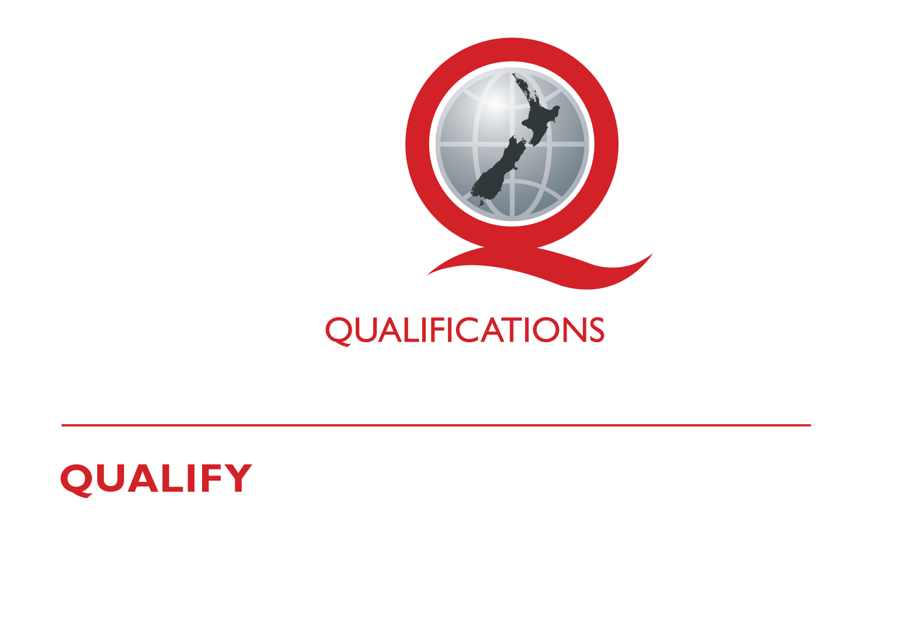
© New Zealand Qualifications Authority 2017

Assessor Information

Assessment criteria
Paetae/Achievement
Explain procedures for conducting a tour on a marae. To include planning and evaluation.

There are four (4) assessment tasks that the ākonga must correctly complete to gain credits for this standard. Once the ākonga has correctly completed the tasks, the assessor must complete the assessment schedule for each ākonga.

Ākonga assessment booklet
The ākonga receives this. It outlines important information for the ākonga including:
- assessment and other information
- assessment tasks.

Ākonga assessment tasks
These sheets and any other evidence should be collected by the assessor and retained for assessment and moderation purposes.
Where ākonga choose to provide oral description/evidence, this must be recorded (i.e. recorded onto DVD or USB flash drive). Where ākonga work has been selected for moderation, the DVD or USB flash drive must be included with the materials.
Where a recording of the demonstration is submitted for moderation, the ākonga identification sheet (refer following link: http://www.nzqa.govt.nz/assets/Providers-and-partners/Assessment-and-moderation/mod-visevidence-cvr.doc) must be included.
You will need to discuss with the ākonga the length of time they have to complete the assessment. He ture-a-kōnui: one credit equates to 10 notional hours of teaching, practice and/or study, and assessment.

Authenticity
As per NZQA requirements:
- you must verify that the work submitted for assessment has been produced by the ākonga
- you must consider (and manage) the potential for work to have been copied, borrowed from another ākonga, photocopied from a book or downloaded from the internet.
Ākonga may work with and learn from others to gather information from a variety of sources. However, you must be clear that the work to be assessed has been processed and produced by the ākonga.
To help manage authenticity of ākonga work, where the ākonga is asked to complete any written tasks, the ākonga is asked to use their own words as well as provide reference/s for their information. Please ensure you discuss this with your ākonga.
For further information, please refer to the following link:
http://www.nzqa.govt.nz/providers-partners/assessment-and-moderation/assessment-of-standards/generic-resources/authenticity/.

Referencing
This assessment requires the ākonga to reference his/her information. For the purposes of this assessment, the following are examples of reference styles.

Examples of referencing
1 | Book with one author
 | King, M. (2000). Wrestling with the angel: A life of Janet Frame. Auckland, New Zealand: Viking.
2 | Course handout/Lecture notes (electronic version)
 | Archard, S., Merry, R., & Nicholson, C. (2011). Karakia and waiata [PowerPoint slides]. Retrieved from TEPS757-11B (NET): Communities of Learners website: http://elearn.waikato.ac.nz/mod/resource/view.php?id=174650.
3 | Film
 | Māori Television (Producer). (2016). Iwi Anthems, Series 2 Episode 5 [video file]. Retrieved from: http://www.maoritelevision.com/tv/shows/iwi-anthems/S02E005/iwi-anthems-series-2-episode-5.
4 | Magazine/Newspaper article – popular/trade/general interest
 | Fox, D. (2015, 15 September). Viewpoint: Not one more acre. Mana. Retrieved from: http://www.mana.co.nz/heritage/viewpoint.html.
5 | Personal Communication - letters, telephone conversations, emails, interviews, private social networking
 | Smith, J. (2016, 19 October) Personal communication.
6 | Webpage
 | New Zealand Trade and Enterprise. (n.d.). Agribusiness. Retrieved from https://www.nzte.govt.nz/en/export/market-research/agribusiness/.

Preparation for moderation
It is no longer necessary to complete a Moderation Cover Sheet as this information is entered online. If physical materials are sent for moderation, please ensure name of school and standard are included.
Digital submissions can be made directly through the application at any time.
Using the online External Moderation Application, schools and providers must include:
- a copy of the task and any key supporting resources
- a copy of the assessment schedule
- up to 8 samples of student work consisting of the key materials that the assessor has used to make an assessment judgement. (ungraded unit standards: schools – 4 learner samples; providers – 3 learner samples).
For moderation to occur:
- all files must be viewable online
- URLs, e.g. for student created websites, will need to be submitted as links within a document.
For more information on the digital moderation process, please contact your Principal Nominee or Moderation Liaison (ML).

If you have any issues with preparing materials for moderation OR do not have materials to submit (i.e. you didn’t assess this standard), SPEAK to your Principal Nominee (PN) or Moderation Liaison (ML).
Assessor information – Assessment tasks

Outcome 1 | Explain procedures for conducting tours on a marae in a tourism Māori context.

Pre-Assessment Task
Organise a hui with your local marae committee and gain appropriate information regarding the following:
- Procedures for conducting a tour on the marae.
- Roles and responsibilities as well as the responsibilities of the manuhiri (tikanga or marae kawa).
Procedures that need to be followed to ensure very thing goes well. Make sure to record the minutes of your meeting and have them signed off by the marae committee or appointed representative.

Hui held at
Date |  | Time
Present
Discussion

Assessment Task 1
Using information from the hu.

Explain the procedures for conducting a tour on the marae, and working with tangata whenua before, during and after the tour
Before
During
After
These tasks assess performance criteria 1.1, 1.2
1.1 Procedures for conducting tours on a marae are explained in terms of consulting with marae committee and kaumātua.
1.2 Procedures for working with tangata whenua are explained in terms of before, during, and after the tour is conducted.
Outcome 2 | Plan, conduct, and evaluate a tour on a marae in a tourism Māori context.

Assessment Task 2
Plan the tour.
Having consulted regarding the tour and gathered all the relevant information you must now plan the tour. To do this you must complete a RUN SHEET, a draft template has been provided on the following page, you will need to modify it to include all the relevant information.
Ensure that you include ALL the following details in your run sheet or attached additional documents to it to cover them all:
- Dates and timing
- Marae booking and confirmation
- Numbers on tour
- Catering requirements
- Koha
- Names of kaumātua, kuia and hau kāinga where relevant
- Resources needed
- Budget
- Programme - (karakia tīmatanga, pōhiri, mihimihi, housekeeping duties, mihi whakamutunga, karakia whakamutunga).
You must build into your plan contingencies to cope with extraordinary occurrences these could include:
- Unavailability of a marae
- Tangihanga
- Marae over booked
- Change of circumstance
- Environmental conditions.
Your contingencies must cover tangihanga and one other possible extraordinary occurrence.

Run Sheet – tour plan
ĀKONGA: |  | NAME OF TOUR:
DATE: |  | VENUE:
Time | Content | Who is responsible | Check
This task assesses the performance criteria of 2.1 and 2.2
2.1 Tour is planned in accordance with marae’s own procedures for conducting tours on a marae.
2.2 Contingencies are planned to manage the impact of extraordinary occurrences on the tour.

Assessment Task 3
Conduct the tour
- Following your planning you must conduct the tour.
- Ensure that you follow your plan and comply with all aspects of marae tikanga.
- Your trainer or a senior marae representative will observe you conducting the tour and note its progress on the following Observation sheet:

OBSERVATION SHEET
ĀKONGA:  ASSESSOR:  DATE: |  | TYPE OF TOUR:  VENUE:
Criteria | Assessor comments
Tour plan has been provided for observer
Tour has been well planned
Consultation has been carried out with marae committee before the tour
Contingency planning is appropriate for venue and circumstances
Tour is conducted in compliance with marae tikanga
Any concerns with tour guest behaviours are appropriately dealt with.
Any extraordinary occurrences are dealt with as per contingency plans
This task assesses the performance criteria of 2.3
2.3 The tour is conducted in accordance with the plan.

Assessment Task 4
Evaluate the tour.

It is important to review how well the tour went. Gather feedback from the tour guests on what they thought and discuss with the tangata whenua what went well and what didn’t work so well during the event and whether or not the tour was conducted in accordance with the plan etc. This should be done at the completion of the tour.

Using the feedback from the tour guests, the run sheet and the observation sheet as a guide, evaluate how things went.

Look at any variances to the plan and explain why they were needed. Discuss the implications and provide a strategy for improvements. Record all details below.

Evaluation details to be signed off by candidate and kaumātua/or marae representative.

EVALUATION REPORT
Implication | What worked / didn’t work well | Any variances from the plan and strategies for improvements.

Signed |  | Date
 | Candidate
Signed |  | Date
 | Kaumātua / or marae representative
This task assesses the performance criteria of 2.4
2.4 The tour is evaluated in terms of its overall success, and any variance from the plan is justified.

Assessment Schedule

Assessment Task 1 | Evidence for Achieved | Grades
Explain the procedures for conducting a tour on the marae. Include what must be done before, during and after the tour | Oral, written or visual response of the procedure before conducting a hui on a marae working with tangata whenua, what happens during and what happens after the hui.  Before - Research the tikanga and kawa of the marae. Use minutes from consultation with Marae committee  During - Practice and observe marae kawa and tikanga. Observe the different roles of tangata whenua and manuhiri.  After - Poroporoaki and mihi to the host. | N  A
 | Judgement for Achieved
Response includes:
Details of procedures for conducting tours and working with tangata whenua
- before
- during and
- after
a tour on a marae

Assessment Task 2 | Evidence for Achieved | Grades
Plan the tour  Complete a run sheet | Oral, written or visual response of the tour plan.  Completed ‘Run sheet’ displaying all required details.  Contingency plan displaying all relevant details | N  A
 | Judgement for Achieved
Run sheet must include all the following information;
- dates and timing
- marae booking and confirmation
- numbers on tour
- catering requirements
- koha
- names of kaumātua, kuia and hau kāinga where relevant
- resources needed
- budget
- Programme - (karakia tīmatanga, pōwhiri, mihimihi, housekeeping duties, mihi whakamutunga, karakia whakamutunga).
Contingency Plan must include tangihana and one other from the following –
- unavailability of marae,
- marae over-booked,
- environmental conditions,
- change of circumstances

Assessment Task 3 | Evidence for Achieved | Grades
Conduct the tour. | Oral, written or visual response of conducting the tour.  Completed observation sheet | N  A
 | Judgement for Achieved
- Observation sheet is completed by trainer and/or marae person.
- Sheet shows that all relevant criteria have been met in accordance with marae tikanga

Assessment Task 4 | Evidence for Achieved | Grades
Evaluate how things went. | Oral, written or visual response of an evaluation of the tour.  Completed Evaluation report.  Feedback from Marae committee and tour guests | N  A
 | Judgement for Achieved
- Feedback from Marae committee and tour guests is included in the evaluation report.
- Any variance from the tour plan is justified.
- Report is signed by marae representative.

UNIT STANDARD 25954 (version 3)

Plan, conduct, and evaluate a tour on a marae in a tourism Māori context

(Level 4, Credits 15)

Overall grade (please circle) | N (Not Achieved) | A (Paetae/Achieved)
Ākonga name |  |  | Assessor name
Ākonga signature |  |  | Assessor signature
Completion date

