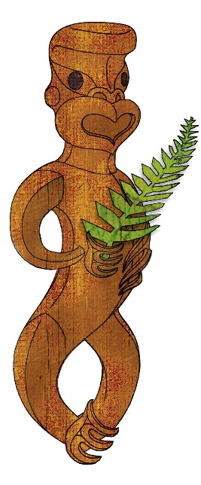
Tīkarohia te Marama – Realise Your Potential
Field Māori Assessment Support Material

TOURISM MĀORI

UNIT STANDARD 31070 (Version 1)

Explain the importance of Māori place names, and use of reo Māori greetings and farewells in tourism

(Level 3 Credits 4)

ĀKONGA BOOKLET

Name
Organisation
Kaiako/Assessor
NSN Number
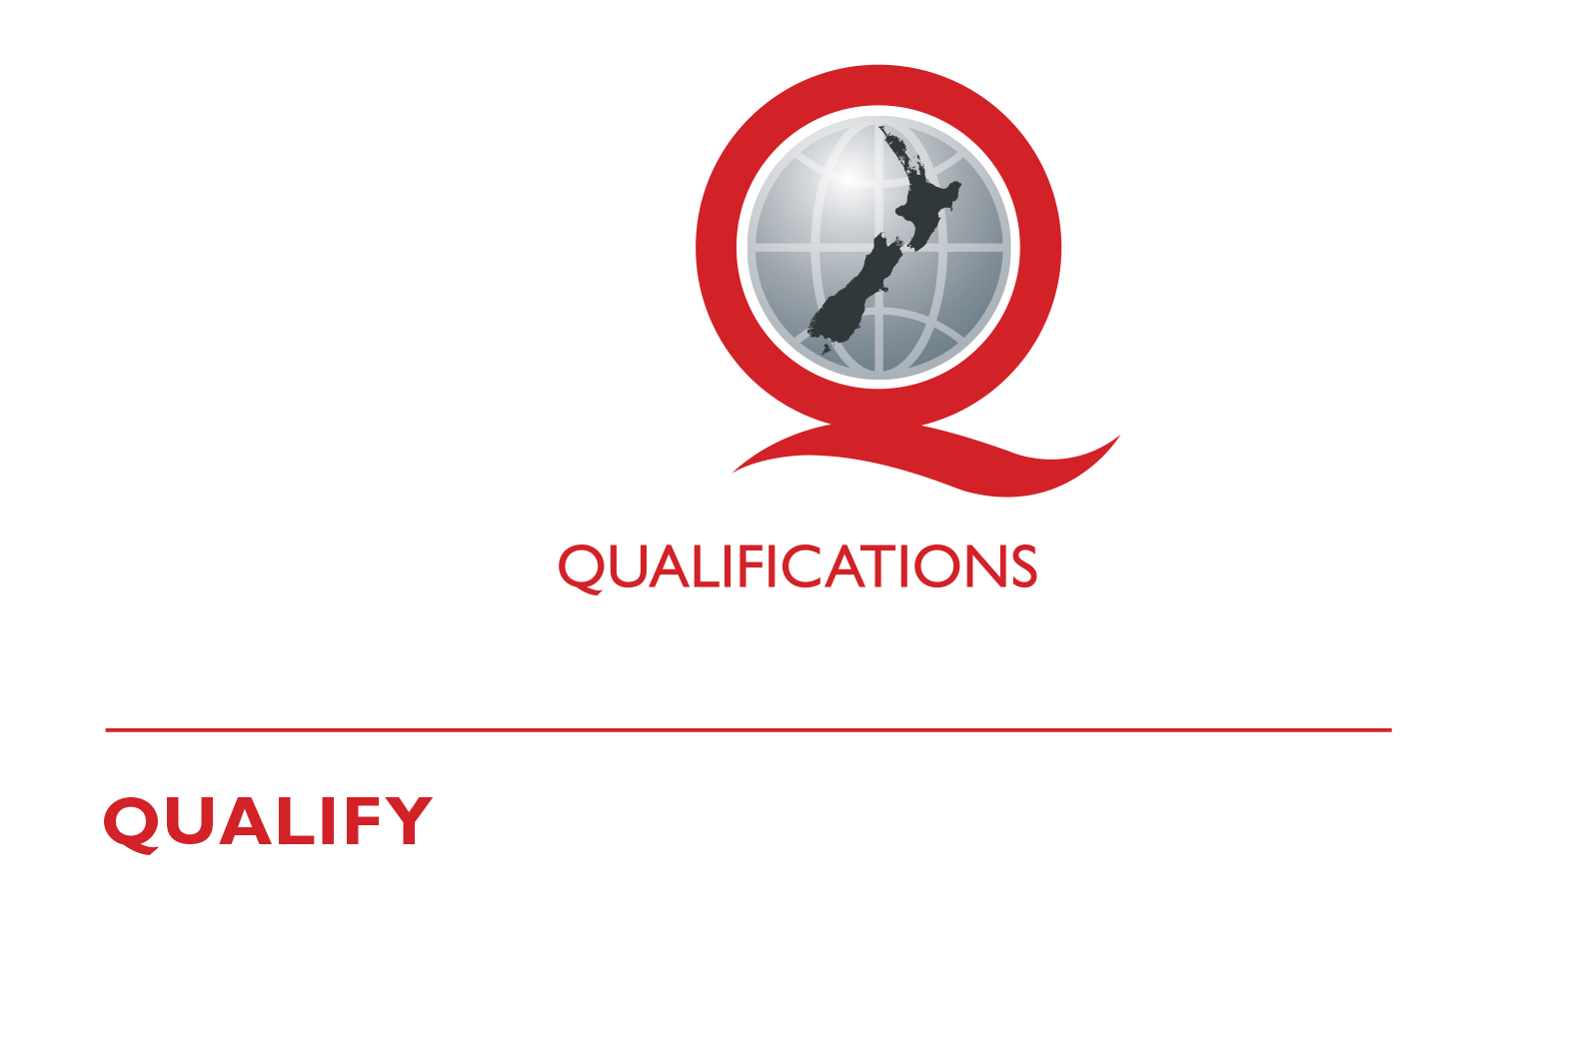
© New Zealand Qualifications Authority 2018
Tēnā koe
This is your assessment booklet for Tourism Māori unit standard 31070 Explain the
importance of Māori place names, and use reo Māori greetings and farewells in tourism.

Assessment criteria
Paetae/Achievement
People credited with this unit standard are able to explain the importance of Māori place names and list and use a range of te reo greetings and farewells in tourism.

There are two (2) assessment tasks for this standard that you must correctly complete.
The tasks are:
- Interview a local kaumātua, kuia, or iwi representative;
- Select six Māori place names, record them and recite them.

Your kaiako will discuss the length of time you have to complete this. PLEASE remember to reference where you get your information from for Tasks 1 and 2. Your kaiako will discuss this with you.

Authenticity
As per NZQA requirements:
- all work submitted for assessment must be produced by you
- the assessor will consider (and manage) the potential for work to have been copied, borrowed from another ākonga, photocopied from a book, or downloaded from the internet.
You may work with and learn from others to gather information from a variety of sources. However, the assessor must be clear that the work to be assessed has been processed and produced by you. To help manage authenticity of your work, where you are asked to complete any written tasks, you will be asked to use your own words as well as provide reference/s for your information.
If you have any pātai, or are unsure about anything, kōrero ki tō kaiako.
For further information, please refer to the following link:
http://www.nzqa.govt.nz/providers-partners/assessment-and-moderation/assessment-of-standards/generic-resources/authenticity/.

ĀKONGA ASSESSMENT TASK SHEET

Name |  | NSN #

Outcome 1 | Explain the importance of Māori place names in tourism.

Assessment Task 1
Interview a local kaumātua, kuia or iwi representative and find out about:
- The historical accounts behind the naming of three local Māori place names and the importance of correct pronunciation of each place name. |  | (1.1)
- The influences Māori mythology in terms of pūrākau and pakiwaitara had on the naming of these places |  | (1.2)
Historical account of three Māori place names and the importance of the pronunciation of the place names. (1.1)
1
2
3
4
5
6

The influences pūrākau and pakiwaitara had on the naming of these places (1.2)
1
2
3

Reference/s:
This task assesses the performance criteria of 1.1, and 1.2.
You may use the attached sheet to record your answers and/or use a range of other techniques to present your descriptions e.g. PowerPoint, mind maps, posters, drawings etc.
You must present information in your own words, and references must be provided.

Outcome 2 | List and use a range of te reo greetings and farewells in tourism.

Assessment Task 2
When greeting manuhiri in te reo, it is important to be able to greet them in the appropriate manner using the correct phrasing and pronunciation.

1a: List in the table below, one appropriate Māori greeting for each of the following;

Greetings for | Informal greeting | Formal greetings
A group

Two people
One person

1b: List in the table below, one appropriate Māori farewell for each of the following

Farewell for | Informal farewell | Formal farewell
A group
Two people
One person

1c: Learn and recite place names, greetings and farewells.

Pronunciation Observation Sheet
Note: The assessor or verifier must have Reo Maori at level 4 or above or equivalent.

ĀKONGA:

aSSESSOR/VERIFIER

Date:

Place names |  | Assessor Comments
 |  | Te reo kia tika □ Te reo kia rere □ Te reo kia Māori □
 |  | Te reo kia tika □ Te reo kia rere □ Te reo kia Māori □
 |  | Te reo kia tika □ Te reo kia rere □ Te reo kia Māori □
 |  | Te reo kia tika □ Te reo kia rere □ Te reo kia Māori □
 |  | Te reo kia tika □ Te reo kia rere □ Te reo kia Māori □
 |  | Te reo kia tika □ Te reo kia rere □ Te reo kia Māori □
Formal Greetings |  | Assessor Comments
Group |  | Te reo kia tika □ Te reo kia rere □ Te reo kia Māori □
Two people |  | Te reo kia tika □ Te reo kia rere □ Te reo kia Māori □
One person |  | Te reo kia tika □ Te reo kia rere □ Te reo kia Māori □
Informal Greetings |  | Assessor Comments
Group |  | Te reo kia tika □ Te reo kia rere □ Te reo kia Māori □
Two people |  | Te reo kia tika □ Te reo kia rere □ Te reo kia Māori □
One person |  | Te reo kia tika □ Te reo kia rere □ Te reo kia Māori □
Formal and informal farewells |  | Assessor Comments
Group |  | Te reo kia tika □ Te reo kia rere □ Te reo kia Māori □
Two people |  | Te reo kia tika □ Te reo kia rere □ Te reo kia Māori □
One person |  | Te reo kia tika □ Te reo kia rere □ Te reo kia Māori □
informal farewells |  | Assessor Comments
Group |  | Te reo kia tika □ Te reo kia rere □ Te reo kia Māori □
Two people |  | Te reo kia tika □ Te reo kia rere □ Te reo kia Māori □
One person |  | Te reo kia tika □ Te reo kia rere □ Te reo kia Māori □
 |  |  | Achieved: Yes No

This task assesses the performance criteria of 1.1, 2.1.

