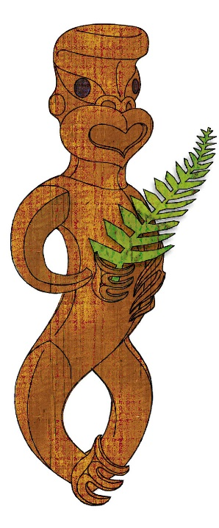
Tīkarohia te Marama – Realise Your Potential
Field Māori Assessment Support Material

TOURISM MĀORI

UNIT STANDARD 31071(version 1)

Identify and explain the cultural significance of natural and man-made attractions in tourism Māori

Level 3, Credits 6

ĀKONGA BOOKLET

Name
Organisation
Kaiako/Assessor
NSN Number

Tēnā koe
© New Zealand Qualifications Authority 2018
This is your assessment booklet for Tourism Māori unit standard NEW 02, Identify and explain the cultural significance of natural and man-made attractions in tourism Māori.

Assessment criteria
Paetae/Achievement
People credited with this unit standard are able to identify and explain the cultural significance of natural attractions and man-made attractions in tourism Māori.

There are TWO (2) assessment tasks for this standard that you must correctly complete.
The tasks are:
- Select TWO natural attractions and explain the cultural significance of each one. Record the information required in the table below for each of the two attractions
- Select TWO man-made attractions and explain the cultural significance of each one. Record the information required in the table below for each of the two attractions.

Your kaiako will discuss the length of time you have to complete this. PLEASE remember to reference where you get your information from for Assessment Tasks 1 and 2. Your kaiako will discuss this with you.

Authenticity
As per NZQA requirements:
- all work submitted for assessment must be produced by you
- the assessor will consider (and manage) the potential for work to have been copied, borrowed from another ākonga, photocopied from a book, or downloaded from the internet.
You may work with and learn from others to gather information from a variety of sources. However, the assessor must be clear that the work to be assessed has been processed and produced by you. To help manage authenticity of your work, where you are asked to complete any written tasks, you will be asked to use your own words as well as provide reference/s for your information.
If you have any pātai, or are unsure about anything, kōrero ki tō kaiako.
For further information, please refer to the following link:
http://www.nzqa.govt.nz/providers-partners/assessment-and-moderation/assessment-of-standards/generic-resources/authenticity/.
ĀKONGA ASSESSMENT TASK SHEET

Name |  | NSN #

Assessment may be presented in a number of ways which may include but are not limited to – artwork, computer, dance, drama, kapahaka, oral, poster, pakiwaitara, pūrākau, photo images, roleplay, social media, tuhituhi, video, waiata, whakaari.
You must present information in your own words, and references must be provided.
Outcome 1 | Identify and explain the cultural significance of natural attractions in tourism Māori.

Assessment Task 1

Select TWO natural attractions and record two examples for each of the following - name, location, features, activities, potential hazards.
- Gather information about the natural attractions in your local area.
- Information can be gathered from the following: oral history, kaumātua, kuia, pakeke, Māori Land Court records, local museum, I site, hotels, libraries, internet, pūrākau, pakiwaitara, whakairo.
- Natural attractions are attractions in nature which are not man-made but are culturally significant to local Māori and may include but are not limited to - awa kōpaka (glacier), awa pounamu, maunga, awa, whenua, moana, motu, ngāwhā, roto, ana, flora, and fauna, pāharakeke (natural nursery), conservation sites/national parks, marine reserves, mahinga mataitai, taiapure.
- From your findings select two natural attractions and record the information required in the table below for each of the two attractions
- Information must include two examples for each of the following - name, location, features, activities, potential hazards.
Attraction | Natural attraction 1 | Natural attraction 2
Name
- include the story behind the name
- significance to local iwi
Location
- landmarks (tohu whenua)
- tribal boundaries
- GPS coordinates
- Mapping
Features
- physical features
- inhabitants (fauna, flora, wildlife)
- wairuatanga
Activities
- tikanga
- past/present
- kaitiakitanga
- manaakitanga
Potential Hazards
- breaking tapu (physical, mental, spiritual)
- physical hazard
- environmental

For EACH attraction explain its cultural significance in Tourism Māori.
- What event or action took place on this site to make it culturally significant?
- Who was involved?
- Where did this happen?
- When did it happen?
- Why is the cultural significance at this attraction?
- Reference all material
Attraction #1 | Cultural significance of this site

- What event or action took place on this site to make it culturally significant?
- Who was involved?
- Where did this happen?
- When did it happen?
- Why is the cultural significance at this attraction?
- Reference all material
Attraction #2 | Cultural significance of this site
Reference/s:

Outcome 2 | Identify and explain the cultural significance of man-made attractions in tourism Māori.

Assessment Task 2

Select TWO natural attractions and record two examples for each of the following - name, location, features, activities, potential hazards.
- Gather information about the natural attractions in your local area.
- Information can be gathered from the following: oral history, kaumātua, kuia, pakeke, Māori Land Court records, local museum, i site, hotels, libraries, internet, pūrākau, pakiwaitara, whakairo.
- Natural attractions are attractions in nature which are not man-made but are culturally significant to local Māori and may include but are not limited to - awa kōpaka (glacier), awa pounamu, maunga, awa, whenua, moana, motu, ngāwhā, roto, ana, flora, and fauna, pā harakeke (natural nursery), conservation sites/national parks, marine reserves, mahinga mataitai, taiapure.
- From your findings select two natural attractions and record the information required in the table below for each of the two attractions
- Information must include two examples for each of the following - name, location, features, activities, potential hazards.
Attraction | Natural attraction 1 | Natural attraction 2
Name
- include the story behind the name
- significance to local iwi
Location
- landmarks (tohu whenua)
- tribal boundaries
- GPS coordinates
- Mapping
Features
- physical features
- inhabitants (fauna, flora, wildlife)
- wairuatanga

Activities
- tikanga
- past/present
- kaitiakitanga
- manaakitanga
Potential Hazards
- breaking tapu (physical, mental, spiritual)
- physical hazard
- environmental

For EACH attraction explain its cultural significance in Tourism Māori.
- What event or action took place on this site to make it culturally significant?
- Who was involved?
- Where did this happen?
- When did it happen?
- Why is the cultural significance at this attraction?
- Reference all material
Attraction #1 | Cultural significance of this site
- What event or action took place on this site to make it culturally significant?
- Who was involved?
- Where did this happen?
- When did it happen?
- Why is the cultural significance at this attraction?
- Reference all material
Attraction #2 | Cultural significance of this site
Reference/s:

