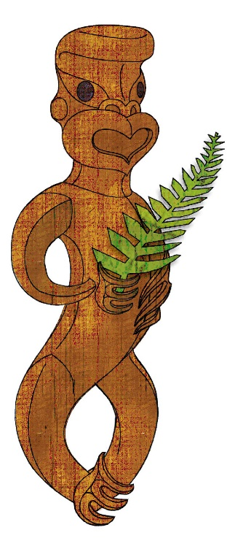

Tīkarohia te Marama – Realise Your Potential
Field Māori Assessment Support Material

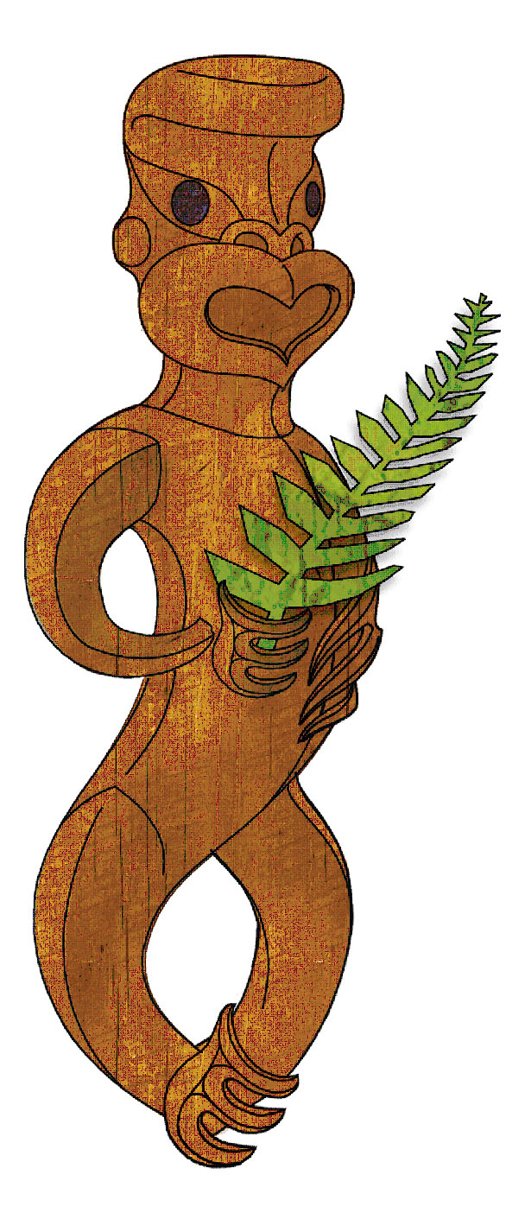

TOURISM MĀORI

UNIT STANDARD 31071 (version 1)

Identify and explain the cultural significance of natural and man-made attractions in tourism Māori

Level 3, Credits 6

ASSESSOR BOOKLET

© New Zealand Qualifications Authority 2018

Assessor Information

Assessment criteria
Paetae/Achievement
People credited with this unit standard are able to identify and explain the cultural significance of natural attractions and man-made attractions in tourism Māori.

There are TWO (2) assessment tasks that the ākonga must correctly complete to gain credits for this standard. Once the ākonga has correctly completed the tasks, the assessor must complete the assessment schedule for each ākonga.

Ākonga assessment booklet
The ākonga receives this. It outlines important information for the ākonga including:
- assessment and other information
- assessment tasks.

Ākonga assessment tasks
These sheets and any other evidence should be collected by the assessor and retained for assessment and moderation purposes.
Where ākonga choose to provide oral description/evidence for any of the THREE tasks, this must be recorded (i.e. recorded onto DVD or USB flash drive). Where ākonga work has been selected for moderation, the DVD or USB flash drive must be included with the materials.
Where a recording of the demonstration is submitted for moderation, the ākonga identification sheet (refer following link: http://www.nzqa.govt.nz/assets/Providers-and-partners/Assessment-and-moderation/mod-visevidence-cvr.doc) must be included.
You will need to discuss with the ākonga the length of time they have to complete the assessment. He ture-a-kōnui: one credit equates to 10 notional hours of teaching, practice and/or study, and assessment.

Authenticity
As per NZQA requirements:
- you must verify that the work submitted for assessment has been produced by the ākonga
- you must consider (and manage) the potential for work to have been copied, borrowed from another ākonga, photocopied from a book or downloaded from the internet.
Ākonga may work with and learn from others to gather information from a variety of sources. However, you must be clear that the work to be assessed has been processed and produced by the ākonga.
To help manage authenticity of ākonga work, where the ākonga is asked to complete any written tasks, the ākonga is asked to use their own words as well as provide reference/s for their information. Please ensure you discuss this with your ākonga.
For further information, please refer to the following link:
http://www.nzqa.govt.nz/providers-partners/assessment-and-moderation/assessment-of-standards/generic-resources/authenticity/.

Referencing
This assessment requires the ākonga to reference his/her information. For the purposes of this assessment, the following are examples of reference styles.

Examples of referencing
1 | Book with one author
 | King, M. (2000). Wrestling with the angel: A life of Janet Frame. Auckland, New Zealand: Viking.
2 | Course handout/Lecture notes (electronic version)
 | Archard, S., Merry, R., & Nicholson, C. (2011). Karakia and waiata [PowerPoint slides]. Retrieved from TEPS757-11B (NET): Communities of Learners website: http://elearn.waikato.ac.nz/mod/resource/view.php?id=174650.
3 | Film
 | Māori Television (Producer). (2016). Iwi Anthems, Series 2 Episode 5 [video file]. Retrieved from: http://www.maoritelevision.com/tv/shows/iwi-anthems/S02E005/iwi-anthems-series-2-episode-5.
4 | Magazine/Newspaper article – popular/trade/general interest
 | Fox, D. (2015, 15 September). Viewpoint: Not one more acre. Mana. Retrieved from: http://www.mana.co.nz/heritage/viewpoint.html.
5 | Personal Communication (letters, telephone conversations, emails, interviews, private social networking)
 | Smith, J. (2016, 19 October) Personal communication.
6 | Webpage
 | New Zealand Trade and Enterprise. (n.d.). Agribusiness. Retrieved from https://www.nzte.govt.nz/en/export/market-research/agribusiness/.

Preparation for moderation
It is no longer necessary to complete a Moderation Cover Sheet as this information is entered online. If physical materials are sent for moderation, please ensure name of school and standard are included.
Digital submissions can be made directly through the application at any time.
Using the online External Moderation Application, schools and providers must include:
- a copy of the task and any key supporting resources
- a copy of the assessment schedule
- up to 8 samples of student work consisting of the key materials that the assessor has used to make an assessment judgement. (ungraded unit standards: schools – 4 learner samples; providers – 3 learner samples).
For moderation to occur:
- all files must be viewable online
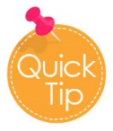
- URLs, e.g. for student created websites, will need to be submitted as links within a document.
For more information on the digital moderation process, please contact your Principal Nominee or Moderation Liaison (ML).

If you have any issues with preparing materials for moderation OR do not have materials to submit (i.e. you didn’t assess this standard), SPEAK to your Principal Nominee (PN) or Moderation Liaison (ML).
Assessor information – Assessment tasks

Assessment may be presented in a number of ways which may include but are not limited to – artwork, computer, dance, drama, kapa haka, oral, poster, pakiwaitara, pūrākau, photo images, roleplay, social media, tuhituhi, video, waiata, whakaari.
You must present information in your own words, and references must be provided.
Outcome 1 | Identify and explain the cultural significance of natural attractions in tourism Māori.

Assessment Task 1

Select TWO natural attractions and record two examples for each of the following - name, location, features, activities, potential hazards.
This task assesses the performance criteria of 1.1 and 1.2
  - Natural attractions are identified
  - Natural attractions are explained in terms of the cultural significance associated with them and in accordance with the kōrero of the local iwi and/or hapū.
- Gather information about the natural attractions in your local area.
- Information can be gathered from the following: oral history, kaumātua, kuia, pakeke, Māori Land Court records, local museum, I site, hotels, libraries, internet, pūrākau, pakiwaitara, whakairo.
- Natural attractions are attractions in nature which are not man-made but are culturally significant to local Māori and may include but are not limited to - awa kōpaka (glacier), awa pounamu, maunga, awa, whenua, moana, motu, ngāwhā, roto, ana, flora, and fauna, pāharakeke (natural nursery), conservation sites/national parks, marine reserves, mahinga mataitai, taiapure.
- From your findings select two natural attractions and record the information required in the table below for each of the two attractions
- Information must include two examples for each of the following - name, location, features, activities, potential hazards.
Attraction | Natural attraction 1 | Natural attraction 2
Name
- include the story behind the name
- significance to local iwi
Location
- landmarks (tohu whenua)
- tribal boundaries
- GPS coordinates
- Mapping
Features
- physical features
- inhabitants (fauna, flora, wildlife)
- wairuatanga
Activities
- tikanga
- past/present
- kaitiakitanga
- manaakitanga
Potential Hazards
- breaking tapu (physical, mental, spiritual)
- physical hazard
- environmental

For EACH attraction explain its cultural significance in Tourism Māori.
- What event or action took place on this site to make it culturally significant?
- Who was involved?
- Where did this happen?
- When did it happen?
- Why is the cultural significance at this attraction?
- Reference all material
Attraction #1 | Cultural significance of this site
- What event or action took place on this site to make it culturally significant?
- Who was involved?
- Where did this happen?
- When did it happen?
- Why is the cultural significance at this attraction?
- Reference all material
Attraction #2 | Cultural significance of this site
Reference/s:
Outcome 2 |  | Identify and explain the cultural significance of man-made attractions in tourism Māori.

Assessment Task 2

Select TWO man-made attractions and record two examples for each of the following - name, location, features, activities, potential hazards.
This task assesses performance criteria 2.1, and 2.2
2.1 Man-made attractions are identified.
2.2 Man-made attractions are explained in terms of the cultural significance associated with them and in accordance with the kōrero of the local iwi and/or hapū.

- Gather information about man-made attractions in your local area.
- Information can be gathered from: kaumātua, kuia, whānau, pakeke, local museum, I site, libraries and internet.
- Man-made attractions are culturally significant to local Māori and may include but is not limited to - whare whakairo, pā kāinga, māra kai, pā tūwatawata (defensive pā), whare wānanga, ngā ara, waka, marae, urupā, paenga pakanga pā (battle site) mahinga kai, wild life reserves, pāharakeke (man-made nursery).
- From your findings select two man-made attractions and record the information required in the table below for each of the two attractions.
- Information given must include two examples for each of the following: name, location, features, activities, potential hazards.
- Reference all material.

Attraction | Man-made attraction 1 | Man-made attraction 2
Name
- include the story behind the name
- significance to local iwi
Location
- landmarks (tohu whenua)
- tribal boundaries
- GPS coordinates
- Mapping
Features
- physical features
- inhabitants (fauna, flora, wildlife)
- wairuatanga
Activities
- Tikanga
- Past/
- Present
- Kaitiakitanga
- Manaakitanga
Potential Hazards
- Breaking tapu (physical, mental, spiritual)
- Physical hazard
- Environmental

For EACH attraction explain its cultural significance in Tourism Māori.
- What event or action took place on this site to make it culturally significant?
- Who was involved?
- Where did this happen?
- When did it happen?
- Why is the cultural significance at this attraction?
- Reference all material
Attraction #1 | Cultural significance of this site
- What event or action took place on this site to make it culturally significant?
- Who was involved?
- Where did this happen?
- When did it happen?
- Why is the cultural significance at this attraction?
- Reference all material
Attraction #2 | Cultural significance of this site
Reference/s:

Comments on this support material
Please contact Māori Qualifications Services mqs@nzqa.govt.nz if you wish to suggest changes to the content of this resource.

Assessment Schedule

Assessment Task 1 | Evidence for Achieved | Grades
Select TWO natural attractions and record two examples for each of the following - name, location, features, activities, potential hazards. | Name of the attraction - include stories behind the name, the significance of this attraction to local iwi  Location – may include GPS co-ordinates, mapping, tribal boundaries landmarks,  Features – may include physical, inhabitants (fauna, flora, wildlife), wairuatanga  Activities – may include tikanga around the activity, past or present activities, kaitiakitanga, manaakitanga  Potential hazards – may include breaking tapu (physical, mental, spiritual), physical hazards, environmental  Referencing | N  A
 | Judgement for Achieved
Two natural attractions are selected and information given
two pieces of information about the name is given
two pieces of information about the location is given
two features given
two activities given
two potential hazards given
references are given

Assessment Task 2 | Evidence for Achieved | Grades
Select TWO man-made attractions and record two examples for each of the following - name, location, features, activities, potential hazards. | Name of the attraction - include stories behind the name, the significance of this attraction to local iwi  Location – may include GPS co-ordinates, mapping, tribal boundaries landmarks,  Features – may include physical, inhabitants (fauna, flora, wildlife), wairuatanga  Activities – may include tikanga around the activity, past or present activities, kaitiakitanga, manaakitanga  Potential hazards – may include breaking tapu (physical, mental, spiritual), physical hazards, environmental  Referencing | N  A
 | Judgement for Achieved
Two man-made attractions are selected and information given
two pieces of information about the name is given
two pieces of information about the location is given
two features given
two activities given
two potential hazards given
references are given

Assessment Task 1 and 2 | Evidence for Achieved | Grades
For EACH attraction from Assessment Task 1 and Assessment Task 2, explain the cultural significance of the attraction in Tourism Māori. | Cultural significance of the attraction to hapū and iwi is given  Events leading to the cultural significance of this attraction is explained  Referencing | N  A
 | Judgement for Achieved
One attraction (either natural or man-made) is chosen
Cultural significance is explained
References given

Overall grade (please circle) | N (Not Achieved) | A (Paetae/Achieved)
Ākonga name |  |  | Assessor name
Ākonga signature |  |  | Assessor signature
Completion date

