Contents
This guide contains information for schools and Tertiary Education Organisations (TEOs) who will use the external moderation application. It contains information on:
- Login
- Navigation
- User Access
- Manage Notifications

For a full list of guides to the External Moderation Application see: Related Guides

Login
Log in to the external moderation application
- Log in to the secure provider extranet (Provider Login), using your usual Education Sector (ESL/ESAA) login details.
- Select the External Moderation link from the Moderation section.
- The landing page of the application displays. You can now navigate to the appropriate part of the application.
The secure extranet will look different
TIP
The secure extranet will look different
TIP
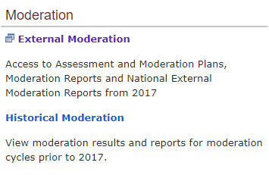
Note:
Access to historical results (prior to 2017) via the Historical Moderation link. Moderation results for 2017 onwards is via the new external moderation application (see below).

Navigation
Navigate the application
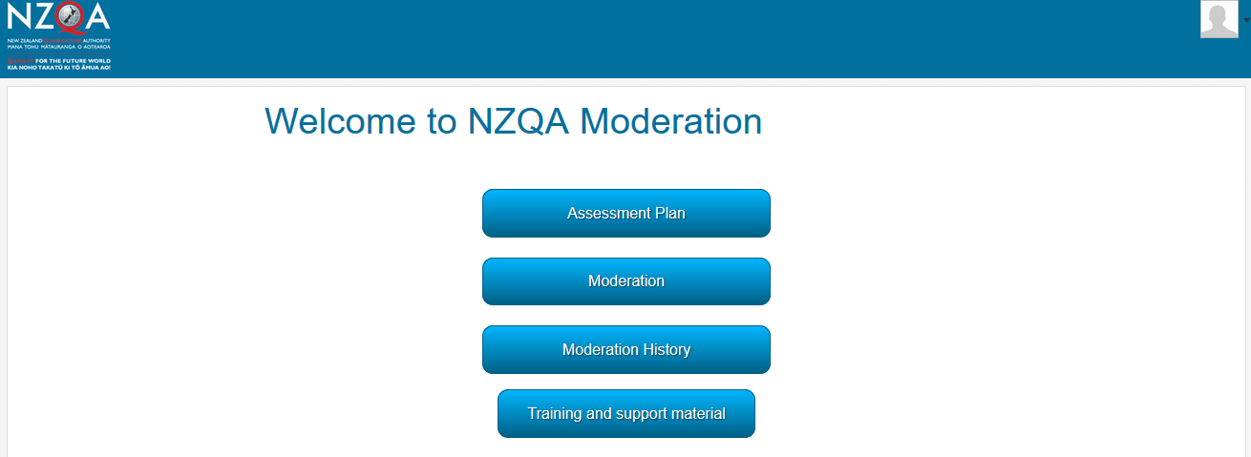
Landing page

- NZQA Logo – click on the logo to return to the landing page from anywhere in the application.
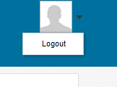
- Menu Buttons – provide access to different parts of the application. The buttons available are dependent on your access.
- User Profile – click here to ‘Logout’.

.
Button | Section
View your current Assessment Plan, select standards, and submit your plan.
Refer to the guide Submit assessment plan for more information about this section.
View moderation plans for the current and previous (or next cycle), prepare moderation submissions, view reports, and submit queries and appeals for moderation reports.
Refer to the guide Submit material for moderation for more information about this section.
 | View moderation results and reports for the previous five years (from 2017 onwards). Results prior to 2017 are available via the Historical moderation link
Annual Summaries | View the current annual summary (NEMR), and action plan, and access historical summaries and action plans (currently unavailable).
 | Training materials and ‘how to’ guides for the External Moderation application.

Please note:
The functionality available depends on the access role your organisation has granted you. Not all functions are available to all users. See the next section for a summary of access rights.

User Access
Manage user access
If you need to arrange access to the moderation application for staff, please follow the normal Ministry of Education procedure for access to NZQA systems, via the Education Sector Logon (formerly ESAA).
An email address is mandatory and must be unique to the user (not shared by another person who will also login via ESL). This email is used for verifying identity, not for sending notifications.
The following roles are available for users of the external moderation application:

Secondary MoE role | Tertiary MoE role | Type of access to the moderation application
General Security User | TEO View Only | Users have the role of ‘Moderation Viewer’, and can:  - view the moderation plan,  - view moderation reports and results.
Moderation Process | TEO Administration | Users have the role of ‘Moderation Processor’, and can:  - enter assessment judgements/grades  - upload material for moderation  - view moderation reports and results  - submit queries about moderation reports.
High Security User | TEO Management Authoriser | Users have the role of ‘Moderation Authoriser’, and can:  - select standards and submit assessment plans  - view moderation plans  - enter assessment judgements/grades  - upload material for moderation  - authorise moderation submissions  - view moderation reports and results  - submit queries about moderation reports  - lodge appeals  - view annual summaries and manage action plans.
Moderation Management View Only | TEO Management View Only | Users have the role of ‘Moderation Management Viewer’, and can:  - view moderation reports and results  - view annual summaries and action plans.
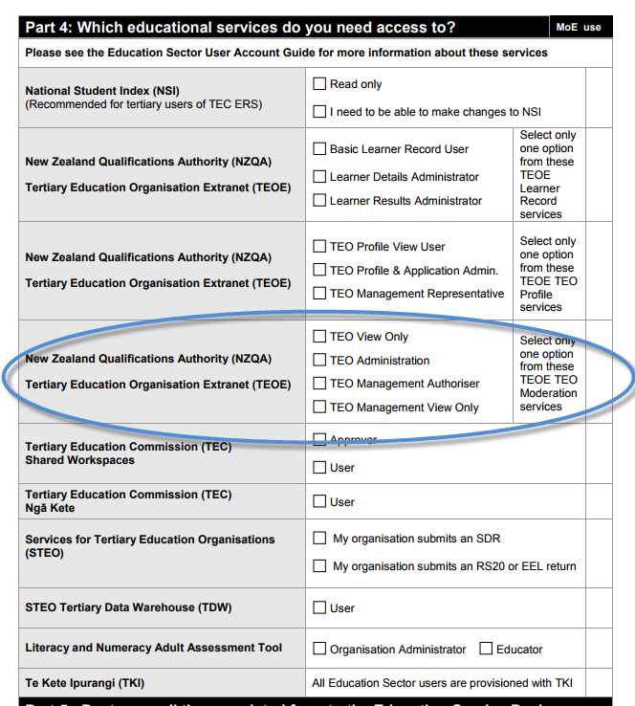
For TEOs:
The access required is on the following section of the ESL form:

Manage Notifications
Manage notifications
Regardless of the security role assigned above, only the person recorded with NZQA as the moderation contact, i.e.:
- Schools: Principal’s Nominee
- TEOs: Moderation Liaison
will receive notifications from the external moderation application. Notifications will be sent to the email address held by NZQA for the moderation contact.
The application will notify you of outcomes or of tasks you need to complete. For example, you might receive an email when your assessment plan is ready for you to review, or an email reminding you to submit materials for moderation.
If you want us to send the notifications to a different email address, you’ll need to update your preferred email address in NZQA’s secure provider extranet (Provider Login).
This information may take up to 48 hours to update the application.

Related Guides
The following guides provide further information on using the external moderation application:
Guide | For how to:
Access the External Moderation Application | Access and navigate the application.
Submit an Assessment Plan | Select standards and submit an assessment plan.
View, Print & Customise Moderation Plan or History Views | View, customise or print/export assessment plan, moderation plan or moderation history views.
Submit Material for Moderation | Create a moderation submission and submit to NZQA.
Digital Submission Tips | Additional tips relating to digital submissions including, submitting cloud-based files, video files, file types accepted and size limits.
View and Query a Moderation Report | View or print a moderation report. Submit a query.
Appeal a Moderation Report | Appeal a moderation outcome.
Browser & Application Issues | Resolve browser issues and oracle errors

The guides can be found at: http://www.nzqa.govt.nz/providers-partners/assessment-and-moderation/moderation-online/qrgs-and-faqs/

Note: Browsers
The External Moderation is supported across a range of browsers, however not all browsers behave in the same way. If you are experiencing issues with functionality described in this guide with a browser please try a different one. We have found Mozilla Firefox provides the best experience when using the application.
For specific advice on browser issues see guide: Browser & Application Issues

