Contents
This guide contains information for schools and Tertiary Education Organisations (TEOs) who need to submit an assessment plan to NZQA.
- Complete and Submit a Plan
- Selecting standards
- Search & Filter Standards
- Submit a Nil Assessment Plan
For a full list of guides to the External Moderation Application see: Related Guides & Resources

Assessment Plans Overview
Assessment plans for the next moderation cycle are released towards the end of October, each year.
You will receive an email notification when the plan is released, and a reminder to submit your plan prior to the due date. Plans are due by the end of November.
TEOs
Must select all the standards they are intending to assess, and provide the earliest date that the learner evidence will be available for moderation.
Schools
Selection and submission is optional, but provides a way to communicate your preferences for moderation to NZQA. If you have no preference on what is selected within a system, then no selection is required for that system. If you wish to indicate your preferences, then please limit your selections to approximately 10% of the standards within that system.

Quick Steps
- Log in to the application and select Assessment Plan.
- Select the relevant moderation system.
- Select the relevant standards from the system ☑.
- Enter the Date Materials Available for each selected standard, if required.
- Save the selected standards in the system.
- Repeat for all relevant systems.
- Enter a comment (optional).
- Select Submit Plan to submit to NZQA.

Complete and Submit a Plan
Complete and submit an assessment plan
Role required: Moderation Authoriser (High Security User)
- Log in to the application and select Assessment Plan.
- Select the Yes radio button, if you are assessing NZQA standards in the next year.
- To select standards, either:
  - Choose the Select Standards link (to view all standards), or
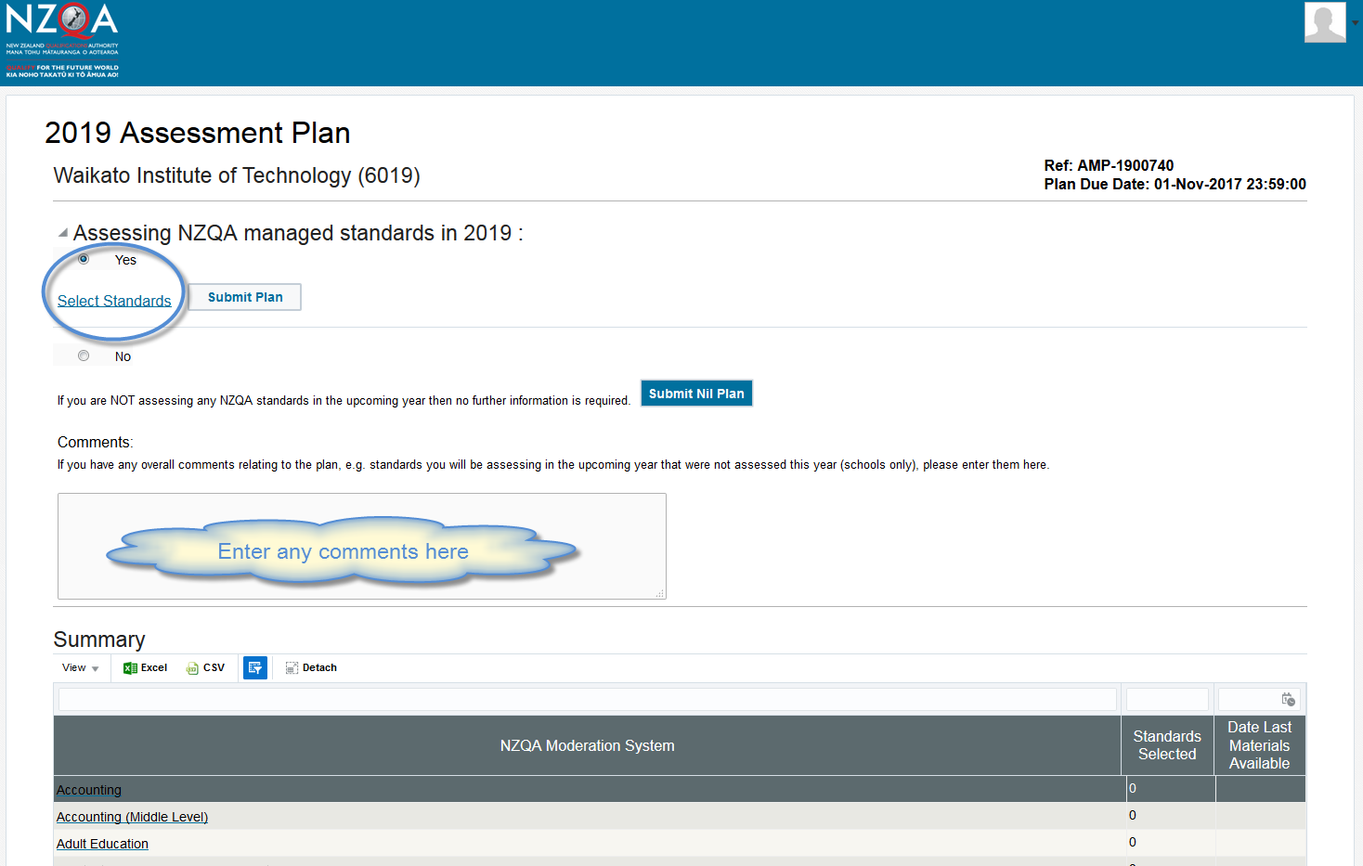
  - Select the link to an individual system from the summary table.
- Select individual standards, as required (see the Select Standards section of this guide) for all relevant systems.
- As you save your selections the Summary table updates with the:
- number of standards selected within the system
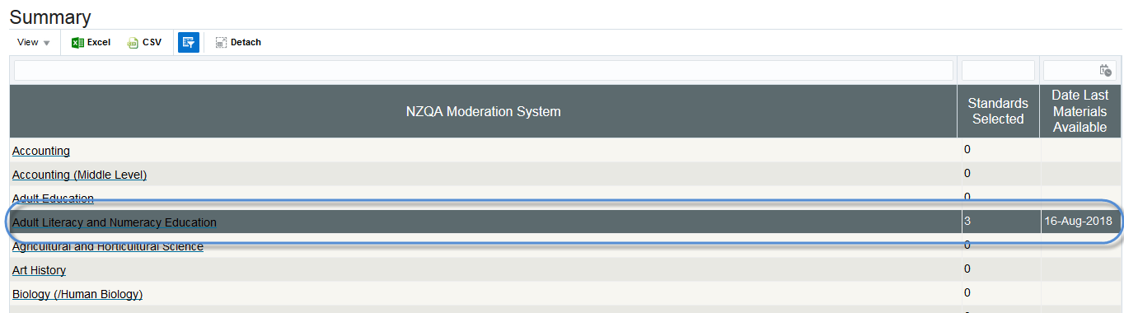
- ‘latest’ materials available date.

Complete and submit an assessment plan, continued
- Add a comment (optional) - the comment will be visible to the NZQA staff member responsible for confirming your organisation’s moderation plan. The comment field takes a maximum of 250 characters.
  - Note: there is no specific Save for the comment field – it is saved when you submit the plan.
- Select Submit Plan, when all standards are selected and the plan is ready to submit.
- A warning message will display, select Yes to submit the plan to NZQA.
- Result: Following submission (or the due date for school plans) the plan will be locked and read only

Locked Plans
A plan will be locked when:
- it is submitted by the school or TEO
- the plan submission date is passed (schools only).
The message is updated when:
  - the moderation plan is available, or
  - an exemption, or Nil plan status is confirmed for a TEO.

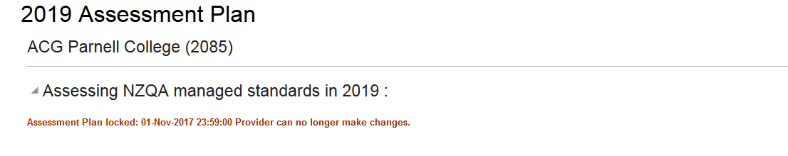
Example:

Selecting standards
Select Standards
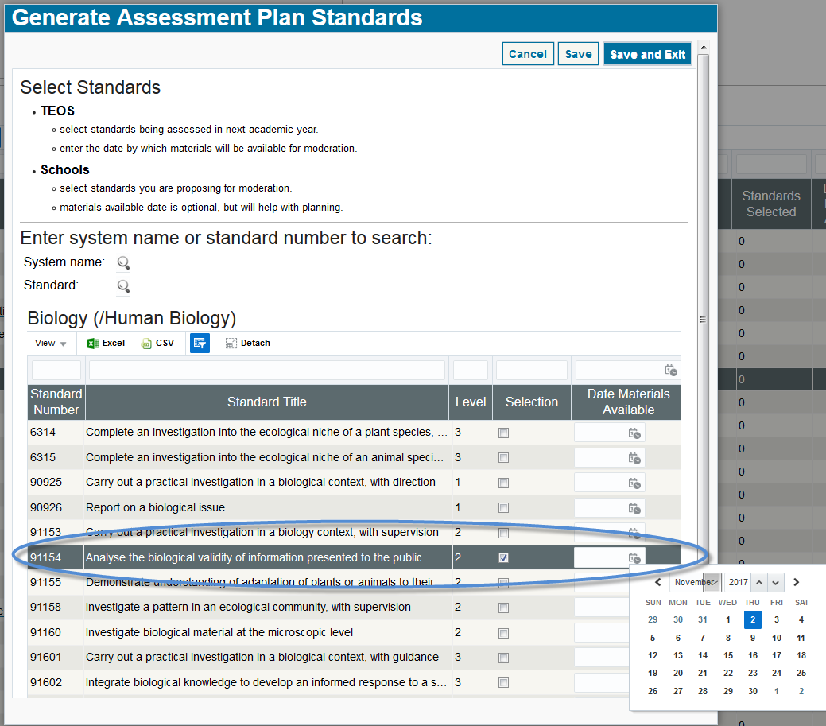
To select standards:
  - Select the standard (tick) - Selection checkbox.
  - Add the Date Materials Available (optional for schools):
    - choose the date from the calendar
    - or, enter the date in the format: dd/mm/yyyy.
  - Continue selecting standards for this system, as appropriate.
  - Save your selections using:
    - Save - to save without closing the window.
    - Save and Exit - to save and return to the plan overview.
Note: Error on Save
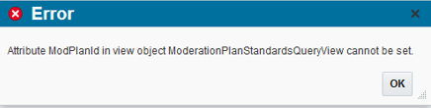
This error occasionally appears when saving selections.
To clear the error, Select OK and re-try the Save.
Note: Select Standards & System Name
The NZQA Moderation System name that appears at the top of the list, on the Select Standards window, defaults to that for the first standard on the list. So, if you open a:
- System - then it is the system name
- all standards (i.e. use the Select Standards link) – it displays the system for the first standard in the list, and may change if the standards are re-ordered or filtered.

Search & Filter Standards
Search for a standard
To quickly search for an individual standard or all standards in a system
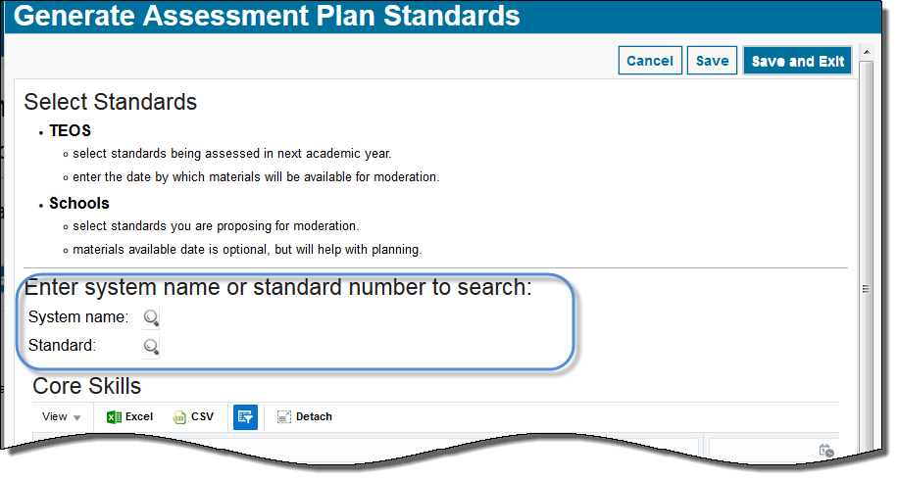
- Use the Select Standards link (for all standards) or open an individual system:
Note: You can also search for a standard by opening any of the systems in the Summary panel.
- Click the search icon beside:
  - System name – to search for all the standards within a moderation system.
  - Standard – to search for a specific standard
- Search for the standards.
To search for… | Then…
All standards within a system | - Type the first few letters of the name of the moderation system.  - Select Search.  - Select the required system from the result list.  - Click OK to return to the main search screen.
A specific standard | - Type the exact standard number, then Search.  - Select the standard, then OK to return to the main search screen.
Advanced Search | - Use the advanced search feature to find a system when you are unsure of the name:  - e.g. ‘Contains: Design’, returns:  - Graphics and Design Technology  - Technology – Design and Visual Communication

- The Select Standard page updates with all the standards that match the search criteria.
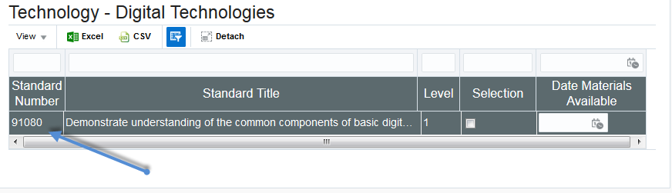
  - Example: Search for standard: 91080

Filter standards
Use the Filter option to quickly find a standard.
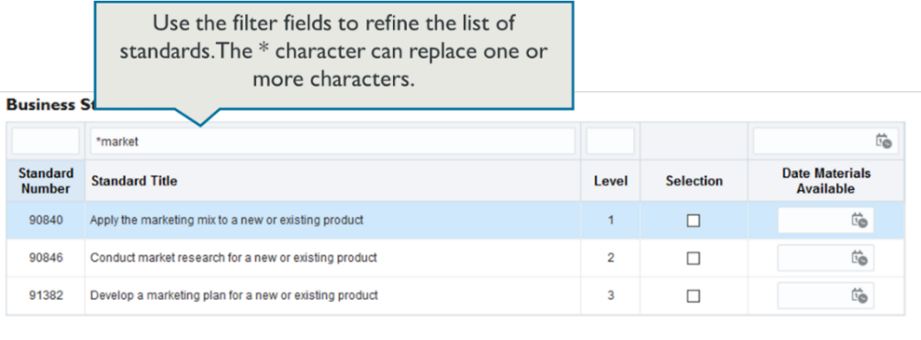
- Open the Select Standards window (either all or for a specific system).
- Enter the filter criteria in the field above the column you want to filter on.
- Press Enter, (on your keyboard) to apply the filter.
To find … | Then…
a specific standard | Enter the full standard number in the Standard Number field.
a range of standards | If the standards begin with the same series of numbers, type the common numbers followed by an asterisk in the Standard Number filter field.  Example: 9084* will display standards: 90840, 90841, 90842, etc
standards that contain a specific word | Enter the word in the Standard Title filter field, or  Use wildcards to find ‘like’ words: e.g. *market in the Title field will display any standards that contain words like market, markets, marketing, supermarket.
all standards for a level | Enter the level number in the Level filter field.
all ‘selected’ standards | Enter ‘T’ in the Selection filter field.

Remove Filter
A filter, will apply until you change or remove it, even if you open another system.
To remove the filter – just delete the text entered in the filter field(s) and press Enter (on your keyboard).

Submit a Nil Assessment Plan
Submit a Nil assessment plan (TEOs only)
TEOs who are not assessing any NZQA managed standards in the upcoming year should submit a Nil plan.
- Log in to the application and select Assessment Plan.
- Select the No radio button, if you are NOT assessing NZQA standards in the next year.
- Add a comment (optional). The comment will be visible to the NZQA staff member responsible for confirming your organisation’s moderation plan. The comments field takes a maximum of 250 characters.
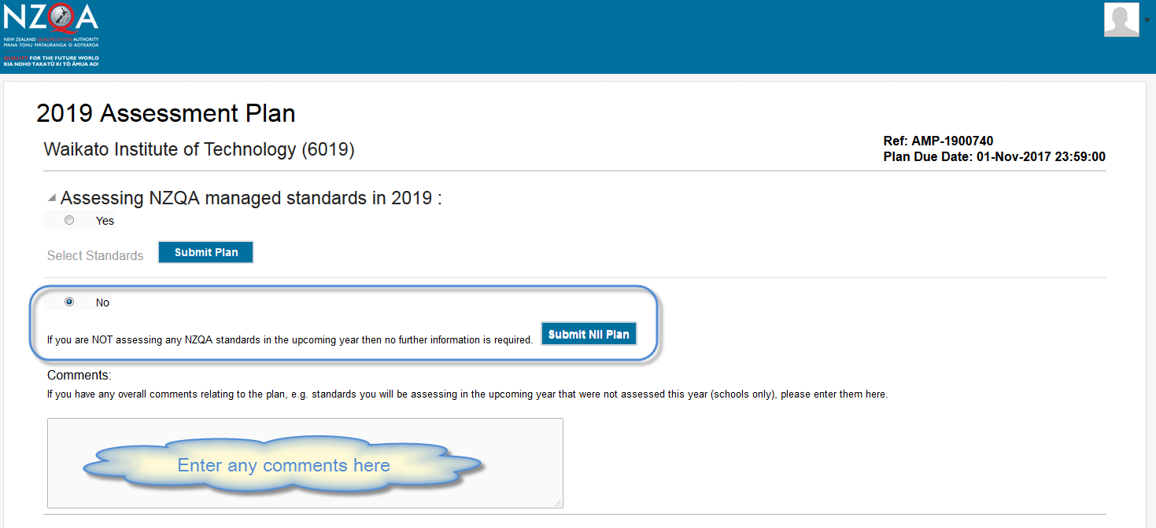
- Select Submit Nil Plan, if the plan is ready to submit.
- A confirmation message will appear - select Yes to submit the Nil plan to NZQA.
- Result: Following submission the plan will be locked and read only.

Related Guides & Resources
The following guides provide further information on using the external moderation application:
Guide | For how to:
Access the External Moderation Application | Access and navigate the application.
Submit an Assessment Plan | Select standards and submit an assessment plan.
View, Print & Customise Moderation Plan or History Views | View, customise or print/export assessment plan, moderation plan or moderation history views.
Submit Material for Moderation | Create a moderation submission and submit to NZQA.
Digital Submission Tips | Additional tips relating to digital submissions including, submitting cloud-based files, video files, file types accepted and size limits.
View and Query a Moderation Report | View or print a moderation report. Submit a query.
Appeal a Moderation Report | Appeal a moderation outcome.
Browser & Application Issues | Resolve browser issues and oracle errors

The guides can be found at: http://www.nzqa.govt.nz/providers-partners/assessment-and-moderation/moderation-online/qrgs-and-faqs/

Note: Browsers
The External Moderation is supported across a range of browsers, however not all browsers behave in the same way. If you are experiencing issues with functionality described in this guide with a browser please try a different one. We have found Mozilla Firefox provides the best experience when using the application.
See the relevant guide for specific advice on browser issues. (QRG4 –Browser & Application Issues)

