Contents
This guide contains information for staff from schools and Tertiary Education Organisations (TEOs) who will create submissions for moderation. It contains information about how to:
- Create a submission for a Standard
- Enter learner grades and upload materials
- Submit one or more standards to NZQA
- Tips
- Understand Report Dates and Statuses

For a full list of guides to the External Moderation Application see: Related Guides

Quick Steps
- Log in to the application and select Moderation.
- Select the required standard.
- Complete the Submission Details and Assessment Task sections.
  - Upload digital materials for task, if this is a digital submission.
- Save the submission.
- Add Learners:
  - enter a grade for each learner, and comments as appropriate.
  - upload digital materials, as required.
- Save, and update status to Ready to Submit.
- Submit the standard to NZQA for moderation (authorisers only).

Create a submission for a Standard
Create a submission for a standard
Role required: Moderation Processer or Moderation Authoriser (High Security User)
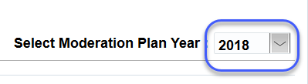
- Log in to the application and select Moderation.
- CHECK – you have the correct plan year selected.
  - Change the year in the Select Moderation Plan Year field, if required.

- Select (click on row) the relevant standard.
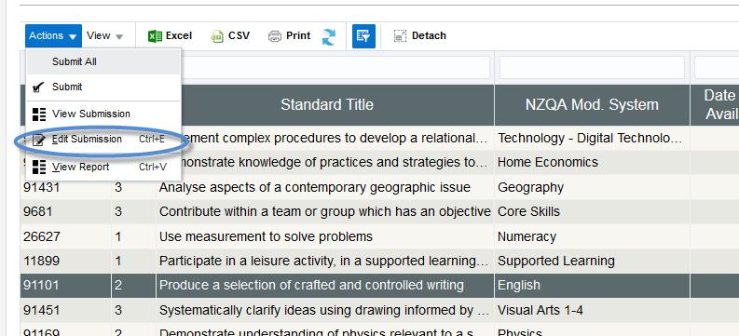
- Open the Actions menu (from the ribbon, or ‘right-click’ on the selected standard) and select Edit Submission.

Create a submission for a standard, continued
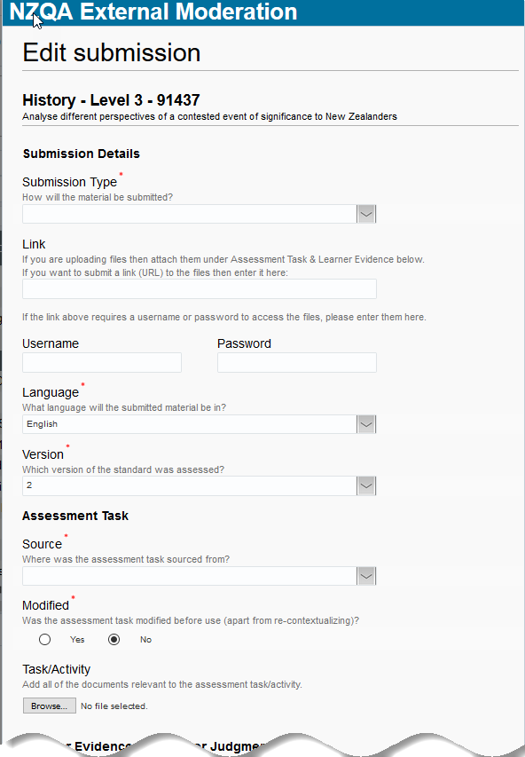
- Complete the Submission Details section:
  - Submission Type
    - Digital - if submitting materials on-line
    - Physical - if submitting materials by courier.
  - Language
    - English - default
    - Te Reo Māori or ‘Other’ – choose the appropriate value.
  - Version
    - defaults to the latest version of the standard, update if a different version was assessed.

- Complete the Assessment Task section:
  - Source
    - the source of the assessment task.
  - Modified
    - Yes - if the assessment task was modified (other than context) before use.
    - No - if the assessment task was unmodified (other than context).

- If making a digital submission, either:
  - Enter a link (e.g. to Google Docs, SharePoint, etc)
  - Include a username and password, if needed to access the files.
Or
  - Attach the assessment task files to the submission, in the Task/Activity section:
    - Select Browse
    - Find the file you want to upload, select it then click Open.
    - Repeat as required.
See: Tips for how to:
  - Submit a link/url to the moderation materials.
  - Delete a document.

Enter learner grades and upload materials
Enter learner grades and upload materials
Role required: Moderation Processer or Moderation Authoriser (High Security User)
Notes:
- Complete the Submission Details and Assessment Task sections (as above), before adding learners.
- Enter a learner grade for ALL learners that you are submitting evidence for.
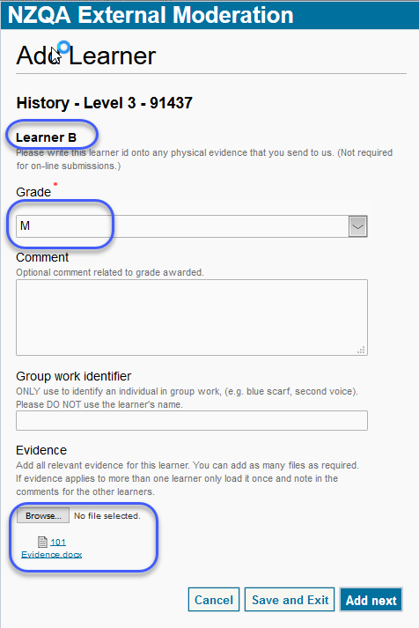
- Select Add Learner.
- Enter the details for the learner.
  - Learner Identifier - is automatically assigned (Learner A-H).
  - Label any physical materials being submitted with the matching identifier.
  - Grade – select the learner’s grade from the list of values (mandatory).
  - Comment – an optional comment on the grade awarded, or to note if evidence applies to more than one learner.
  - Group work identifier – use this option to identify an individual in a group work. Use a description (red shirt) not the learner’s name.
- If this is a digital submission and you have not included a link, then attach the learner evidence:
  - Select Browse...
  - Find the file you want to upload, select it then click Open.
  - Repeat as required.
- To add more learners (to a maximum of eight), click the Add next button, and repeat from step 2.
- Select Save and Exit, when all learner grades are added.
  - As each learner is added the summary table (on the Edit Submission window) is updated.
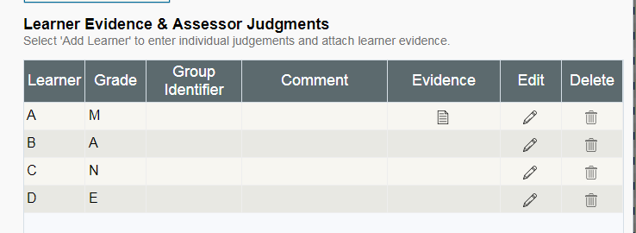
  - From the summary table, you can:
    - view the attached evidence
    - open and edit the learner record,
    - delete the entire record.
- When the standard is ready for submission select Ready to Submit.
  - The status of the standard is now ‘Submission - Ready to Submit’
  - The standard remains editable until it is submitted.
See: Tips for how to respond to validation error messages.

Submit one or more standards to NZQA
Role required: Moderation Authoriser (High Security User).
- Log in to the application and select Moderation.
- Review standards where the status is ‘Submission - Ready to Submit’.
Check:
- The Submission Details and Assessment Task sections are complete.
- A learner grade is entered for ALL learners that you are submitting evidence for.
- Digital submissions only - at least one document/file is uploaded for:
- Assessment task
- Student A
- Submit the standard(s) for moderation.
For one standard:
- Select the standard and open the action menu (right-click).
- Select Submit.
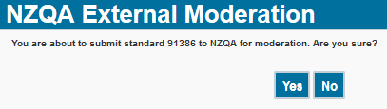
- Displays a confirmation message for the standard:
- Select Yes

For multiple standards:
- Note: submits ALL standards with status ‘Ready to Submit’
- Select a standard and open the action menu (right-click).
- Select Submit All.
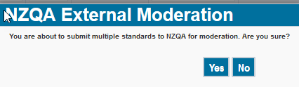
- Displays a confirmation message for the standards:
- Select Yes

Result:
- The standard is submitted to NZQA for moderation.
- The status changes to ‘Submission – Submitted’
- The submission is no longer editable.

Tips
Deleting an attached document
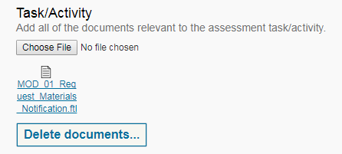
If you’ve uploaded the wrong document for a:
Task:
- Select Delete documents to open the Delete window.
- Select Delete to delete the file.

Learner:
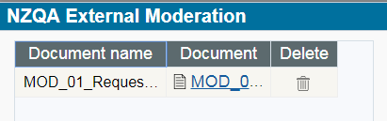
- Select Edit 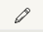 for the relevant learner on the summary table.
- Select Delete documents to open the Delete window.
- Select Delete to delete the file.

Submitting a link
Files stored in a cloud storage system (e.g. Google Drive, SharePoint) can easily be submitted by providing a share link or URL.
Ensure that:
- the files relevant to the standard are organised so that the assessment task and work for each of the students is readily identifiable by the moderator.
- the share rights are set so the moderator can directly access the materials. For example:
- Google Drive: “Anyone with the link can view”.
- SharePoint: provide a temporary username and password so the moderator can access the materials.
- the link/URL is copied into a document, along with any other relevant information for the moderator.
- the document is uploaded against:
  - the assessment activity/task
  - at least one learner (A)
Once the moderation is complete and the report becomes final, access to the materials can be removed.
For further information see the guide: Digital Submission Tips

Validation errors
The following are common validation error messages and what to do about them:

Message | Action
At least one learner must be created. Please try again. | Add Learner to create a learner record. Ensure you create a record for ALL the learners you are submitting evidence for.
For digital submission  You must enter a url OR upload files for assessment task and learner evidence before submitting this standard | Check there is either:  - a link entered in the Link field  OR  - a valid file uploaded for:  - the assessment task  - at least one learner.  Ensure you create a record and enter a grade for ALL the learners you are submitting evidence for.
Standard (number) not ready to submit. Please enter results before submitting. | Check there is at least one learner record created for the submission.  Check the status is ‘Submission - Ready to Submit’.

View Previous/ Next Plan
At certain times of the year, and depending on your submission date, you may have two moderation plans available.
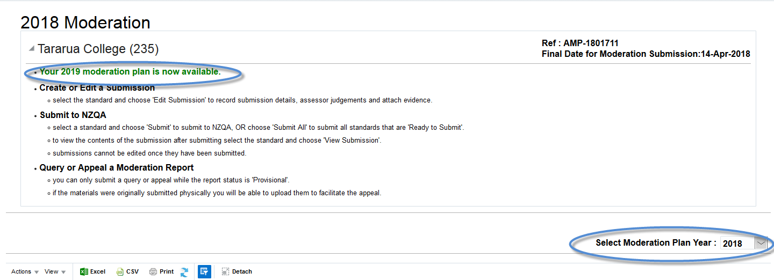
Use the year drop-down to change between plans.

Understand Report Dates and Statuses
When the … | Status changes to … | Report (Due) Date is …
- PN/Mod Liaison submits online. | Submission - Submitted | Blank
- moderator requests physical materials. | Report – Pending Material | Blank
- moderator accepts the submission (digital submission OK, or physical materials received). | Report - In Progress | Due date = Accepted date + 15 days*
- moderator completes the report. | Report - Provisional | Provisional report publication date
- provisional period (20 days*) expires, and  - no appeal has been received. | Report - Final | Final report publication date
- appeal is accepted. | Appeal – In progress | Due date = Appeal accepted date + 20 days*
- appeal is completed. | Report - Final (Appeal) | Final report (inc. appeal) publication date.

Notes
- * All timeframes are business (working) days.
- The due date at the point where a submission (or appeal) is accepted is an estimate. The actual date may be sooner or later, depending on moderator workload.
- Your PN/Mod Liaison will receive a notification when the report is ready.
- Submitting a query does not change the status of a report or affect the Report (Due) Date.

Related Guides
The following guides provide further information on using the external moderation application:
Guide | For how to:
Access the External Moderation Application | Access and navigate the application.
Submit an Assessment Plan | Select standards and submit an assessment plan.
View, Print & Customise Moderation Plan or History Views | View, customise or print/export assessment plan, moderation plan or moderation history views.
Submit Material for Moderation | Create a moderation submission and submit to NZQA.
Digital Submission Tips | Additional tips relating to digital submissions including, submitting cloud-based files, video files, file types accepted and size limits.
View and Query a Moderation Report | View or print a moderation report. Submit a query.
Appeal a Moderation Report | Appeal a moderation outcome.
Browser & Application Issues | Resolve browser issues and oracle errors

The guides can be found at: http://www.nzqa.govt.nz/providers-partners/assessment-and-moderation/moderation-online/qrgs-and-faqs/

Note: Roles and Access rights
Access to functions within the application are restricted based on roles. Which roles you have is determined by your MOE ESAA set-up.
For a full list of roles and access rights see the guide: Access to the External Moderation Application.

Note: Browsers
The External Moderation is supported across a range of browsers, however not all browsers behave in the same way. If you are experiencing issues with functionality described in this guide with a browser please try a different one. We have found Mozilla Firefox provides the best experience when using the application.
For specific advice on browser issues see the guide: Browser & Application Issues.

