Contents
This guide contains information for schools and Tertiary Education Organisations (TEOs) who want to:
- View a moderation report.
- Print (download) moderation reports.
- Query a moderation report.

For a full list of guides to the External Moderation Application see: Related Guides

Quick Steps
- Log in to the application and select Moderation.
- Select (click) the required standard
  - The status must be Report- Provisional, Report-Final or Report-Final (Appeal)
- Right-click on the selected standard.
- Select the required menu option.
- For Query:
  - Select View Report, then Query Report.
  - Enter your query and Submit.

View a Moderation Report
View a moderation report
Role required: any person with access to the application can view reports.
Notes: Only reports in the following statuses can be viewed:
- Report-Provisional
- Report-Final
- Report-Final (Appeal)
Once final, reports will remain available indefinitely. However, any attached documents (learner evidence, tasks etc) may disappear six months after the report is finalised as these are not retained by NZQA.
- Log in to the application and select Moderation
- Select (click) on the required standard, then right-click to access the menu.
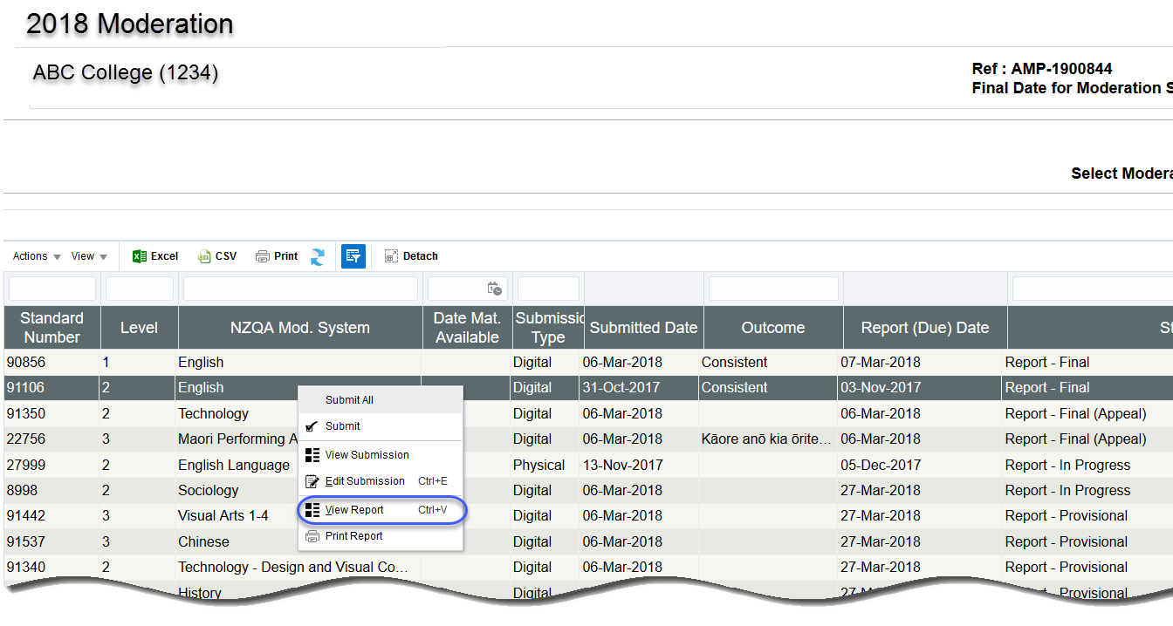
- Select View Report from the menu.

Result: The Overview section of the report is displayed

View a moderation report, continued
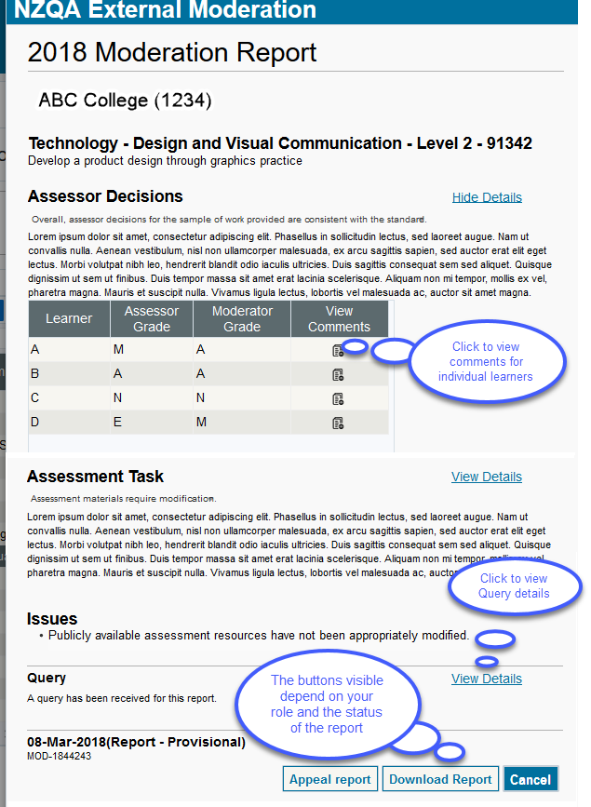
- Drill down to each section, as required.
  - Assessor Decisions: The outcome of the moderation. To see the learner grades, select View Details.
  - Assessment Task: The outcome for the assessment task, if moderated. To see the detail of any issues and recommendations, select View Details.
  - Issues: This section only displays if one or more issues were identified during moderation.
  - Query: This section only displays if your organisation has sent in a query about this moderation report. To see query details, select View Details.
  - Appeal: This section only displays if your organisation has appealed this moderation report.
In this example, no appeal has been created.
- Select Download Report to generate a printable version of the report.
- Select Cancel to close the report.
View Learner Details
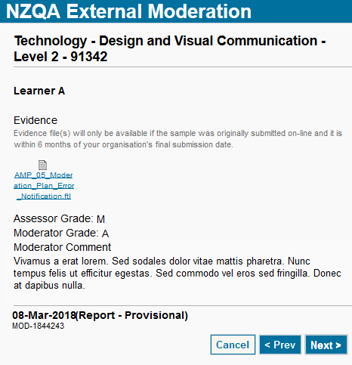
The assessor and moderator’s grades for the learners are displayed in a summary table. To view the details for a specific learner:
- Click the View Comments ( ) icon for that learner.
- View the Evidence that was uploaded for the learner (digital submissions only).

- View assessor and moderator grades and comments.

Use the <Prev and Next> buttons to move through the list of learners.

Print a Moderation Report
To print a single moderation report
Role required: any person with access to the application can print reports.
Notes:
- This function creates a download (pdf) file of the selected report.
- The file name is in the format <ModerationSubjectName>-<StandardNumber>-<Year>
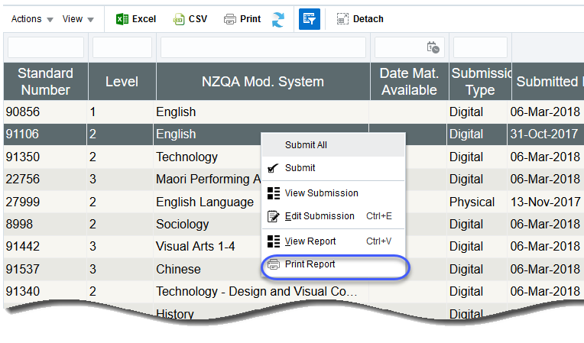
- Log in to the application and select Moderation
- Click on the required standard.
- Right-click to access the menu.
- Select Print Report from the menu.

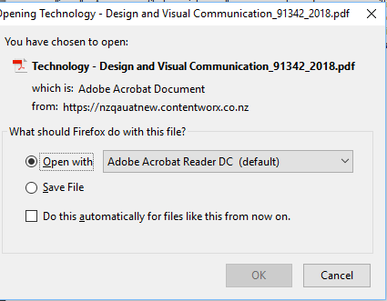
Result: Depending on your browser and personal set-up:
- a pop-up may open with options to save or open the file

- the downloaded file link may appear somewhere on the screen

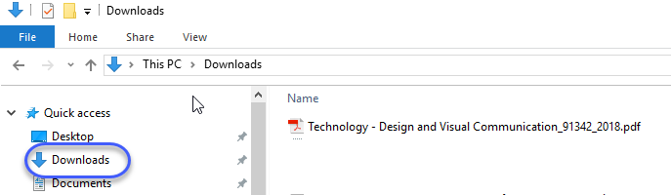
- the file will also be accessible from your browser download menu and/or the ‘downloads’ folder on your device.
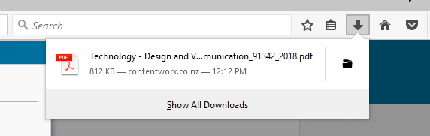

To print multiple moderation reports
Role required: any person with access to the application can print reports.
Notes:
- This function creates a single .zip file for ALL the selected reports.
- The zip file name is in the format <Reports>-<FileCreatedDate>-<Year>
- The individual reports (within the zip) are pdfs and have the file name format: <ModerationSubjectName>-<StandardNumber>-<Year>
- Log in to the application and select Moderation History
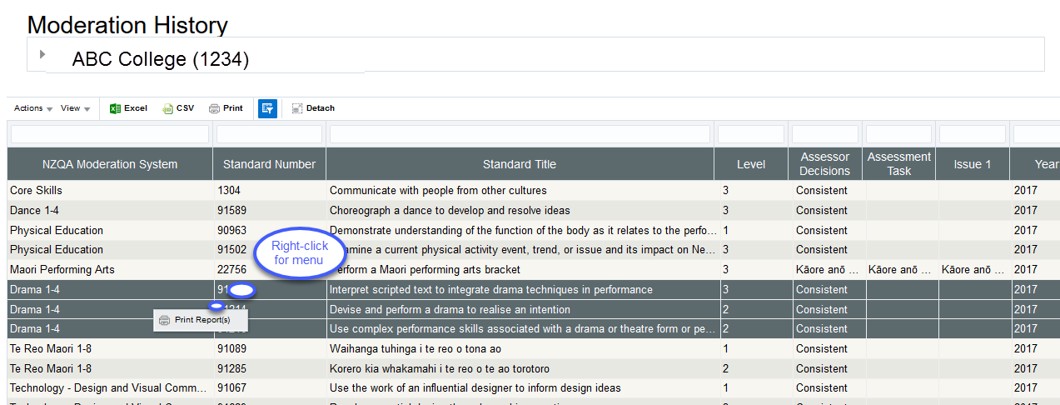
- Ctrl-click to select multiple standards from the table:
  - You can select up to 75 standards.
  - The reports will be in a single pdf file.
- Right-click on a selected standard to access the menu.
- Select Print Report(s) from the menu.
Note: the download time is dependent on the number and size of the reports selected.
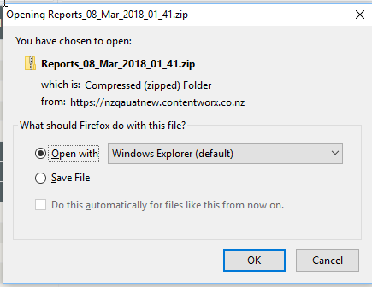
Result: Depending on your browser and personal set-up:
- a pop-up may open with options to save or open the file

- the downloaded file link may appear somewhere on the screen

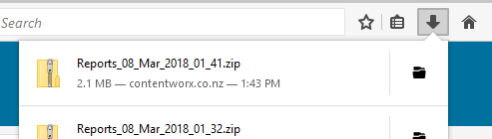
- the file will also be accessible from your browser download menu and/or the ‘downloads’ folder on your device.

Query a Moderation Report
To query a moderation report
Role required: Moderation Processer or Moderation Authoriser (High Security User)
Use a Query where you’re not clear on the meaning of something in the moderation report, to clarify the decisions and comments following moderation.
You can only submit a query if the status of the report is ‘Report-Provisional’.
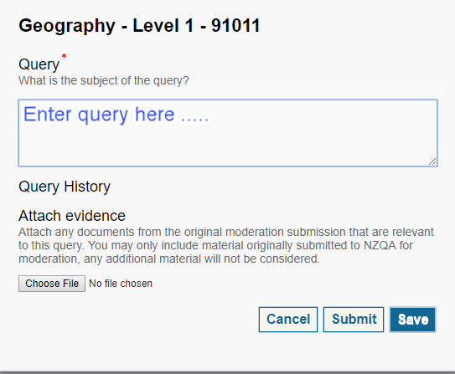
- View the report as above.
- Select Query report.
- Type your question in the Query field.
- Upload any relevant evidence using the Choose File function.
- Note: Only evidence from the original submission should be included.
- Save or submit your query:
  - Save to save your query without submitting it.
  - Cancel to return to the report, without saving the query.
  - Submit, then click Yes to send the query to NZQA.
Notes:
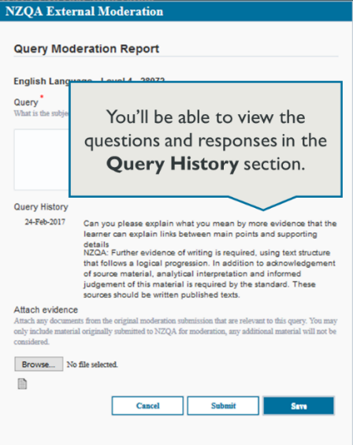
Submitting a query doesn’t change the status of the standard in the moderation plan. The only difference is that a Query section gets added to the report.

The Principal’s Nominee or the Moderation Liaison will receive an email notification when the moderator responds to the query.

To view a query, click the View Details link on the moderation report, then view the question(s) and response(s).

Related Guides
The following guides provide further information on using the external moderation application:
Guide | For how to:
Access the External Moderation Application | Access and navigate the application.
Submit an Assessment Plan | Select standards and submit an assessment plan.
View, Print & Customise Moderation Plan or History Views | View, customise or print/export assessment plan, moderation plan or moderation history views.
Submit Material for Moderation | Create a moderation submission and submit to NZQA.
Digital Submission Tips | Additional tips relating to digital submissions including, submitting cloud-based files, video files, file types accepted and size limits.
View and Query a Moderation Report | View or print a moderation report. Submit a query.
Appeal a Moderation Report | Appeal a moderation outcome.
Browser & Application Issues | Resolve browser issues and oracle errors.

The guides can be found at: http://www.nzqa.govt.nz/providers-partners/assessment-and-moderation/moderation-online/qrgs-and-faqs/

Note: Browsers
The External Moderation is supported across a range of browsers, however not all browsers behave in the same way. If you are experiencing issues with functionality described in this guide with a browser please try a different one. We have found Mozilla Firefox provides the best experience when using the application.
For specific advice on browser issues see the guide: Browser & Application Issues.

