

NCEA
Design and Visual Communication
(DVC)

Guide Notes and Instructions 2019

Thank you for taking on this significant role.

These ‘Guide Notes and Instructions’ must be read by all markers.

Please reread these guide notes and instructions as you perform each of the tasks associated with marking.

All guide notes will be available online at: https://secure.nzqa.govt.nz/for-partners/marker/view-forms.do.

PANEL LEADER AND CHECK MARKER CONTACT DETAILS
All work associated with the marking process is STRICTLY CONFIDENTIAL.
You must not discuss the contents of candidate portfolios, assessment schedules or associated material with any person or organisation outside of the Panel.

 | Name | School address, phone and fax | Home address and phone | Email address
Panel leader
Check marker

We welcome any suggestions from markers to help us review and modify our processes for the marking of NCEA DVC.

Contents

Changes to the guide notes and instructions made in recent years 5
GENERAL INFORMATION FOR ALL MARKERS 6
Portfolio submission date 6
Marker responsibilities 6
Marking calendar 7
BEFORE MARKING 8
Enter address information 8
Logging into your marking home page 10
Pre-approval process for travel over 100 km 10
Marker pack 10
DURING MARKING 11
Receiving portfolios 11
Identifying portfolios 12
Panel meeting 13
Assessment decisions 13
Marking practices 14
Portfolio management 15
Test marking 15
Check marking 15
Courier bookings 17
Marking home page 18
Marking pages 19
View your details 20
Forms 20
Entering results 20
Portfolios requested by NZQA 22
Search for Candidate 22
AFTER MARKING 24
Marker report 24
Marking evaluation 24
Final pick-up of portfolios 25
Remaining Materials 25
Marker Claims 26
LEADING A PANEL 28
Additional panel leader materials 28
Marking timelines 28
Initial contact with markers 28
Benchmarking Meeting 29
Bench marked Portfolios 29
Other preparation 30
Profile of Expected Performance (PEP) 30
Test marking 31
The Panel Meeting 31
Monitoring Performance 33
Check Marking 34
Re-marking 35
Reallocating Portfolios 36
Panel leader report 37
Reviews and Reconsiderations 37
Review Meeting 37
APPENDICES 39

Appendix A: | Planning Sheet for Marking Timelines | 39
Appendix B: | Portfolios Sent for Check Marking Form | 40
Appendix C: | Check Marking Summary Form | 41
Appendix D: | Marker’s Check List | 42
Appendix E: | Panel Leader Check List | 43
Appendix F: | Authenticity Statement Check Sheet | 44
Appendix G: | Excess Portfolio Material Sheet or Submissions in Clear Files | 45
Appendix H: | Instructions for Reallocating Portfolios Electronically | 46

Contact information

Marker helpline  8 am – 5 pm weekdays | 0800 222 230 | examinations@nzqa.govt.nz
NZQA physical address | Level 14, 125 The Terrace, Wellington 6011
NZQA postal address | PO Box 160, Wellington 6140
NZQA Freepost | Freepost 3221, PO Box 160, Wellington 6140
Return delivery address for portfolios | NZQA c/o Bluestar, 33 Jackson Street, Petone, Wellington 5012
CourierPost | 0800 501 501 | www.courierpost.co.nz

Changes to the guide notes and instructions made in recent years
- NZQA removes all address information from its marker contracting system at the start of every year. You must enter addresses in each year. Use the online validation tool to ensure your addresses are entered correctly.
- If no delivery address was available at the point of contracting, your delivery address defaulted to your school address. You must ensure that your delivery address is correct.
- Cartons are replacing the orange bags used in previous years for the portfolio movements.
- Each carton of portfolios sent to you will generate an email to you. The email will contain a tracking number and a link to the CourierPost tracking website.
- Attach the Customer Use label of the courier tickets to the Answer Booklet Control Sheet.
A separate courier tracking sheet will not be provided. This differs from the information provided on the online Marking Processes and Administration Movie.
- You must use the online Pre-approved Travel Form.
- Markers must complete an Online Marker Evaluation Form.
- Courier pick-ups can be booked using an online tool.
- Forms will be provided only in these Guide Notes and Instructions. Separate versions of forms will not be provided online.
- Printlink is now known as Bluestar (sorting vendor).

Communication
- NZQA may communicate with you by email, phone, text, or through messages published on the Marker Home page.
- If you have any questions relating to the content of these guide notes, please contact your national assessment facilitator on 0800 222 230 (Marker Helpline).
- If you need cartons, stationery, or for general administrative queries, contact the marker helpline on 0800 222 230.
- The CourierPost contact number is 0800 501 501.

GENERAL INFORMATION FOR ALL MARKERS

Portfolio submission date
The date for the submission of portfolios is Wednesday, 30 October 2019.

Marker responsibilities
Markers need to be available for marking until Friday 20 December 2019, and are required to:
- receive portfolios
- attend a panel meeting
- assess portfolios according to the assessment schedule, panel leader instructions, and these
Guide Notes and Instructions
- ensure that all candidate material is assessed consistently and fairly
- follow instructions and/or advice given by the panel leader regarding assessment
- ensure that portfolios and control sheets/web results are free from marker errors and omissions
- maintain the security and confidentiality of all portfolios, associated marking material and all work relating to the submission
- meet all deadlines
- write a Marker Report for the panel leader
- arrange for collection of portfolios by CourierPost
- return all Control Sheets and completed non-personalised (blank) assessment envelopes to NZQA in the CourierPost bag provided.

The Panel leader has responsibility for:
- quality control of marking through the consistent application of the assessment schedule by markers on the panel
- conducting the benchmarking process
- organising and conducting the benchmarking meeting, panel meeting, and cut score meeting
- liaising with the national assessment facilitator (NAF) and if needed the examiner
- the organisation, briefing, and operation of a panel of markers
- permitting markers to start marking
- requiring markers to stop marking
- monitoring the quality and progress of result entry online
- writing the final assessment schedule and panel leader’s report for the examiner
- fulfilling their check marking and marking responsibilities.

Marking calendar

 | Panel leaders/Check Markers |  | All Markers
Sep |  | Sep | Markers able to change personal details on NZQA website
Oct | Read all sections of these Guide Notes  Send letter to markers, including expected marking timelines | 23 Oct | Last day to change portfolio delivery addresses online (see page 4).  Read Section 1 of these Guide Notes and Instructions  Receive Marker Pack  Contact 0800 222 230 if Markers’ Pack  has not been received
2 – 8  Nov | Benchmarking Meeting(s)  One day or two evenings | 5 – 13  Nov | Receive portfolios for marking  Check all portfolios received prior to panel meetings
9 – 12  Nov | Panel Meeting – one full day  (or equivalent)
13 Nov | Begin marking  Check assess and provide feedback | 13 Nov | Begin marking  Send check marking and receive feedback
Nov/ Dec | Continue contacting markers and remind them to enter results daily | Nov/ Dec | Enter results daily (initial results only to start with) on the web
3 Dec | Last day to return check marking to markers
9 Dec | Last day portfolios delivered to a school or workplace address After this date, all deliveries will be to a home address
20 Dec | Last day to click Final Submit
18 Dec | Set of marked GPs to NAF at NZQA
16 - 27  Dec | Arrange collection of assessed portfolios  18 December is the preferred pick-up date of portfolios  Same day bookings for 16, 17, 18 and 27 December collections, book pick-ups before 12.00 pm for pick-up by 5.30 pm.  Advance bookings for 19 and 23 December collections, book pick-ups before noon on the day prior (working day), e.g. for Monday 23 December collection, book before  12.00 pm Friday 20 December
19 Dec | Final date to send Control Sheets
20 Dec | Collate Marker Reports/write Panel leader Report  Send letter of thanks to markers | 20 Dec | Final date to email Marker’s Report to the panel leader. Return any other materials, including CourierPost bags to NZQA
10 Jan  2020 | Email/post Panel leader’s Report/Marker Reports to NZQA.  Complete Panel leader Claim online | 10 Jan 2020 | Complete Marker Claim online
Feb/ Mar | Assess reconsiderations | Feb/ Mar | Dispose of benchmark material, assessment schedule, etc

BEFORE MARKING

Enter address information
If you did not update your delivery address during contracting, we have set your delivery address to your school address. To avoid delays and misplaced deliveries, you must check your delivery addresses are accurate.

CourierPost will not leave portfolios at an address if no one is available to sign for the delivery.

We strongly recommend that you use a school address for portfolio deliveries before
9 December. After this date, CourierPost will make any further deliveries to your home address. Rural area deliveries may take up to three working days.
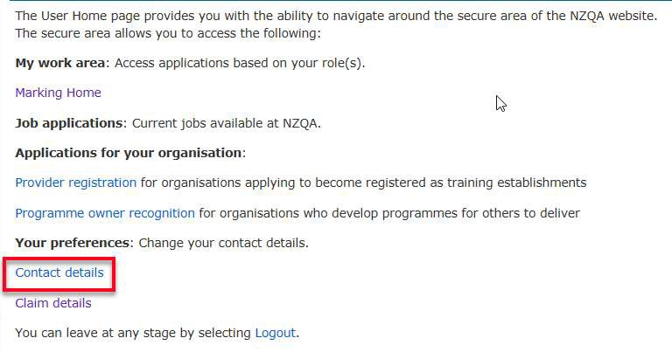You must use the address validation tool to enter your address. You can find the tool by following the Contact details page link on your Marker Home page.

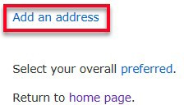On your Contact details page select Add an address.
Use the radio buttons to select the School or Other address type. For school addresses select the
school name from the pop-up menu and the address field auto completes. Click Save. Choose, Other. Start typing; the field auto completes. Select the correct address and save.

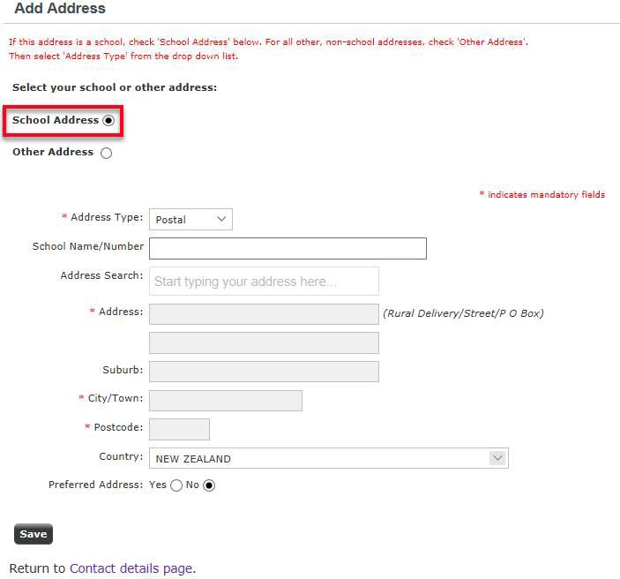

If an address does not appear in the drop-down list, contact the Marker helpline for assistance. Repeat the process above for entering your Delivery, Home, Pick-up and Work addresses.
28 October is the last date to check and update your portfolio delivery address. From
this date, the address file does not automatically update after any changes that you make online.

To ensure you receive your portfolios, you must notify the Marker helpline of delivery address changes made from 28 October onwards.

Logging into your marking home page
To change your details, go to http://www.nzqa.govt.nz/login/.

On the Login page, click on All other users Login and enter your user name/ID and password.

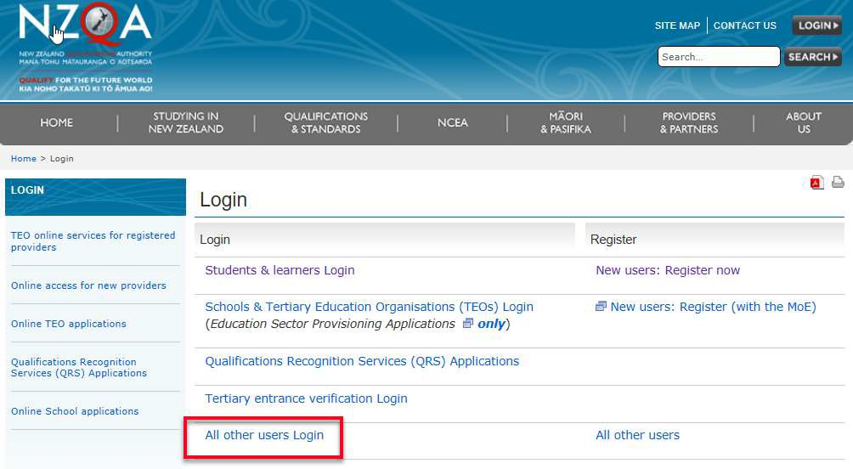Select Marking Home page, then click on View Your Details. Please note any changes made to your details on QAccess will not be updated on your Marking Home page. You will need to update these separately.

Pre-approval process for travel over 100 km
The marking incidental fee covers the first 100 km of travel to panel and any other marking meetings. If your travel is likely to exceed 100 km and you require payment for the extra kilometres, you must request pre-approval from your NAF. Complete the online Pre-approved Travel Form by 28 October. If you anticipate any difficulty completing this process, please phone the Marker Helpline 0800 222 230.

Payment is conditional on a pre-approval form being received by NZQA. Where you claim for travel over 100 kilometres, and a Pre-approval Travel Request Form has not been completed, your claim may be delayed.

Marker pack
A marker pack of stationery and courier materials will be sent to your delivery address by 23 October. It contains:
- an orange pre-addressed courier bag (for returning unused materials, processed non- personalised (blank) Assessment Envelopes and Control Sheets to NZQA)
- Blue CourierPost bags (for the movement of portfolios to the check marker). Return any unused bags
- CourierPost labels addressed to the panel leader/check marker for check marking
- 2 x cartons and courier labels for returning assessed portfolios to Bluestar (use if the original cartons are damaged)
- 10 x spare envelopes for candidate material (use if the original envelope is damaged)
- 10 x A3 clear plastic bags (for combined NCEA and NZ Scholarship portfolios, use if the original is damaged)
- 2 ‘Saturday Delivery-only’ stickers for use, if required
- Adhesive tape for resealing portfolio cartons.
Contact the NZQA helpline if you have not received these materials by 23 October 2019.

DURING MARKING

Receiving portfolios
CourierPost will send you an email each time a single carton or bag of portfolios is sent to you. Each email will have a tracking number and a link to their online tracking service.

Call CourierPost at once if there are any courier problems. If there is a reoccurring problem, call the Marker Helpline.

CourierPost will deliver the portfolios during 6-14 November. Most will arrive in cartons; some may be in orange courier bags. They are likely to arrive in several consignments. If a person is not available to sign for a consignment, CourierPost will not leave the portfolios but will leave instructions to arrange delivery. If unmarked portfolios are left without a signature, phone the Marker Helpline immediately on 0800 222 230.

When you receive the cartons/bags:
- Check the courier label. Your four-digit marker code must be displayed. If your marker code is not on the label, open the box and check the contents. Phone the Marker Helpline if the portfolios are not for a standard you are marking.
- Locate the Answer Booklet Control Sheets in the first carton of each consignment, and using the candidate NSN to identify the portfolio, tick the received column for received portfolios and enter Z for any portfolios not received.
- As soon as you have checked receipt of all portfolios, enter the Z result on to your Marking Pages. You should no longer receive absent portfolios (Y) unless a school submits an empty assessment envelope.
- The Void (V) category no longer applies – as you will only be marking the one standard.
- We strongly recommend that you keep the portfolios in the same order as the Answer Booklet Control Sheets as they should appear in the same order as your Marking Pages for entering the grades.

What if:
- you receive an envelope with no portfolio?
Treat this as an Absent portfolio – enter Y on both the ABCS and on your Marking Pages. The envelope can be returned to NZQA with the blank assessment envelopes.

- you receive a portfolio that is not on the Answer Booklet Control Sheet or is handwritten on the Answer Booklet Control Sheet?
Use the Marking Pages to search for the candidate, add to the Answer Booklet Control Sheet and reallocate to ‘yourself’. If the candidate doesn’t exist, record into a notebook and contact the Senior Business Liaison Officer on 0800 222 230, or examinations@nzqa.govt.nz, as soon as you have finished checking all portfolios, they will initiate a Late Entry process. Once this has occurred, you will be able to mark the portfolio and enter the results.

- a candidate is listed on your Answer Booklet Control Sheet, but there is no assessment envelope for that candidate?
Write Z on the Answer Booklet Control Sheet. Do not enter Z results online until the last day of marking, as it may turn up later.

If required, email the Senior Business Liaison Officer with the following information:
  - Assessment envelopes where the authenticity section does not have a student signature (a teacher can pp sign for the student). NOTE: Teacher signatures are no longer required
  - Groups of missing portfolios or missing Answer Booklet Control Sheets.
  - Cartons that are missing (after 14 November).

Chaser Packs
You may receive some portfolios after the bulk of your portfolios have arrived. These ‘chaser’ packs contain portfolios which may have come from rural delivery areas and were not part of the initial sorting process or are portfolios which were sent to the wrong marker and have been re- directed. This may include portfolios from overseas.

Overseas Portfolios
These may not arrive until marking is well underway.

Identifying portfolios
All candidate assessment envelope will be personalised with a barcode. The example below shows the data contained in the barcode for a portfolio.
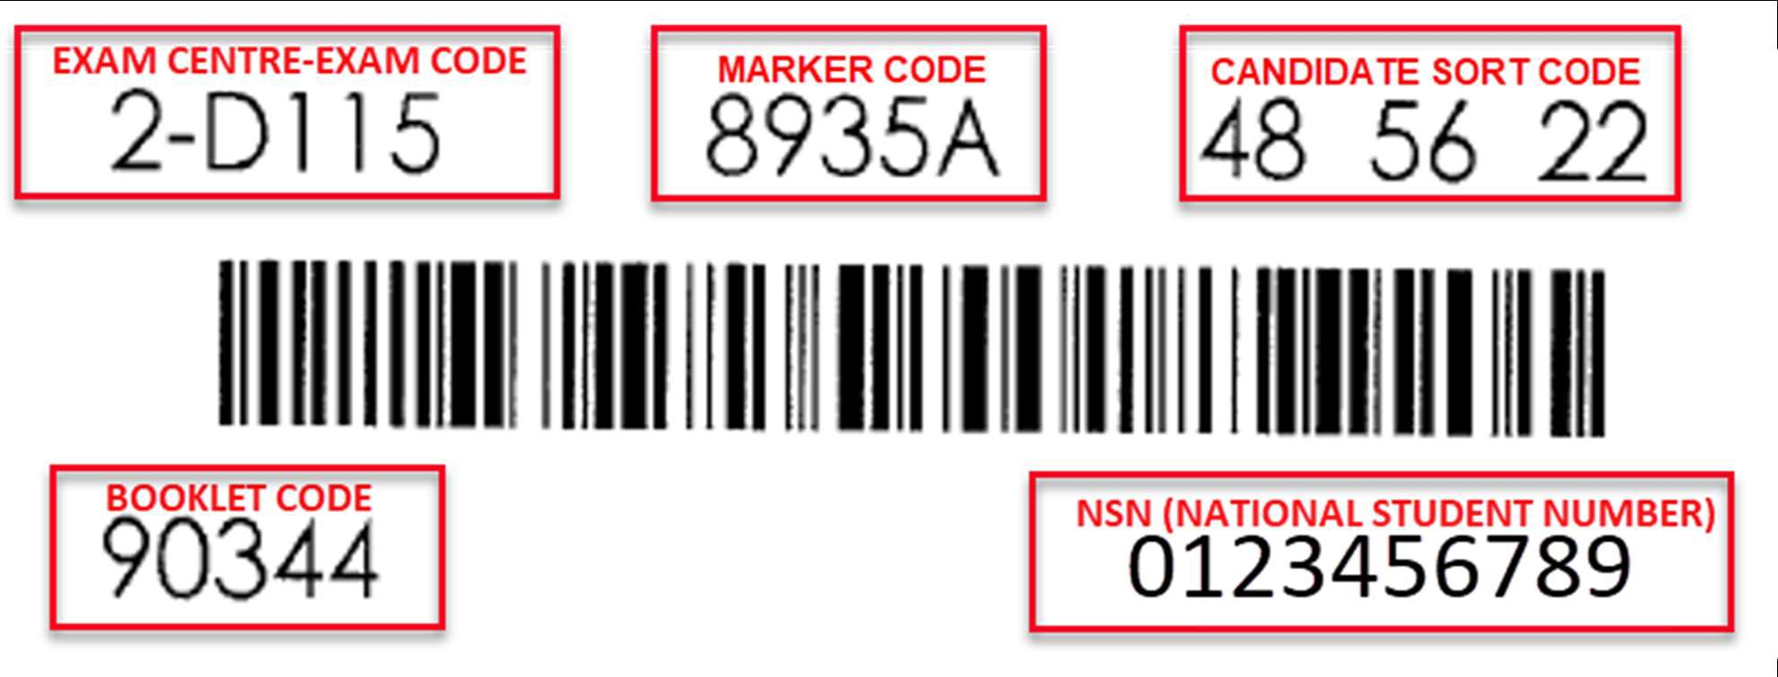

- The Exam Centre Code is the number of the study provider where the candidate is entered for this standard. This is followed by an Exam Code for a specific candidate at that study provider.
- Your Marker Code consists of four numbers and the letter A.
- The Candidate Sort Code assists with the sorting of portfolios back to the study provider.
- The NSN (National Student Number) is the candidate’s unique identification number.
- The Booklet Code indicates the achievement standard number.

Panel meeting
All markers will attend the one-day panel meeting. The panel leader and senior marker will organise and run the panel meeting. The purpose of the panel meeting is to:
- ensure all markers have a clear understanding of the assessment schedule
- establish consistency in marking using benchmarking scripts provided by the panel leader
- achieve a consistent standard of assessment as specified in the assessment schedule
- ensure all markers have a clear understanding of all administrative processes
- give you authority to start marking. You must not start marking before the panel leader has given you permission.

Panel Meeting Dates
Level | Standards | Meeting Location | Dates
Level 1 DVC | 91063 |  | November
Level 1 DVC | 91064 |  | November
Level 1 DVC | 91065 |  | November
Level 2 DVC | 91337 |  | November
Level 2 DVC | 91338 |  | November
Level 2 DVC | 91339 |  | November
Level 3 DVC | 91627 |  | November
Level 3 DVC | 91631 |  | November

Materials available at the panel meeting:
- practice assessment envelopes
- bench mark materials
- these Guide Notes and Instructions.

Materials to bring the Panel Meeting:
- a copy of the achievement standard(s) and assessment specifications you are to be assessing against
- laptop (if instructed by your panel leader)
- a red pen, pencil and highlighter
- anything else the panel leader has asked you to bring, e.g. ‘Post-its’, exemplars, USB stick.

Assessment decisions
Throughout the assessment process, you will be required to make interpretations based on your professional judgement to arrive at grades. In exercising professional judgement, you must ensure that:
- the candidate performance meets the standard required by the achievement standard as illustrated by bench mark materials
- the candidate’s evidence is consistent with the assessment schedule
- the evidence provided by the candidate is sufficient for a reliable judgement, and
- other markers would make a comparable decision.
As the panel is assessing a nation-wide set of standards, markers will need to put aside their personal opinions on the standard of marking they would apply to their own student work.

Marking practices
There are non-negotiable marking practices that must be followed by all markers. It is important for review and reconsideration purposes that you follow the instructions below.
- Use a red pen ONLY for marking.
- Do not use correcting fluids/tapes.
- The nature of the subject allows for candidates to use pencil, this need not be recorded.
- Do NOT write on or place any lines in the shaded A, M, E boxes on the envelope.
- For non-personalised assessment envelopes, write on the top left corner:
  - your 4-digit marker code
  - the candidate’s NSN
  - the exam centre code
  - the exam code.
- If you need to change an entry on the assessment envelope, cross out the error, write in the correct result in red pen and initial next to the change.
- DO NOT write comments to candidates.
- Results must be entered in, correct and legible writing, on the Answer Booklet Control Sheet.
Use the capital letters N, A, M, E, Y or Z.
- If there is any doubt as to whether evidence for a particular standard has been presented in the portfolio then enter N as the result. You may ask your senior marker to make a ruling on this portfolio (add the portfolio to the others sent to your check marker).
- On the assessment envelopes, use the capital letters N, A, M, E. (and Y or Z only as outlined above)
- Do not put any numbers or letters on the candidate material, unless instructed to by the panel leader.

Codes | Reason
N | Not Achieved
A | Achievement
M | Achievement with Merit
E | Achievement with Excellence
Y | Envelope containing no candidate work
Z | Missing envelope

As a marker, you should be confident that:
- all work has been marked
- the grade has been entered in the appropriate place on the assessment envelope.

These procedures will minimise the possibility of your marking being challenged by candidates.

If it becomes obvious that you will be unable to complete the marking of your allocated portfolios by the specified date, you must tell your panel leader immediately.

Arrangements will need to be made to ensure that someone marks all portfolios before the final deadline.

Portfolio management
A large amount of candidate material will be sent to you for marking. It is important that you follow the procedure as set out below to ensure that materials are not mixed up and sent back incorrectly.
- Mark ONE portfolio (envelope) at a time.
- Record the result onto the Answer Booklet Control Sheet.
- At the end of each days marking, enter the results online from the completed Answer Booklet Control Sheet. Initial entry only until permission is given to enter double.
- Check to ensure that the same result is on the assessment envelope and the Answer Booklet Control Sheet.
- Check the authenticity statement on the assessment envelope is signed.
- Complete authenticity statement check sheet (Appendix G), if required.
- Complete excess portfolio material form (Appendix H), if required.
- Place the portfolios back into the cartons.
- Place the return to Bluestar courier label over the original label and seal the carton. Only use the orange bag if the carton is not reusable. Remove the Customer tab from the label and attach to the Answer Booklet Control Sheet.
- Place the Answer Booklet Control Sheet into the pre-addressed signature-required courier bag (the same one that holds all the replacement/blank envelopes) provided and return to NZQA.

What do I do if:
- an envelope contains more than one standard in it for the same level, e.g. L1 Working (2-D) drawings is underneath the L1 Freehand sketching pages.
  - Mark your standard as per the instructions above.
  - Place the other standard into a clear plastic bag and send to NZQA in an orange courier bag.

Test marking
The first 30 portfolios marked and entered (initial entry only) will be Test Marking. You should not proceed with marking until clearance is given by the panel leader. Test marking starts immediately after the panel meeting and follows the marker timeline. (See Appendix A) Test Marking gives the panel leader and NAF an indication of how the results will pan out.

Check marking
Check marking is the process that ensures consistent marking.

Your panel leader will explain the check marking procedures and provide the marking and check marking timeline at the panel meeting.

All markers, including panel leaders, are required to submit a percentage of portfolios for check marking.

After sending portfolios for check marking, continue marking; do not enter any further results until you receive your check marking feedback.

Feedback from your panel leader or check marker may require you to go back over earlier marking and make changes to portfolios already marked. This must be done to ensure you are marking to the same standard as the other members on the panel. This is a normal part of marking. If check marking changes a result, you must change the online result. If you do not do this, the result on the

envelope will be different to the results on the candidate’s result page. You must confirm with the panel leader or check marker that this has been done.

ALL CHECK MARKING IS COURIERED IN THE BLUE COURIER BAGS PROVIDED

Preparing for check marking:
- ensure the work has been marked and the assessment envelope has been completed
- ensure the result is entered on your Marking Pages, as initial entry only, do NOT complete double entry
- use the Portfolios Sent for Check Marking Form (See Appendix B) to keep a record of those portfolios sent for check marking
- double check you have entered the correct grade on the Portfolios Sent for Check Marking Form (See Appendix B)
- write your name on a post-it or blank piece of paper and attach it to one of the portfolios you are going to send
- attach a CourierPost label (provided) to the blue courier bag and fill it with candidate portfolios (remember the maximum weight restriction of 7 kg)
- address the bag to your check marker – you will be provided with pre-addressed stickers
- Check markers/ panel leaders please reuse the blue courier bags – returning marked work to makers in the same bag but with new CourierPost label and marker address
- phone CourierPost on 0800 501 501 to arrange for collection
- attach a ‘Saturday Delivery’ sticker for bags couriered on a Friday – only drop-offs occur on Saturdays (no pick-ups).

Responding to check marking:
- be prepared for feedback at an arranged time
- follow the advice and instructions of your panel leader/check marker
- discuss the extent of any required review of grades already entered
- review and amend any results as required by the check marker, this is of utmost importance.
- note the return date and check marker grade on the Portfolios Sent for Check Marking Form
- remove ALL check marking notes/post-it notes; candidates must not see these.
- change results on Answer Booklet Control Sheet, as required.

Courier bookings
The preferred option for markers to book check marking pick-up and final pick-up is using the online booking tool. If for some reason you cannot use the booking tool please phone 0800 501
501. The online booking tool is easily accessible and available 24/7.

Step | Instructions | Screen shot
1. | Visit www.courierpost.co.nz | 
2. | Select Book a Pick Up in the drop- down menu.  Select Book a Pick Up by Address.  Do not use the Site ID option. | 
3. | Enter information in each field.  You can request an email confirmation of your job booking. This will be useful in case you need to query the pick-up.  You can also click on Remember me option, so the next time you enter your name, the system will remember your pick-up details.  Pick-ups booked by phone require  you to repeat all of your details.  You must complete all required fields as indicated by an asterisk.  Please enter NZQA under the ‘Company name’ for CourierPost performance reporting purposes.  Other fields are optional. For example, ‘Pick up instructions’ is not required. | 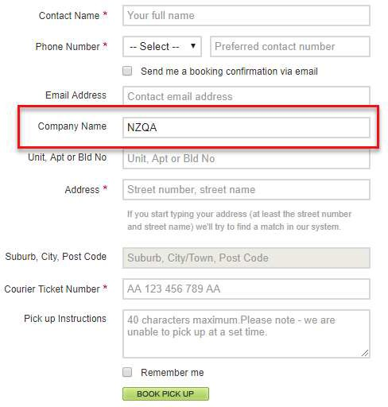
 | Click on “BOOK PICK UP” button at the bottom.  You will see a pop-up window with the job booking number.  This job booking number is to be used for any query for this pick-up. | 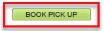

Marking home page
When you log in and click on Marking Home page, the top area of the screen displays messages to markers, which you should always check. From the Marking Home page, you will see the link to your Marking Pages.

Select ‘Marker Home’
The top area of the screen is reserved for general messages to all markers, personal messages about reallocated portfolios, or specific notifications to you.

‘View your Details’
This screen allows you to change personal details such as e-mail and phone numbers, and update address information. Once you have entered this area, please review your information. If you need to make changes, click on either the marker details or address ‘Edit’ links.

‘Marking Pages for Marker Code xxxx’
All the entries allocated to you will appear here. If you have more than one marker code, separate pages will be allocated for each marker code you may have. If your marker pages are not visible contact NZQA earlier rather than later.

‘Allocated Entries for Marker Code xxxx’
This option will only appear if portfolios are allocated to you after your marker pages were set up. A message indicating that additional portfolios have been allocated, will appear in your personal messages.

When you enter this page, the additional entries that have been allocated to you will appear in school name order.

Supplementary entries with a result will appear at the bottom of the list; those with no result will appear at the top. You may select one or many for result entry.

‘Unallocated Entries’
If, for any reason, you receive portfolios to mark and they do not appear on the Marking Pages, you may capture their results using this option.

Marking pages
Below is an example of the online Marking pages, with explanations. This is best read in association with the open marking page.

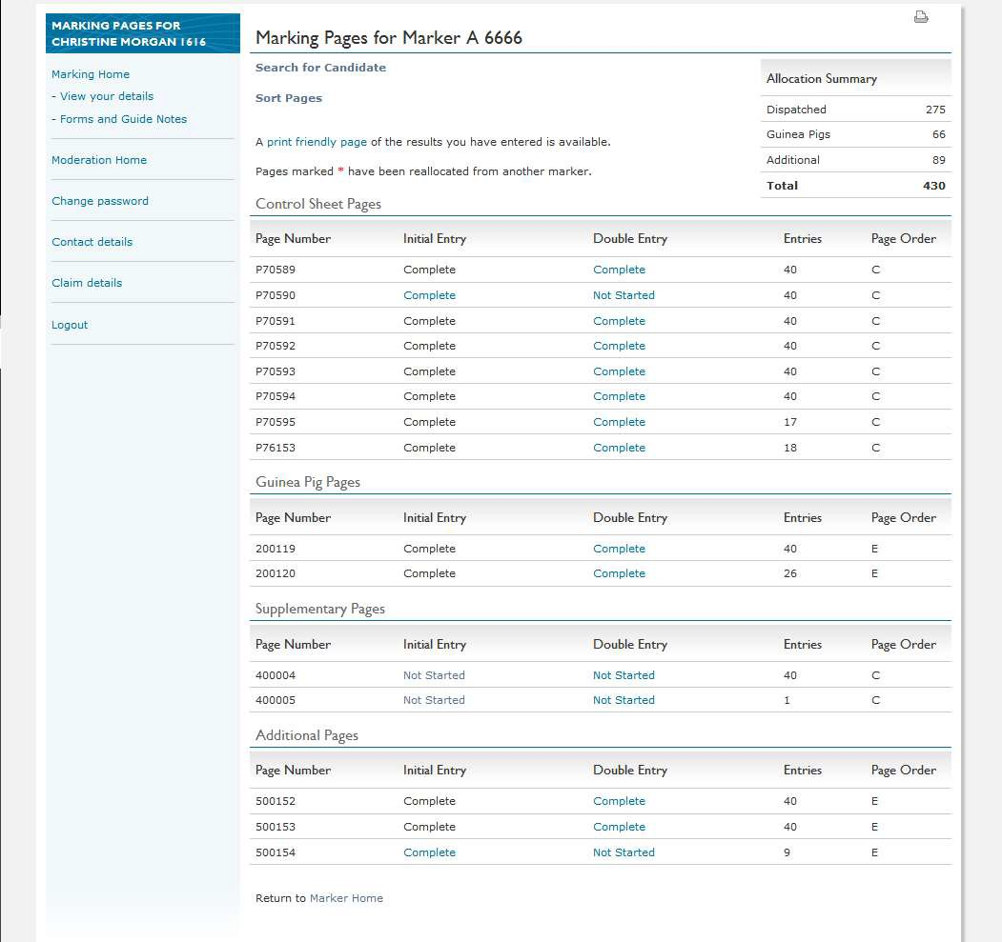
A
B
C
D
E
F

- Allocation summary
This table provides a summary of the entries which should appear on your Marking Pages.

- Search for Candidate/Sort Pages
The Search for Candidate link finds the location of a result entry line on your Marking Pages.

Do not use the Sort Pages function unless your NAF asks you to, because the sort cannot be undone. It re-sorts the entries on the Marking Pages into Exam Centre Code/Exam Code order.

- Control Sheet Pages
Each Control Sheet Page has one line. The number of portfolios per page is up to 40, shown in the Entries column.

The Page Order column shows either C if the portfolios are in Answer Booklet Control Sheet order, or E if they are in Exam Centre Code/Exam Code order.

As marking progresses, new pages may appear. NZQA may reallocate pages to you from another marker, they will appear at the end of your Control Sheet Pages, highlighted with a red asterisk.

- Guinea Pig Pages
These pages will be present if guinea pigs are chosen for your standard. Your panel leader will give/send your guinea pig portfolios during/after the panel meeting. They are listed in school order.

- Supplementary Pages
Supplementary Pages will only appear when you reallocate a portfolio from another marker to yourself.

- Additional Pages
Additional Pages may appear from 13 December. Most of these pages will contain information for portfolios you did not receive. As soon as these pages appear, if you do not have a portfolio listed on the page, enter Z in each column.

Other result entry lines may be for portfolios you have marked but could not enter elsewhere.

All pages, including Additional Pages, must show as Complete before the Final Submission button will appear.

View your details
Change personal details such as email, phone numbers, and addresses using this screen. After 28 October you must notify the Marker Helpline on 0800 222 230 of any change of address.

Online changes made after this date, will not change the address to which your portfolios will be delivered.

Forms
Forms used during the marking and results entry process are available by clicking on the link(s) below, or at the end of these Guide Notes and Instructions.

Form | Delivery
Pre-approved Travel Form | Online Pre-approved Travel Form
Irregular Answer Booklet Form | Courier to your panel leader.
Test Marking Summary Form | Email to panel leader
Supplementary Result Sheet/Change of Result Sheet | Email or courier to NZQA
Marker Report Form | Email to your panel leader
Marking Evaluation Form. | Online Marking Evaluation Form.

Entering results
Initial result
- All results must be entered from the assessment envelope.
- To enter results, click on Not started or In Progress on the relevant page listed in the Initial Entry column. This will display the entries on the Mark Sheet Entries page (see over page).
- Some pages may have an initial status of In Progress where NZQA has entered a Y for a candidate who did not submit a portfolio.
- If there are two separate lines on your Marking Pages for the same candidate, enter the result on one line and enter a Z (missing) on the other line.
- Any results entered on a page must be saved by clicking on Save.

- When you have entered a full page of results and Saved, the status on the Marking Pages
screen will show as Complete.

Double entry
- Results for each page must be entered twice. Your panel leader will give approval to double enter your results.
- All double result entry must be entered from the assessment envelope to ensure the correct result is entered. Results should not be copied from the Answer Booklet Control Sheet or other record, as any error will be repeated.
- Click on Not Started or In Progress for the page shown in the Double Result column to double enter the results. The process for double result entry is the same as the process for entering initial results.
- Once you have completed making entries on a page, click on Save to continue. If the Mismatch screen is displayed, the double result entry displayed does not match the initial result and you need to recheck the portfolio and enter the correct result.

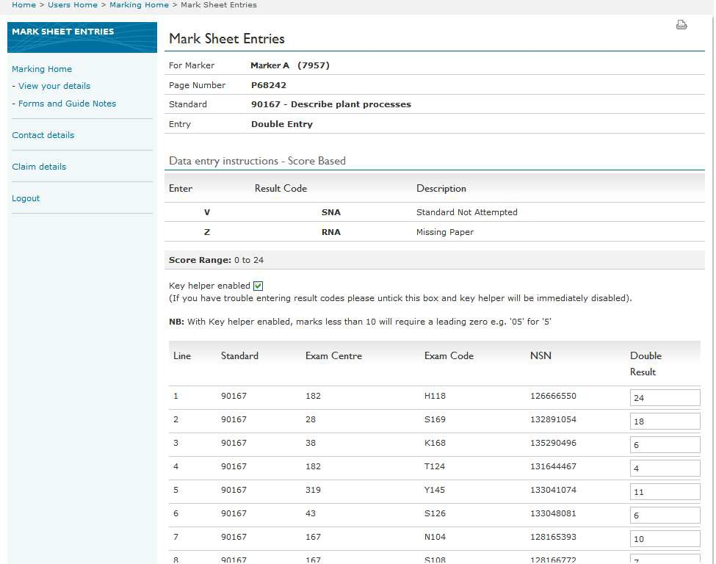Mark sheet entries page

Mismatch screen
The Mismatch screen shows any results that do not match. You must make a third and final decision about what the correct results should be. Enter the confirmed result and click Save. You will then return to the Marking Pages screen.

Late changes
Before the Final Submission button has been clicked, you are able to make late changes to results even if a page is shown as Complete. To make final changes to results, click on Complete under the Double Entry column, re-enter the results and click Save.

Final submission
The Final Submission button will appear on screen from 13 December when all your Marking Pages, including and Additional Pages, are completed.

Your panel leader will give approval to click the Final Submission button.

When you are certain no more edits are required, click the Final Submission button. You are asked to confirm, if you answer Yes, your entries are complete. The message ‘The final submission is now complete’. Pages can be viewed but not edited’ will appear. If you need to unlock the pages, call the Marker Helpline.

All results must either be entered online or recorded using a Supplementary Result Sheet/Change of Result Sheet and email to examinations@nzqa.govt.nz at the completion of marking or send the physical copy to Level 14, NZQA, PO Box 160, Wellington 6140. Keep a copy for your records.

20 December is the date for final submission of results for all examinations.

Portfolios requested by NZQA
Portfolios may be requested by NZQA in relation to possible breaches of examination rules. The message ‘NZQA requires the return of booklets’ will appear beside the Booklets returned to
NZQA link on your Marking Home page. This message will disappear once the requested portfolios have been checked off in the Booklets returned to NZQA screen.
You will be sent a letter and pre-paid courier bag to follow up this online request. If you receive this request, you must immediately complete the following steps:
- Find the portfolio in your allocation by using the Search for Candidate link.
- Mark it as usual.
- Enter the result online on your Marking Pages and record it on the Answer Booklet Control Sheet.
- Send the portfolio to NZQA using the pre-paid courier bag.
- If you have not yet received the portfolio, wait until the final week of marking and if it still has not arrived, complete the form at the bottom of the letter and return it in the pre-paid courier bag.

Search for Candidate
Use the Search for Candidate link to:
- locate a portfolio requested by NZQA
- transfer a result entry line from another marker’s allocation to your allocation to enter a result.

Locate a result entry line:
- click on Search for Candidate
- enter either the candidate’s NSN or both their Exam Centre Code and Exam Code
- select the relevant standard number from the drop-down list

- click on Search.
- If the candidate is found, you will see their entry on the Control Sheet Page.
- If the candidate is not found, there will be a notification message.
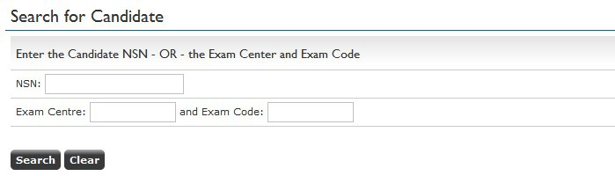

Transfer a result entry line to yourself:
- click on Search for Candidate
- enter either the candidate’s NSN or both their Exam Centre Code and Exam Code
- select the relevant standard number from the drop-down list
- click on Search. If the candidate is found, the details of the requested portfolio will appear
- 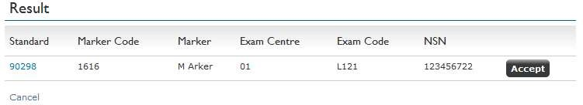click on Accept.

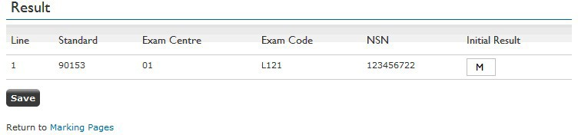The result entry line will be transferred (your name and marker code will appear) and you can add a result by clicking on Edit and then on Save.

When you transfer a result entry line from another marker to yourself a Supplementary Page will be created on your Marking Pages.

Additional portfolios transferred from other markers to you will appear on this Supplementary Page
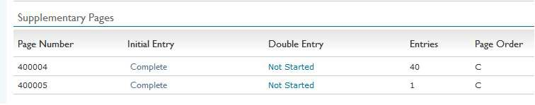until there are 40 result entry lines, when a new Supplementary Page will be created.

When you transfer a result entry line from another marker to yourself warning messages might appear.
- ‘Warning: forbidden learner’ or ‘Warning: forbidden provider’ mean the result entry line belongs to a specific candidate indicated as forbidden, or a candidate from a school indicated as a forbidden provider.
- Do not mark the portfolio.
- Send it to your panel leader who will reallocate the result entry line.

- ‘Reallocation failed: result code already present’ means a marker has already entered a result for this candidate for the same standard.
- Check that you have entered the NSN correctly.
- If you are still unable to transfer the result entry line, mark the portfolio as normal and email the result and the NSN to your NAF.
- Download and complete an Irregular Answer Booklet Form and include the other marker’s code, the candidate’s NSN, and the standard number.
- Send the form and portfolio to your NAF using a orange courier bag.
If you cannot find a result entry line on the Marking Pages after using Search for Candidate, wait until after 13 December when Additional Pages become visible. If there is still no result on the entry line, download and complete a Supplementary Result Sheet/Change of Result Sheet, copy it for your records, then email it to your NAF.

AFTER MARKING
Marker report
All markers are to write a Marker’s Report. An electronic version of the relevant section (Part B), Design and Visual Communication Template may be downloaded from the Marker Section of the website.
The report is in two parts: Part A: Marking Administration, and Part B: Assessment Report.

Part A: Marking Administration
NZQA wants to know:
- how successful the marking process was
- how successful the marking administration process was
- what should be improved for next time.

Part B: Assessment Report
This part requires you to comment about the evidence you observed which will explain the results and assist teachers to help candidates in following years.
For help with completing Part B please read, Writing Report Notes, which is available on the Forms for Markers page.
Email the completed Parts A and B to your panel leader as soon after marking as possible. These should arrive no later than Wednesday 18 December 2019.
Your panel leader will use each Marker Report to produce Part A and B of the Panel leader Report for NZQA.

Marking evaluation
Use the Marker Evaluation Form link to access and complete the evaluation form and then submit.

Final pick-up of portfolios
The panel leader will give approval for the courier collection of portfolios.

Preparation of cartons/bags
Before sending by courier:
- seal the cartons/bags
- double check that the Bluestar courier label covers the original label, on the cartons/bags
- ensure that the Customer Use label has been removed and placed on the Answer Booklet Control Sheet.
- telephone CourierPost on 0800 501 501 to arrange for collection on one of the dates below
- state that you require an NZQA DVC pick-up (large cartons) and give your address (someone will need to be present for the collection of the portfolios).

Courier arrangements
18 December is the preferred pick-up date of portfolios.
Same day bookings for: 16, 17, 18 and 27 December collections, book pick-ups before 12.00 pm for pick-up by 5.30 pm.

Advance bookings for: 19 and 23 December collections, book pick-ups before 12.00 pm on the day prior (working day), e.g., for Monday 23 December collection, book before
12.00 pm, Friday 20 December.

If you are going to drop off your cartons/bags at a CourierPost depot, please inform the Marker Helpline. You must not drop cartons/bags off at a Post Shop or Post Centre.

If your cartons/bags are not picked up by 23 December, you must arrange a pick-up before noon on 27 December for collection by 5.30 pm the same day.

Do not return split consignments. All your cartons of portfolios must be picked up by CourierPost or dropped off at CourierPost in one consignment.

Courier tracking
To track the courier consignments, complete the following steps:
- log on to www.courierpost.co.nz
- enter the consignment number (from the Sender Tracking Label portion of the courier ticket) in the Track & Trace field
- click on Trace Now, view the date and time of pick-up, the courier identification, and delivery status.
Please retain all tracking numbers used for check marking until February 2020.

Remaining Materials
Using the pre-addressed courier bag, send all Answer Booklet Control Sheets, spare assessment envelopes, unused courier bags and envelopes and Saturday Delivery stickers. Remember to retain the Customer Use label.

Do not return benchmark material. You may dispose of these at the end of February 2020.

Marker Claims
Payment for marking will be made under the terms of the marker’s contract.

Marker claims can be made online, and if correct by 17 January, will be paid by 1 March. You can print a copy of your claim from the NZQA website at any time. If a marker claim is not complete, payment may be delayed.

Any claims for postage, couriers, telephones, and meals must have a GST receipt.

NZQA is unable to pay for items that are classified as capital expenditure (e.g. filing cabinets and computers) or tax deductible (e.g. printer paper, cartridges, USB sticks, etc.).

Completing your claim online
Log in, go to Marking Home, and click on Claim Details (this button will appear towards the end of marking) and then on Start Claim.

If the contract drop-down list is not Panel Leader, Marker, or Check Marker, call the Marker Helpline.

If you have different marking roles on separate panels, for example, panel leader on one panel, marker on another, call the Marker Helpline before you make the second claim.

Enter your claim entitlements on the Payment Information page, as below.

Claim type
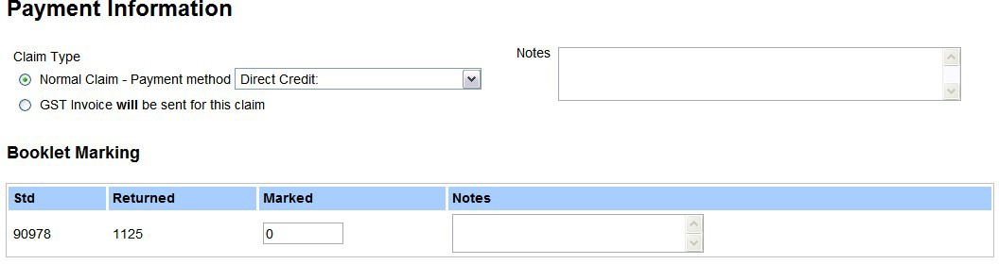If you are submitting a GST invoice for your services, select the GST Invoice option. Otherwise, leave the Normal Claim option selected and choose the payment method.

Booklet (portfolio) marking
If you marked more than one standard, there will be a line for each.

The Returned box will contain the number of portfolios for which you entered. Y and Z portfolios are not included.

If you were a senior marker, enter the number of portfolios you check marked in the Marked box, and include a comment in the Notes box.

Marking Fees
Tick the Marker Administration fee and Marking Incidentals boxes.
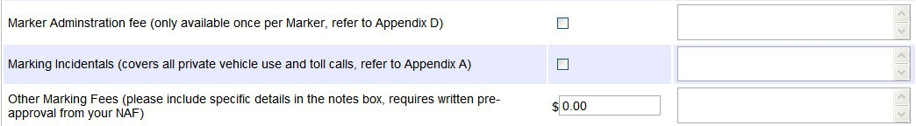

Claim summary
Click on Save. A summary of the claim will appear for you to check.

If you need to change any details, click on Edit Claim Information, make the changes, and click on
Save again.

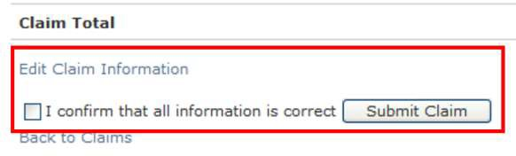Check the accuracy of all information to avoid delays in your claim being processed. When the claim is correct, tick the confirmation box, and then click on Submit Claim.

A confirmation message will appear. You
cannot edit the claim any further. If you need to change something, call the Marker Helpline.

If you have receipts to send, print out a copy of your completed claim form, attach the receipts and post to NZQA in an envelope from your Marker Pack.

Receipts must be itemized and include the GST number. EFTPOS receipts without a GST number will not be accepted. This might delay payment of your claim.

Tracking claims
To track your claim, log in and click on Claim Details. A message will appear which indicates the status of your claim.

The initial status will be Submitted, which changes to Approved, and then to Sent for Payment.

If NZQA requires additional information you will be contacted and the status will be On Hold. This might delay payment of your claim.

LEADING A PANEL
(Co-ordinating Panel leader, Panel leader and Check Marker)

Additional panel leader materials
In addition to the contents of the Marker’s Pack, Panel leaders will receive extra courier bags and labels and brown envelopes. These will be dispatched with the Marker’s Pack in October.

Marking timelines
The panel leader will need to:
- finalise the Marker’s daily marking quotas and cumulative totals on marking timeline. See
Appendix A
- determine Check Marking Dispatch Dates on Appendix A
- give a completed copy of Appendix A to the NAF at the benchmarking meeting
- Provide each marker with a copy of this timeline at the Panel Meeting.
This year the final date for submitting results is 20 December 2019.

Initial contact with markers
The panel leader will send a letter to all markers (including Check Markers) during October.

The letter will:
- emphasise that it is essential to attend all meetings, be on time and stay for the full duration.
This is not negotiable (if a marker cannot attend, then another marker will need to be contracted to replace them)
- give dates, times and venue for the Panel Meeting(s) and travel arrangements, if required
- include a list of materials that markers need to bring to the meetings, such as a laptop, achievement standards, specifications and red pens
- instruct markers to read the DVC Guide Notes and Instructions before the panel meeting(s). They will be available under the “Forms for Markers” section when they log on to their marker home page.
- stress the concept of assessment through a ‘single pair of eyes’
- emphasise that all work associated with the submission is strictly confidential and that markers must ensure the security of all portfolios in their possession
- give important deadlines, such as the dates that the check marking should be received.

The Senior Business Liaison Officer will send out a further letter to those who are travelling to the meeting venue from outside the region.

Benchmarking Meeting
Prior to this meeting, familiarise yourself with the assessment schedule for 2019.
Clear marking standards must be set at the Benchmarking Meeting.
If required, additional subject specific instructions and/or marking conventions will be finalised at this meeting.

Attendance
The attendees at the NCEA DVC Benchmarking Meetings will be the panel leader and the senior marker.

The aim of this meeting time is to:
- verify standards to confirm the assessment schedules
- select and photocopy portfolios and selected drawings from portfolios to be used as benchmarks
- establish marking benchmarks
- write notes of explanation on benchmarks to ensure the same interpretation and application is explained to all markers
- finalise Panel Meeting procedures and agendas
- confirm procedures and timelines for marking and check marking.

Unless otherwise arranged, the panel leader will be sent guinea pig portfolios prior to the benchmarking meeting.

Bench marked Portfolios
Bench marked portfolio (BM) selection and processing You should:
- select portfolios which will copy well
- NOT write on ANY original candidate portfolios
- NOT remove any material from portfolios.

Follow this procedure for ALL externally assessed standards:
NOTE: It is preferable for this material to be scanned and given out to each marker electronically by either providing them with a USB for them to download onto their computer, or providing each marker with a USB containing all the benchmark material.
- Sort (overall/holistic reaction) the portfolios into four piles for NCEA (N A M E).
- Check the assessment schedule against the portfolios to confirm sort decisions in 1 above.
- From your initial selection, select portfolios which typify each grade. Also select portfolios which are ‘border-line’. Label each portfolio with a BM identification number grade and position BM1N, BM2N/A, BM3A, BM4A/M, BM5M, BM6M/E, BM7E (although not in that number order).
- From your initial selection choose two other examples of each result. These must be labelled BMA, BMB, BMC, BMD etc. Some of these will be used at the Panel Meeting for group discussion. At least four of these will be set aside for markers to mark independently either at or after the Panel Meeting.
- Cover the label of each portfolio with a Post-it sticker to hide the name and NSN.
- Photocopy each labelled BM portfolio twice, initially. These become your master copies.
- Remove the Post-it stickers from the original portfolios and return them to the correct courier box.
- Send one marked set to your NAF by Monday 18 December 2019. Dropbox is acceptable.

- Where insufficient portfolios at a grade are available, or where portfolios are too large to be photocopied, you may assemble guinea pigs using specific material from a range of portfolios, including guinea pig material from earlier years. These portfolios should be labeled BMS1N, BMS2N/A, BMS3A, BMS4A/M, BMS5M, BMS6M/E, BMS7E (again change the order of these).
- You may also wish to photocopy specific portfolio drawings to exemplify specific aspects against the criteria. These are called “Selectives” and are usually labeled S1, S2, S3, etc.
Scanning and/or photocopying of benchmarks will be arranged at the meeting venue, at NZQA or by the panel leader. Scanned electronic copies can be given out to markers instead of hard copies.
Selected benchmarks must be ready to be distributed to markers at the Panel Meeting. You must provide the NAF with a complete set of labelled BMs before the end of the Bench-mark meeting. If additional BM are developed during marking, a complete, assessed and annotated set of guinea pig portfolios must be sent to your NAF by Monday 16 December 2019.
A set of the annotated exemplars (guinea pigs or benchmarks or other) will need to be submitted to the NAF at the end of the marking round (Dropbox is acceptable). The panel leader will need to provide brief notes (annotations) outlining the reasons that it gained a particular grade, and reasons why it did not gain the next higher grade.

Usually, only three annotated exemplars are required – a mid-level A, a mid-level M and an E. Others can be provided (e.g. different contexts, different modes – CAD vs hand drawn).

Other preparation
Go through subject-specific instructions and check marking timelines; ensure that there are enough photocopies for each marker, or electronic. Ensure each marker has sufficient copies of the assessment schedule to practice with (schedules photocopied on coloured paper is useful). The NAF can provide this.

It may be useful to have red pens, green pens, highlighters, paper clips, Post-it Notes, pencils, erasers, pre-prepared organisational forms, a laptop and printer/scanner if you have access to one.

Profile of Expected Performance (PEP)
DVC does NOT use the Grade Score Marking (GSM) system.
A Profile of Expected Performance (PEP) has been developed for each external standard. This profile of expected performances is based on past statistics, the professional expertise and advice of panel leaders and NZQA staff. The profiles give the upper and lower expected boundaries for Achievement, Merit and Excellence results for each standard expressed as a percentage. Profiles of expected performance provide a guide, not a target.

All panel leaders will be given their relevant PEPs at the benchmarking meeting, if not earlier.

The benchmarking process involves you and your senior marker(s) testing the assessment schedule against a sample of portfolios. This sample will be equivalent to one day’s marking (i.e. a collective 8 hours). This testing is to ensure the schedule is likely to produce results that are consistent with the PEP.

Because of this, you are required to consult with your NAF to discuss your findings.

Test marking
At the bench marking meeting and in the week that follows, senior markers should mark as many portfolios as possible. At least 10 portfolios per senior marker should be marked and submitted for check-marking before the Panel meeting.

Portfolios should be marked from bags selected randomly from their received allocation.

Data from the test marking should be entered initially, daily, so the Spread of Performance (SoP) can be established. No marker should double enter result data, until permission is given by the panel leader or NAF.

The Panel Meeting
The aim of the panel meeting is to set the standard, emphasise that marking must take place through ‘a single pair of eyes’ and to confirm administration arrangements.

The panel leader/senior marker run the panel meeting.

Agenda for the Panel Meeting:
- Welcome and introduction
Welcome and thank markers for joining the panel. Provide each marker with copies of the assessment schedule, a copy of the Panel marking timeline, GPs for assessment/discussion at the meeting and panel leader/senior marker contact information.

- The role of the marker
Outline the purpose of the meeting. Explain that all comments or discussions will be directed through you.

Stress the principle of assessment through a “single pair of eyes” (those of the panel leader) to achieve “between-marker consistency”. Explain that candidates should be neither advantaged nor disadvantaged by the marker they have been allocated.

Emphasise to markers that all work is confidential.

Explain that markers may have to modify some of their personal expectations and opinions to assess according to the assessment schedule and ensure consistency throughout the panel.

"Markers can have their say, but they may not necessarily have their way".

Remember: Markers are assessing at a national level, not at the classroom level.
The panel leader is responsible for ensuring that they and their markers maintain consistency during their marking, as well as confidentiality and security with all assessment material and assessment information.

- Instructions and procedures for Markers
Give clear instructions on the conventions that are to be followed in assessment. There MUST be consistency between markers, bearing in mind that all candidates can obtain their portfolio from their school and a certain amount of comparison is inevitable.
Stress the importance of following both general and achievement standard-specific instructions.
See Appendix I for a sample Assessment Schedule which shows some of the conventions of marking.

Using the Guide Notes Ask markers to:
- fill in the marking panel Contact Information
- confirm all addresses, telephone, including cell phone numbers and email addresses
- identify when it is best to phone for feedback from check marking
- only use blue courier bags to send and receive check marking
- leave at least four blue courier bags with the senior marker so they can return check marked portfolios to you. The check marker will be provided with printed address stickers to use.

Ensure markers have:
- a marking timeline
- an identified start page, to ensure that portfolios from across the country are marked early.

Review Marking Materials:
- inform markers of what they should have received.
- instruct markers to contact the marker helpline 0800 222 230 if materials are missing.

Ensure Markers understand the following sections:
- Receiving portfolios
- Marking Practices *
- Assessment Decisions *
- Portfolio Management *
- Pick up of Portfolios
- Check Marking
- Entering NCEA Results
- Marker’s Report
- Marker Claims.

- Go through the assessment schedule
Introduce the assessment schedule carefully so that markers understand how each standard has been interpreted and what evidence is required for judgement.

Also tell markers NOT to underline/slash the top boxes which house the criteria of the standard.

Instruct markers that they must ALWAYS refer to the assessment schedule and regularly review their application of the schedule referring to the bench marked portfolios, advice from the check marker and against the achievement standard.

Remind markers again that they may have to be detached from their personal feelings on some issues, and how they think their own students may have presented material.

- Assess bench marked portfolios
Allow time to assess the bench marked portfolios (BM1, BM2, BM3, etc.) and then compare results. Use a whiteboard or grid to compare results. An analysis of how each standard was assessed soon shows up areas of inconsistency that can be discussed and addressed. Get markers to call out their results so a discussion can be had about the grade awarded.

- Assess BMA, BMB, BMC and BMD, etc.
These are the first bench marked portfolios that are marked independently by the senior marking team. Ask markers to assess these. You will check assess marker results and provide feedback. Ensure that all markers understand the schedule and interpretations.

- Check marking
Advise markers of the check marker submission dates. Ask markers to send up to 20 consecutive portfolios for check marking and explain that you will check mark as many portfolios as necessary to determine that they are consistently applying the assessment schedule.

Markers can also submit extra portfolios to the check marker, if the portfolio highlights issues that the marker has found difficult to make judgements on.

- Farewell
Ensure everyone leaves the meeting(s) feeling positive, encouraged and clear on the arrangements for marking.

Emphasise the professional development that the process provides. The marking process can be a bit daunting, but remind everyone that you are available for phone calls throughout the marking period. You might like to tell them the best time to call.

Emphasise the importance of starting immediately and sticking to the timeline.

Monitoring Performance
During marking you are required to monitor trends in candidate performance and keep your NAF informed of these. The NAF will be using a range of research and data tools to ensure that results are within expected boundaries.

Throughout marking there will be a process in place for you and the NAF to monitor the results daily to ensure they are within expectations. The monitoring requires all markers to enter their first 30 results as soon as possible. Double entry MUST NOT take place at this stage.

To ensure appropriate sampling occurs, each marker should begin their assessment in a different part of the country by starting on a different result page AND continuing from this page.

Initial results must be entered as soon as possible after the marking is carried out.

After the panel Marker Meeting(s) the first check mark should occur within the first week of marking.

It is important that you factor the results of the check assessment into the overview you have of the results as you complete the check marking. You and your NAF will then check the results and discuss the outcome before further marking occurs.

Spread of Performance
To access the Spread of Performance (SOP) shown below, you will need to select the SOP button at the top of your Panel details page on the web.

Spread of Performance for 91339 2017
Level of Performance | Candidates | SoP % | PEP (Range) %
E | 56 | 10.3 | (7 - 13)
M | 117 | 21.5 | (19 - 25)
A | 242 | 44.5 | (40 - 46)
N | 129 | 23.7 | (22 - 30)
V | 214
Y | 59
Z | 4
Results captured | 821
Total entries 1659
Percentage of entries with results in this view: 49.5%

Remember, the PEP ranges for N A M E are guidelines, not absolute targets. If a SOP value is outside the PEP range, it is up to the panel leader to give possible reasons for this occurring.
Possible reasons could be professional development, drop in cohort size or bad karma (not really).

Check Marking
Check marking is done to ensure that the marker is consistently applying the assessment schedule.

Check Marking Procedures
- use a green pen only to check mark
- check marking should begin immediately after marking starts
- check mark the senior marker first
- check marking must take priority over the marking of one’s allocated portfolios
- underline on the schedule as if marking for the first time (see Appendix I)
- sign/initial beside the marker’s final grade to indicate that you have check marked the material
- a result should only be overruled if the marker has misinterpreted or not adhered to the assessment schedule
- where a result is overruled, write the new result (in green) on the assessment envelope and sign/initial it
- use the check marking sheet provided (see Appendix C) to record check marking decisions and comments on each marker’s decisions
- refer to these sheets when reporting on marker performance in Part A of the PL Report
- markers send consecutive portfolios for check marking as specified in the marker timeline
- you may check mark as many portfolios as necessary to determine that a marker is consistently applying the assessment schedule
- approximately 8% of each marker’s portfolios should be check marked – some markers may require more check marking – discuss with the NAF
- when preparing your timeline for markers (Appendix A), use the following as a guide:

Batch | From | Send | Number to be check marked
1 | Up to the first 30 portfolios assessed | 20 consecutive | minimum 8
2 | Between 30 and 60 portfolios | 20 consecutive | minimum 8
3 | Between 60 and 100 portfolios | 20 consecutive | minimum 8
4 | Between 100 and 200 portfolios | 10 - 15 consecutive | Discretion of check marker

Check marking Feedback to Markers:
- pre-arrange a time to make contact for feedback by phone or mobile
- feedback to markers immediately after each batch of check marking has been completed
- phone all markers even if there are no apparent problems
- have on hand the portfolios that have been check marked
- tick off comments on the check markers record form as they are made
- start with positive comments
- identify areas where there are problems and give advice and strategies on how to improve reliability of assessment
- instruct them to check all portfolios they have marked since the last check marking and if necessary make adjustments
- ask them how many portfolios they have assessed (i.e. keep checking their progress against deadlines)
- return all portfolios used for check marking to the allocated Marker in the blue courier bag immediately after feedback has been given. Reuse the bag the portfolios were sent in – place marker’s address sticker over the previous one and attach a new CourierPost label
If a marker is not marking to a satisfactory standard, you should discuss the situation with the marker. Strategies may be developed to improve the marker’s skills, taking into consideration the time constraints of the assessment cycle. You may find it useful to assess some portfolios with the marker to give further assistance. You should discuss your concerns with the NAF at this point.

Further samples should be taken for check marking. This sampling must continue until you are satisfied that they are marking to an acceptable standard. Talk to the NAF first.

Markers will be required to enter results daily throughout marking so a current view of results is maintained throughout the marking process and checked at regular intervals by the panel leader and NAF.

Re-marking
Re-marking occurs when there is evidence that the assessment schedule has not been interpreted or applied fairly during marking.

As the assessment schedule is a fixed, if a change is needed in how to interpret the assessment schedule, then all portfolios will need to be re-visited.
Any re-marking undertaken after 20 December will require extra remuneration of all portfolios, fully or partially re-marked, and will require an extension of your contract.
ONLY the Manager of Secondary Examination can grant this.

If, after, sufficient marking has been completed, the spread of performance lies outside the expectations, the panel leader will need to provide the NAF with an explanation of why this may

have occurred. A completed check-list of possible factors must support this explanation, including whether:
- this is a new standard or a new version with significant difference which justify the change in results distribution
- there is evidence of a significant change or difference in the cohort, that may be indicated by a change in the entry numbers; entry numbers between standards at the same level may also vary considerably within the same year
- there is evidence of a change in the level of performance of the cohort – for example, comments made in the previous Assessment Report have obviously been taken on board
- intervention strategies have been undertaken by the sector to address issues specifically related to assessment of this achievement standard? For example, there may have been significant professional development undertaken by the Subject Association.

The panel leader report may include these comments, and they may be subsequently included as part of the Assessment Report published in April.

To cover the highly unlikely event that the final results are unjustifiably outside the PEP parameters, there is a possibility that all portfolios will need to be re-marked. It is likely the need for such work would be known sufficiently in advance of Christmas, for the work to be completed by this time. In the extremely unlikely event that is cannot be completed before Christmas, markers may be asked about their availability to re-mark portfolios in January, should this be required.

Reallocating Portfolios
If, after providing assistance, you are still not satisfied that the marker is assessing consistently and to the required standard, you must contact your NAF. Do not reallocate any portfolios until your NAF has discussed the situation with you. If necessary, the NAF will relieve the marker of further responsibilities. All their allocation of portfolios, including those already assessed, will need to be reallocated to other markers. In the end, the interests of the candidates must be paramount.

Portfolios may also have to be reallocated because a marker will be unable to finish on time due to illness or slow marking. Act immediately, by contacting your NAF, and if reallocation is not an option, then you or your check marker will have to assess extra portfolios.

If reallocation is required, contact your Senior Business Liaison Officer (copy the NAF) immediately and provide them with the following information:
- The level and standard being assessed, e.g. L2 91337
- The marker code and name of the marker whose portfolios are being reallocated.
- The marker code and name of the marker(s) who is/are receiving the reallocated portfolios.
- The page number(s) of the Marking Pages which correspond with the portfolios which are being reallocated.
- If more than one marker is receiving reallocated portfolios please ensure you provide details of which page numbers are being reallocated to each marker.
- The reason for the reallocation of portfolios.

If a marker is being relieved of marking duties due to inconsistent assessment, all their portfolios need to be reallocated. This includes those already marked which must be remarked.

The marker who is receiving the reallocated portfolios will be informed, via their ‘Home Page’ on the web that portfolios have been reallocated to them. They will then have access to web pages which correspond to the reallocated portfolios they have received, and will be able to continue entering their results via the web.

The marker who is having their portfolios reallocated to another marker will also be informed via their ‘Home Page’ on the web when the reallocation has taken place. As panel leader, you should also be notified once reallocations have been made.

Appendix J gives instructions for reallocating portfolios. Only use this option if there are a small number of portfolios to reallocate (e.g. you receive 3 portfolios for another marker, within your own allocation), but NOT if many portfolios need to be reallocated (e.g. portfolios of a relieved marker). Follow the instructions above for this scenario.

Panel leader report
A panel leader report template can be found on the ‘Forms for Panel Leaders’ section.

Panel leaders should ensure all markers have completed and sent to them a Marker Report by 20 December. This should be done electronically.

You may prefer to collate the Marker Reports as soon as they are received and while details of the marking are still fresh, write your panel leader report. If you wish to dispatch your reports to NZQA before Christmas, advise your markers accordingly.

For each of Parts A and B, collate marker opinions from the Marker Reports and complete the panel leader Report template as a report for the standard. Part A will be retained by NZQA. Part B will be used to produce a published version on the web in April 2020.

For help with completing Part B of the template refer to the booklet ‘Writing Reports’ which will be online on the forms for markers page. Please follow these notes carefully.

Panel leader reports should be completed electronically and emailed to NZQA at examinations@nzqa.govt.nz, by Friday 10 January 2020.

Please attach each marker’s completed Appendix C sheets to their Marker Report form. Send the Marker Report forms to the Senior Business Liaison Officer by Friday 10 January 2020.

Reviews and Reconsiderations
Candidates may send their portfolios to NZQA to have:
- the accuracy of result transfers checked (review), or
- a complete reassessment (reconsideration).

In cases where obvious transfer errors have occurred, NZQA staff will make the changes (review) in February. Panel leaders may be contacted to help resolve some reviews where necessary.

Candidates who have paid for reconsideration will send their portfolios to the Authority in February. These will be processed and sent to the panel leader (or a senior marker), in batches, during February and March. Please completely remark each portfolio using a black pen. You may allocate some, or all, to your senior marker if you wish.

Review Meeting
If a review meeting is called by the NAF, this will involve panel leader(s) and check marker(s), who are responsible for writing the assessment report. Review meetings will be held mid-year following marking. The purpose of this meeting is to review the previous year’s marking processes and outcomes.

The review meeting will include an opportunity to review patterns of performance evident in the results. Justifications of results which fell outside the PEP will be considered.

The following documents will be provided before or at the Review Meeting:
- either the Panel Leader Report for each externally assessed achievement standard at your subject level or the completed Assessment Report
- the Profile of Expected Performance (PEP) and Spread of Performance (SOP) for each standard
Teacher and Candidate survey data collected by NZQA (if your subject was surveyed).

THANK YOU FOR YOUR HARD WORK, YOUR EFFORTS ARE APPRECIATED!

APPENDICES

Appendix A: Planning Sheet for Marking Timelines
(for panel leader use—completed copies to be given to markers)

Day | Date | Daily  Marking Quota | Cumulative Total | Check Marking Dispatch Dates
Portfolios received
Marker Training Meeting(s)
Start page number
1. | 15 Nov. | 10 | 10
2. | 16 Nov. | 10 | 20
3. | 17 Nov. | 15 | 35
4. | 18 Nov. | 15 | 50
5. | 19 Nov. | 10 | 60
6. | 20 Nov. | 20 | 80
7. | 21 Nov. | 20 | 100
8. | 22 Nov. | 30 | 130
9.
10.
11.
12.
13.
14.
15.
16.
17.
18.
19.
20.

Panel leader needs to give a completed copy of this page to their NAF at the benchmarking meeting.

Appendix B: Portfolios Sent for Check Marking Form

Use this form to record and track portfolios sent for check marking.
Marker Code: |  |  |  | Check Marker Name:
NSN | Date Sent | Date Returned |  | Marker Grades | CM Grades | Attach courier customer sticker here
 |  |  |  |  |  | Comments

Appendix C: Check Marking Summary Form
(for panel leader use — modify as required. Attach each marker’s copies to their Marker’s Report at the end of marking and mail to NZQA by 10 January 2020).

2019 NCEA Check Marker Form
Subject: DVC Level: (circle) 1 2 3 AS Number: (circle) 91063 91064 91065 91337 91338 91339 91627 91631

Page Number:
School/Candidate Code (NSN) |  |  | Comments1
School/Candidate Code (NSN) | M | CM

1 Comment on marker performance: | Marking Standard | (Hard, Accurate, Generous)
 | Consistency | (Consistent, Sometimes variable, Erratic)
 | Mechanical processes | (Accurate, Some errors, Frequent errors)

Appendix D: Marker’s Check List
(for personal use)

✓
Have you …
Read these Guide Notes?
Noted the return of results date for your level?
Confirmed your pick-up address on the web (by early December 2019)?
Checked your access to the web prior to results entry?
Checked the receipt of portfolios against the Answer Booklet Control Sheets (ABCS)?
Returned any incorrectly delivered boxes.
Assessed all work.
Place all hand-written assessment envelopes into a small pre-labelled courier bag to send back to NZQA.
Removed all Post-it stickers from portfolios?
Placed candidate portfolios into courier boxes with Bluestar return address?
Recorded all results on the ABCS.
Attached the Return Customer Tab to the ABCS.
Double entered all results.
Returned all ABCS to NZQA in the small courier bag.
Retained the Customer Tab for the ABCS return courier bag.
Returned all unused materials to NZQA?
Sent your Marker Report form to your Panel leader (by 20 December 2019)?
Completed your claim form (by 10 January 2020)?

Appendix E: Panel Leader Check List

At the Benchmarking Meeting | ✓
Have you …
Photocopied/scanned (or have photocopied for you):
□ benchmark portfolios?
□ Assessment envelopes on coloured sheets?
□ timelines?
At the Panel Meeting/Marker Training | ✓
Have you …
□ issued necessary panel contact details to markers?
□ provided markers with a completed copy of Appendix A (or own version)?
□ explained the use of ABCS and how they must be returned to NZQA?
□ emphasised/explained the process for the completion of the Marker Report?
□ asked markers to provide you with at least four blue CourierPost bags for return of check marking?
□ explained daily entry of results and keeping a tally of results to markers?
□ emphasised that markers should wait for feedback on a batch of check-marking before double entering results?
Remind markers: | ✓
□ that all marking must be carried out in a secure environment.
□ to check off portfolios on the ABCS prior to marking.
□ to process all incorrectly delivered portfolios as soon as possible.
□ to finalise their pickup address by early December 2019.
□ of the results completion date, 20 December 2019.
□ to notify you immediately if any problems occur with their marking.
□ that you must receive their Marker Report by 20 December 2019 (or earlier).
After marking | ✓
Have you …
□ emailed a copy of the schedule and posted a full set of marked benchmark portfolios to your NAF by 20 December 2019?
□ completed the Panel Leader Report form electronically and emailed this to NZQA (by 10 January 2020)?
□ attached each marker’s Appendix C sheets to their Marker Report form and posted/emailed these to your NAF by 10 January 2020?
□ sent your claim form to NZQA by 10 January 2020?

Appendix F: Authenticity Statement Check Sheet

Authenticity Statement Check Sheet
Marker Code:
School Number | NSNs

Appendix G: Excess Portfolio Material Sheet or Submissions in Clear Files
SCHOOLS THAT EXCEED THE RECOMMENDED PORTFOLIO SUBMISSION GUIDE
Marker Code:

Name:

Portfolio page guideline:

Level 1: 91063 = 15 pages; 91064 = 5 pages; 91065 = 4 pages.

Level 2: 91337 = 15 pages; 91338 = 7 pages; 91339 = 5 pages.

Level 3: 91627 = 35 pages; 91631 = 15 pages.

Please identify schools where the submission was in excess of the guidelines for most students.

School | Code | Comment

All markers must return this form to: Sue Henry (susan.henry@nzqa.govt.nz)
National Assessment Facilitator (DVC) NZQA
PO BOX 160
Wellington 6140

Appendix H: Instructions for Reallocating Portfolios Electronically
Overview:
The following is the procedure to follow when transferring portfolios between markers on a panel. This procedure will only be required if you receive a portfolio which has not been allocated to you. This might happen because a portfolio has been put into the wrong bag when being packed.

1. | Log into the Marking Home page. | 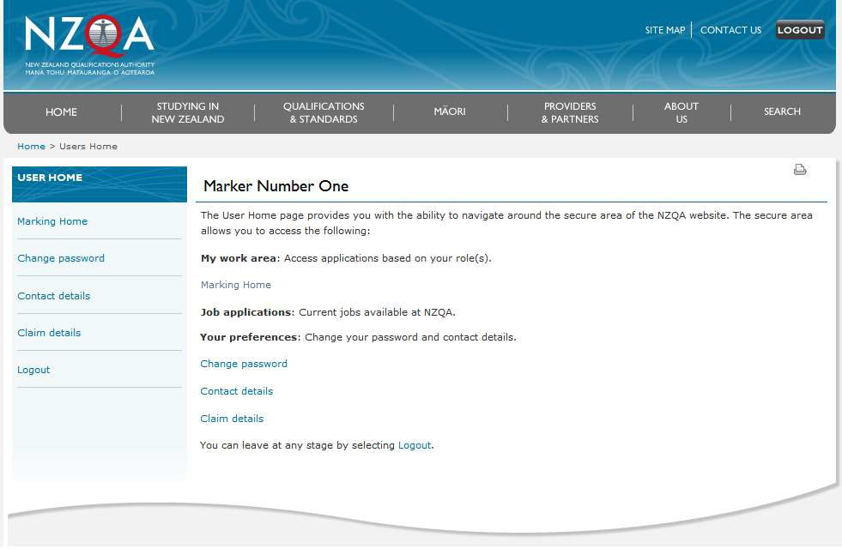
2. | Navigate to the ‘Results Page’ for the specific marker code.  Click on the ‘Search for Candidate’ function.   Note– A search for a candidate who is currently allocated to you will show in the search results an ‘Edit’ button. If you select this then an initial result can be entered though the presented result entry screen. | 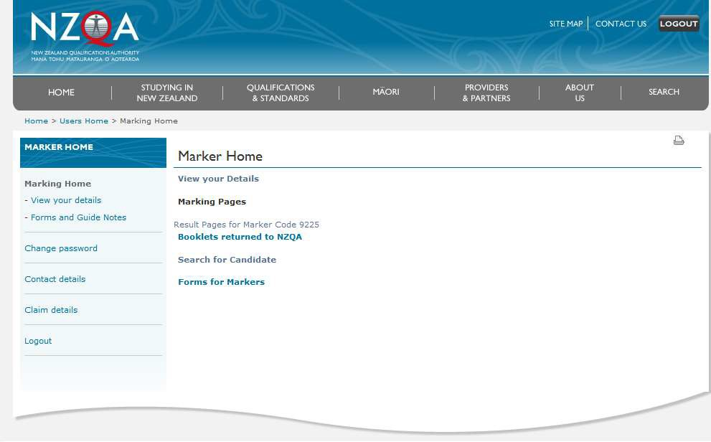

3. | Enter the NSN into the search field.  The system shows the search results and the details of the associated standards for the learner and who these are currently allocated to.
 | Select the ‘Accept' button for each standard where it is displayed to the right.
 |  | Marker Number Two
 |  | Marker Number Two
4. | The system will prompt you to consider if you truly want to accept the allocation from another marker to yourself.  If you wish to accept the allocation select the ‘Yes, Accept’ button and the screen now redisplays the details of the standard and who it is NOW allocated to. | 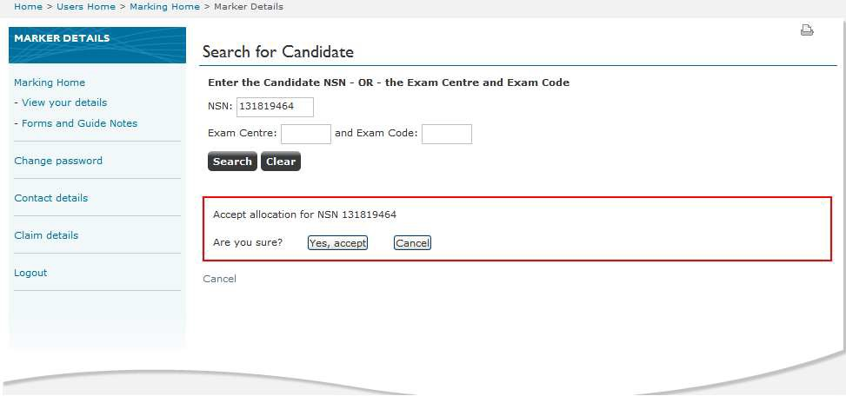
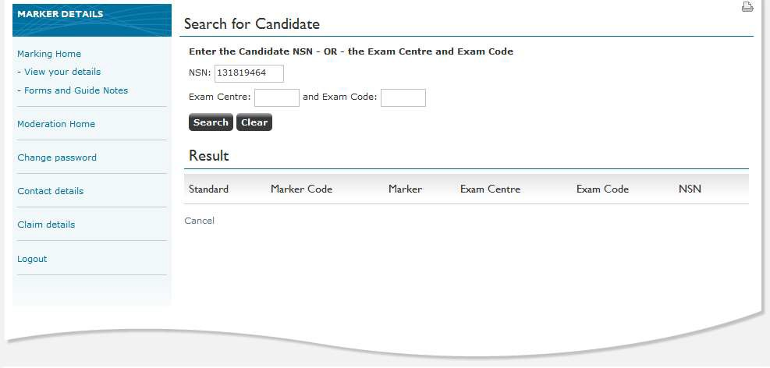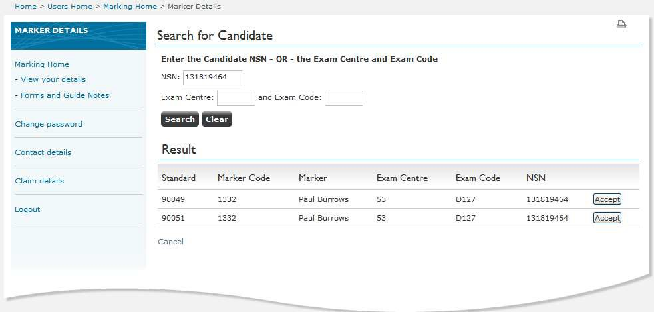

5. | Repeat steps 3-5 and accept the remaining standards displayed.  When all NSNs are accepted, or any time during the process, select the ‘Cancel’ option to return to the mark pages. | 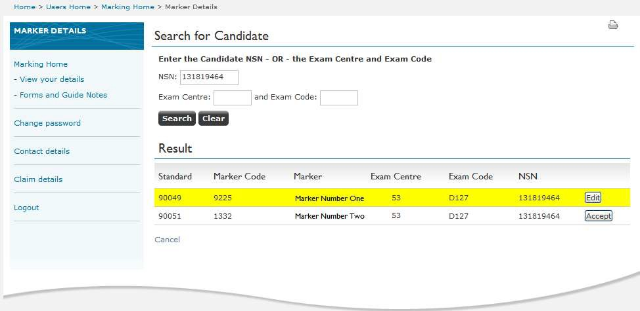
6. | Here you will see a new section called Supplementary Pages including the re- allocated standards. | 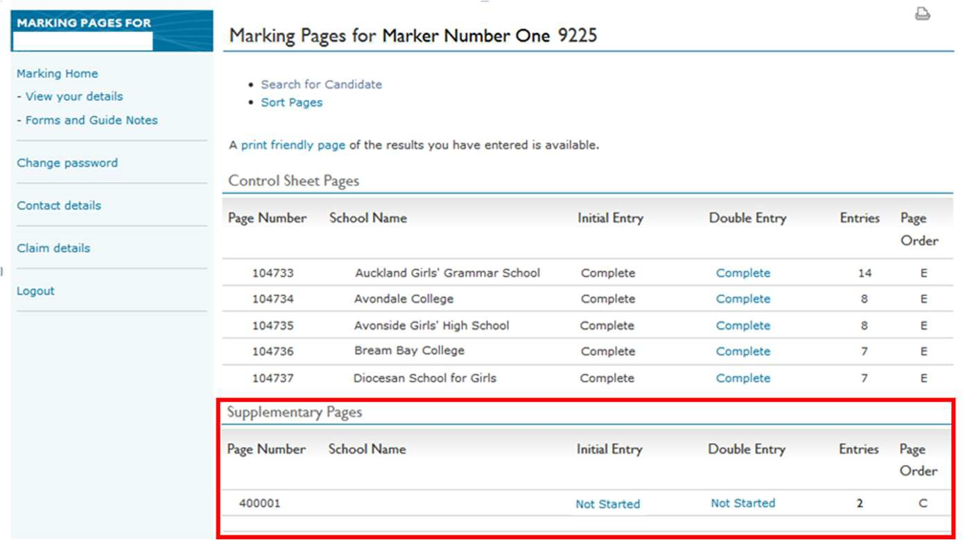
7. | At the accept stage there is an option to enter the initial result via the Edit button and you can enter an Initial result if required.  Note: Performing this action will require you to return to the ‘Candidate Search’ to re-allocate the remaining standards for the NSN. | 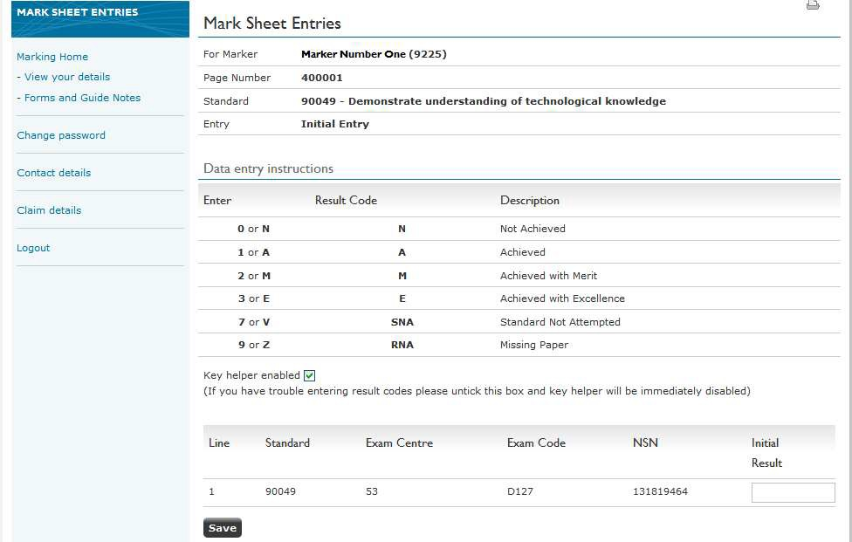

Marker search and re-allocation warnings
- No Matching Results Error
This section sets out the possible errors scenarios that might occur when searching on a NSN where there is none in the system.
Steps:
  - The Marker the accesses the candidate search page.
  - The Marker enters an NSN for which they are not capable of marking according to the system.
  - The Search Page notifies the Marker that there are no records for this NSN.
  - 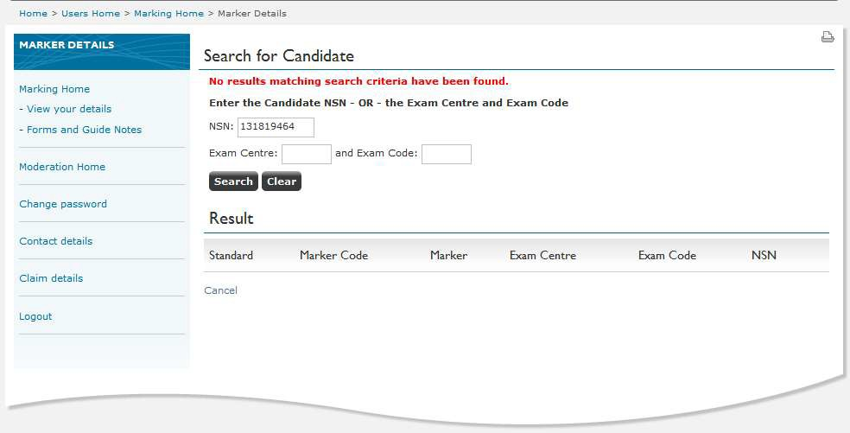Double check the NSN entry to ensure that the NSN entered is correct. If the NSN is entered correctly and you continue to receive the error message contact NZQA.

Screen shot example: Candidate Search page – No matching results.

- Result Already Present Error
This section sets out the possible errors scenarios that might occur when searching on a NSN and there is already a result entered.
  - The Marker accesses the candidate search page.
  - The Marker enters an NSN and selects the ‘Search
  - The system displays the results and the marker selects ‘Accept’ button for a standard.
The Search Page notifies the Marker that the portfolio cannot be re-allocated because there is already a result associated with it.

Screen shot example: Candidate Search page – Result Already Entered.

Note– If there is currently a result entered for the NSN then contact NZQA. Contact NZQA.
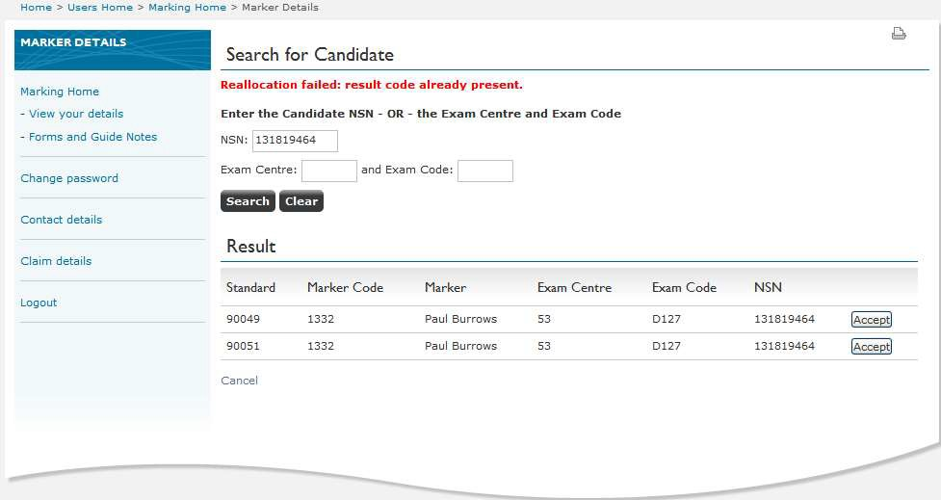

- Forbidden Provider warning message.

This section sets out the possible errors scenarios that might occur when searching on a NSN and there is already a result entered.
  - The Marker the accesses the candidate search page.
  - The Marker enters an NSN and selects the ‘Search’ button.
The Search Page notifies the Marker that the portfolio cannot be re-allocated because there is a forbidden provider association with the marker.

Screen shot example: Candidate Search page
– Forbidden Provider.

Note– This is a warning only and will not stop the Re-allocation occurring.
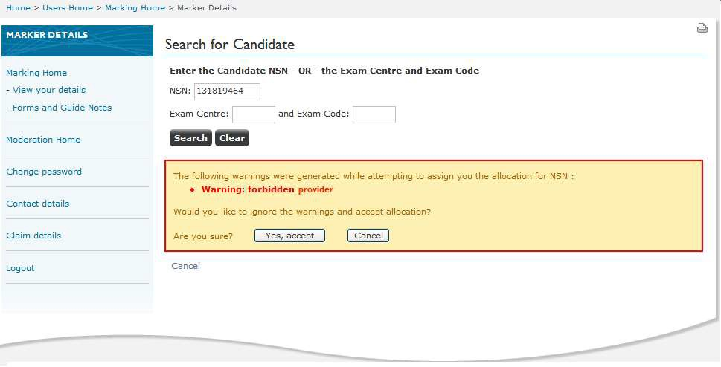

- Forbidden Learner warning message.

This section sets out the possible errors scenarios that might occur when searching on a NSN and there is already a result entered.
  - The Marker the accesses the candidate search page.
  - The Marker enters an NSN and selects the ‘Search’ button.
The Search Page notifies the Marker that the portfolio cannot be re-allocated because there is a forbidden learner association with the marker.
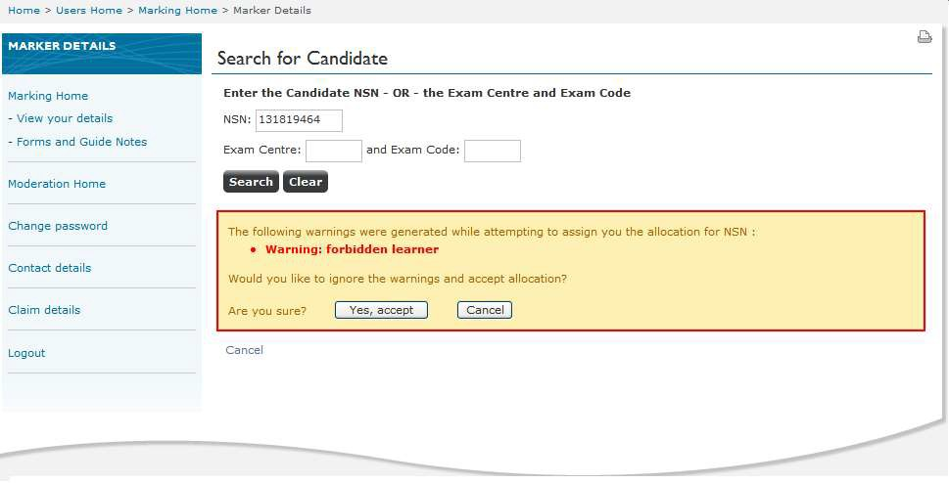

Screen shot example: Candidate Search page – Forbidden Provider.

For further information contact the Senior Business Liaison Officer on 0800 222 230 or examinations@nzqa.govt.nz.

