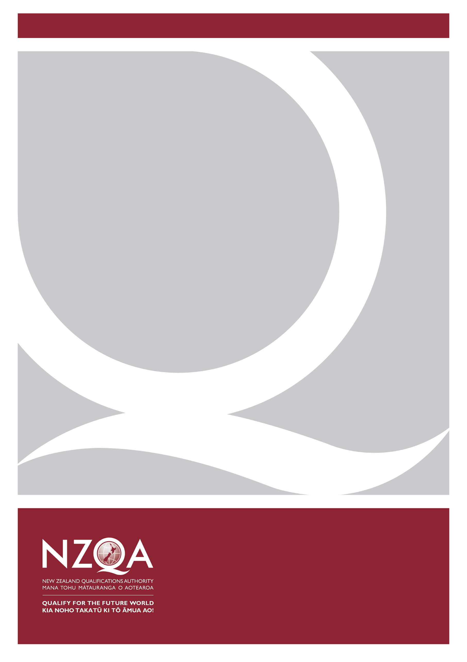
Consultation on draft Principles of Assessment and Aromatawai

April 2021

NZQA
125 The Terrace
PO Box 160
Wellington

Contents
Hei Tīmatanga | Introduction 4
Te kōrero tāhuhu | Background 4
Te take | Rationale 4
Assessment and aromatawai 4
Hei whakahoki kōrero mai | Request for feedback 5
How you can respond to the proposals in this document 5
Appendix 1 – Draft principles 6
Appendix 2 - Survey 17

Hei Tīmatanga | Introduction
Te manu ka kai i te miro, nōna te ngahere
Te manu ka kai i te mātauranga, nōna te ao

NZQA is refreshing the assessment statement and principles that articulate, for all secondary and tertiary providers and assessors, NZQA’s position on high quality assessment.
NZQA is engaging with the education sector on these Principles of Assessment and Aromatawai.
Input from you and your organisation will be invaluable to completing this work.
The development of these principles is the first phase of a larger project to support quality assessment practice:
Phase One: draft assessment principles
Phase Two: develop guidance documents By February 2022
Phase Three: develop contextualised resources. By July 2022

Te kōrero tāhuhu | Background
There is a high demand for guidance about quality assessment practice. NZQA is increasingly being asked to articulate and exemplify to providers what good and/or innovative assessment practice looks like.
NZQA’s assessment position is currently articulated in the publication Learning and Assessment: A guide to assessment for the National Qualifications Framework. Learning and Assessment was first published by NZQA in 1996. The most recent edition was published in 2001 and retains the text of the original. It no longer reflects the NZQF or the pervasiveness of digital media in education and training. There is no reference to Te Ao Māori or the knowledge and perspectives of Pacific peoples.

Te take | Rationale
NZQA’s vision is for learners to ‘Qualify for the future world: Kia noho takatū ki tō āmua ao’.
These Principles of Assessment and Aromatawai are designed to reflect New Zealand’s changing qualification landscape. The draft principles respond to the impact of digital technologies on assessment practices; the power of cultural and local learning contexts; emerging findings of research; and the implications of the partnership of Crown and Iwi in Aotearoa for assessment and qualifications outcomes.
The Principles of Assessment and Aromatawai will, with supporting materials, act as an overarching guide for quality assessment.

Assessment and Aromatawai
The Principles of Assessment and Aromatawai are underpinned by the six dynamic and interconnected kaupapa that are at the heart of Te Hono o Te Kahurangi, a whare ako framework used by NZQA to carry out the quality assurance of mātauranga Māori.
It is envisaged that the values and features of aromatawai will enrich and inform assessment design and be appropriate for all ākonga (learners).

Hei whakahoki kōrero mai | Request for feedback
Please read the draft Principles of Assessment and Aromatawai in Appendix 1 and complete the feedback survey in Appendix 2.
Following consideration of stakeholder feedback, NZQA will seek approval from its Board to publish the principles.
If you have any questions, need more information or would like a face-to-face meeting, please contact us at assessmentandaromatawai@nzqa.govt.nz
Submissions close Friday 28 May 2021.

How you can respond to the proposals in this document
You can provide your views on the proposals in this document by emailing the survey form in Appendix 2 to assessmentandaromatawai@nzqa.govt.nz by Friday 28 May 2021.
If you have any questions, need more information or would like to provide your feedback in another form, please contact us on the above email address.

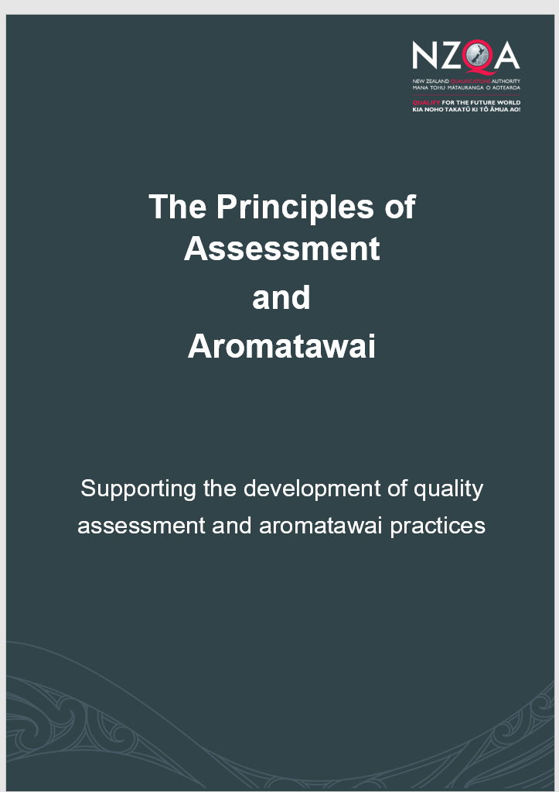
Appendix 1 – Draft principles

Introduction
Tēnei au, tēnei au, te hōkai nei o taku tapuwae, ko te hōkai-nuku, ko te hōkai-rangi, ko te hōkai o to tipuna a Tāne-nui-ā-rangi. I pikitia ai ngā Rangi-tuhaha i Tihi-o-manono, i rokohina atu rā ko Io-Matua-Kore anake. I riro iho ai ngā Kete o te Wānanga, ko te Kete Tuauri, ko te Kete Tuatea, ko te Kete Aronui. Ka tiritiria, ka poupoua ki a Papatuanuku. Ka puta te Ira-tangata, ki te whai-ao, ki te Ao-mārama! Tihei mauri ora!
Here am I, here am I, here am I swiftly moving by, the power of my karakia for swift movement. Swiftly moving over the earth. Swiftly moving through the heavens, the swift movement of your ancestor, Tane-nui-a-rangi, who climbed up, to the isolated realms, to the summit of Manono, and there found, Io-the-Parentless alone. He brought back down the Baskets of Knowledge, the Basket called Tuauri, the Basket called Tuatea, the Basket called Aronui. Portioned out, planted in Mother Earth, the life principle of humankind, comes forth into the dawn, into the world of light. I sneeze, there is life!
NZQA’s primary role is to ensure that New Zealand qualifications are accepted as credible and robust both nationally and internationally. This assessment and aromatawai work supports NZQA’s:
- Statement of Intent: equity of access and outcomes; flexible and future focused; working in collaboration with learners and the sector
- Oversight of the New Zealand Qualifications Framework
- Regulatory role
- Commitment to supporting educational assessment that meets the needs of all ākonga in New Zealand
- Commitment to Te Tiriti o Waitangi and te reo
- Response to the changing assessment and qualifications landscape nationally and globally
- Commitment to ensuring the validity of all assessment and aromatawai practices.
NZQA is committed to assuring credible assessment of learning that meets the education needs of all ākonga (learners) in our communities
The intent of these Principles is to provide guidance and support to kaiako and assessors for the development of quality assessment and aromatawai practices.
They will:
- support the education sector in quality assessment design and aromatawai practices, and
- strengthen a sector wide understanding of aromatawai, a teaching, learning and assessment approach that is underpinned by mātauranga Māori.
This document constitutes the first phase of a larger assessment project.
The following phases will be:
- Phase Two - develop guidance documents
- Phase Three - develop contextualised resources
NZQA’s Role
The purpose of assessment and aromatawai

The overarching purpose of assessment and aromatawai should be to validate, promote, and measure learning; irrespective of ākonga ethnicity, gender, religion, socio-economic status or disability.
Assessment and aromatawai evidence contributes to:
- Informing the teaching and learning process
- Quality assurance and accountability
- Credentialing.
Assessment and aromatawai are integral to all teaching practices and learning outcomes. They evaluate skills and knowledge acquired, providing ākonga with accurate, fair and valuable judgments to inform further learning.
Within the learning context, assessment and aromatawai focus on ākonga; what they can do, their learning journey, experiences and relationships.
Through assessment and aromatawai Kaiako (teacher) knowledge and understanding of an ākonga is used to inform teaching practices to support and guide their learning.
Understanding more about aromatawai
Aromatawai is a teaching, learning and assessment approach which is based on Māori values, beliefs and aspirations. It is envisaged that the values and features of aromatawai will enrich and inform assessment design and will be appropriate for all ākonga.
The term aromatawai is derived from two words that convey its special nature, that is, its role in learning and teaching. ARO is ‘to take notice of’ or ‘pay attention to’ and MATAWAI is ‘to examine closely’.
Rukuhia Rarangahia (2014) contextualises eight positions of aromatawai:
- Aromatawai emanates from ako.
- Aromatawai is focused on learners as learners.
- Aromatawai is focused on teacher competence and confidence.
- Aromatawai is focused on teacher inclinations and dispositions.
- Aromatawai is authentic.
- Aromatawai captures tamaiti, whānau, hapū and community voice.
- Aromatawai captures ākonga potential and talent.
- Aromatawai informs planning and required targeted assistance.
Ministry of Education. Rukuhia Rarangahia Ministry of Education Position Paper: Aromatawai (2014). http://tmoa.tki.org.nz/content/download/2207/16897/file/RUKUHIA%20RARANGAHIA-WEB.pdf
The six underpinning kaupapa
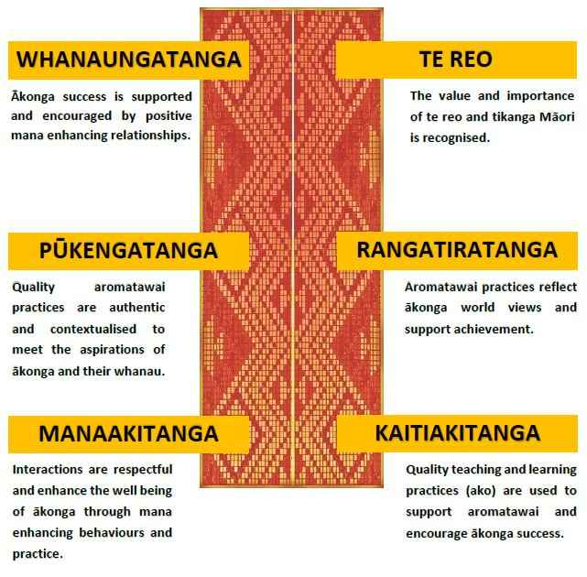
- The six kaupapa are: Rangatiratanga, Whanaungatanga, Manaakitanga, Pūkengatanga, Kaitiakitanga, Te Reo.
- In an assessment and aromatawai context, these kaupapa inform the basis from which to develop a teaching, learning, assessment, and aromatawai approach which recognises ākonga achieving success as relevant to their worldview, context, and practices.
- The kaupapa act as a common point of reference to enrich and inform aromatawai and assessment practices which will be appropriate for all ākonga.
- The kaupapa are the whāriki, the basis on which the principles of assessment and aromatawai are applied in practice.
The Principles of Assessment and Aromatawai are underpinned by the six dynamic and inextricably linked kaupapa that are at the heart of Te Hono o Te Kahurangi, a whare ako framework used by NZQA to carry out the quality assurance of mātauranga Māori.
The five principles of assessment and aromatawai
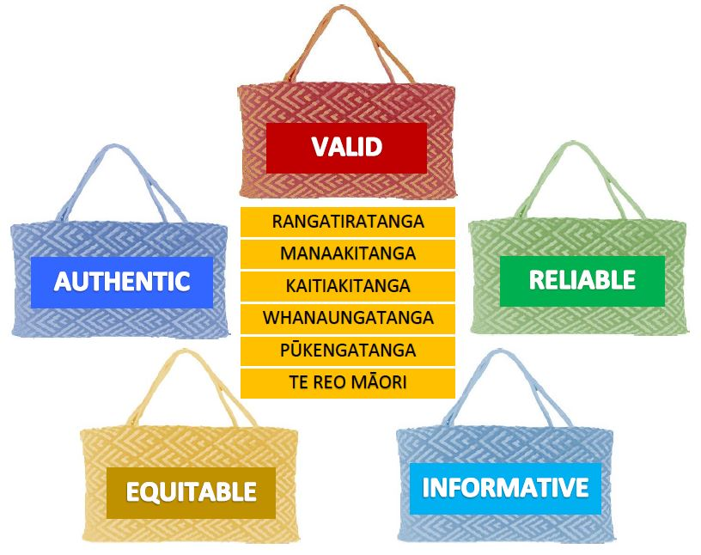
Quality teaching and learning practices (Ako) are used to support and encourage ākonga success.
Ākonga success is supported and encouraged by positive, mana enhancing relationships –whakamana.
Assessment and Aromatawai are | This means that… | Ko te tikanga…
 | Judgements are evidence based, reflect real world contexts and are defensible. | Ka tika te aromatawai kia puāwai te pitomata o te ākonga e tohu ana i ōna pūmanawa.
 | Assessment decisions made against the same outcomes in different contexts are comparable and consistent. | Ka tika te aromatawai hei rokiroki, hei hāpai anō hoki i ngā pūmanawa kia puāwai ai te ākonga.
 | The assessment is valued and contributes to learning progressions and ākonga achievement. | Ka mahi tahi ngā kaiako me te whānau hei painga mā te ākonga, kia eke panuku ai te ākonga
 | Cultural diversity and individual needs are acknowledged and valued. | Ka whakatinanatia te ako me te aromatawai ki tā te Māori tirohanga, kia rangatira ai te tū o te ākonga.
 | Skills, knowledge and competencies acquired by ākonga are affirmed. | Ka pono, ka tika, ka mārama te aromatawai ki tā te ākonga titiro.
The principles of assessment and aromatawai
Aromatawai and assessment judgements reflect real world contexts and are defensible
Characteristics:
- There is a clear and direct alignment between assessment and aromatawai content, criteria and learning outcomes.
- The quality and quantity of the evidence confirms that learning outcomes have been achieved by ākonga.
- Assessment and aromatawai judgements are meaningful, useful and culturally and socially appropriate.
- Ākonga are familiar with the content and contexts of assessment and aromatawai.
- All ākonga know when, where, and what is being assessed, and understand the judgement criteria for the assessment.

- Assessment and aromatawai experiences are meaningful and relevant to ākonga.
- Teaching, learning and assessment are integrated; growing ākonga confidence, capability and independence.
- The evidence produced by ākonga is an accurate measure of what has been learned.
Ka tika te aromatawai kia puāwai te pitomata o te ākonga e tohu ana i ōna pūmanawa.
Aromatawai practices are appropriate and support ākonga to reach their full potential.
Assessment and aromatawai decisions made against the same outcomes in different contexts are comparable and consistent
Characteristics:
- The performance of ākonga to the required standard can be repeated on subsequent occasions.
- Conditions of assessment and aromatawai are provided - the assessment focus and activities are appropriate and relevant for the ākonga and context.
- The interests of ākonga and the integrity of the assessment are maintained.
- The results of assessment or aromatawai meet NZQF requirements for credentialing, and the credibility of the qualification or award is maintained.

Ka tika te aromatawai hei rokiroki, hei hāpai anō hoki i ngā pūmanawa kia pūāwai ai te ākonga.
Aromatawai practices preserve and enhance the inherent skills of ākonga to support them in reaching their full potential.
Assessment and aromatawai is valued, and contributes to learning progressions and ākonga achievement

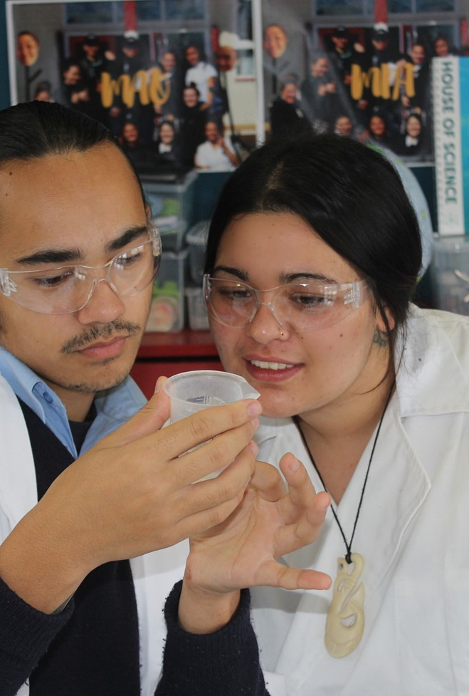
Characteristics:
- Feedback to ākonga is timely, acknowledges achievement, and supports further progress.
- Information is used to improve teaching and learning.
- Results and records are meaningful to ākonga, kaiako, education organisations, NZQA and the wider community.
- All ākonga have a permanent, accurate record of their NZQF achievement for vocational and academic purposes.
- Kaiarotake ensure ākonga are well prepared for their assessment activity or aromatawai.
- Assessment and aromatawai evidences what has been learnt, and the information gathered informs planning to further support ākonga progress.
Ka mahi tahi ngā kaiako me te whānau hei painga mā te ākonga, kia eke panuku ai te ākonga
Kaiako and whānau work together for the benefit of ākonga, and to support their achievement, success, and progression.
Characteristics:
- Assessment and aromatawai activities are inclusive of all ākonga.
- Ākonga are able to respond in contexts relevant to their culture, experience, and world views.
- Assessment and aromatawai activities and approaches used are linguistically and culturally appropriate for ākonga.
- Mātauranga Māori is embraced and the importance and value of te reo is recognised in assessment and aromatawai.
Ka whakatīnanatia te aromatawai ki tā te Māori tirohanga, kia rangatira ai te tū o te ākonga.
Ākonga are empowered by aromatawai practices that reflect their world view.
Assessment and aromatawai acknowledge and value cultural diversity and individual needs

Characteristics:
- Ākonga are provided with valid opportunities to demonstrate their skills and understanding.
- Kaiarotake are confident that all evidence is produced by ākonga; that outside assistance has not influenced, affected, or distorted the assessment or aromatawai.
- The learning context and kaupapa is an important consideration in deciding on ways of gathering evidence for aromatawai and assessment purposes. This means there may be more than one way of collecting valid evidence of learning.
Ka pono, ka tika, ka mārama te aromatawai ki tā te ākonga titiro.
Aromatawai practices are clear, authentic and align with the world view of ākonga.
Assessment and aromatawai affirm the skills, knowledge and competencies acquired by ākonga
- Centre for Curriculum Redesign. Evolving Assessments for a 21st Century Education
- Ministry of Education Position Paper: Assessment [Schooling Sector] 2011
- Ministry of Education. Education Counts, Chapter 6: Student assessment
- https://www.educationcounts.govt.nz/__data/assets/pdf_file/0009/90729/966_OECD-report.pdf
- Ministry of Education. Te Marautanga o Aotearoa – principles of assessment
- Ministry of Education. The NZ Curriculum
- NZQA. Best practice principles for the assessment of unit standards, March 2005
- NZQA. Guidelines for applying for approval of programmes leading to New Zealand qualifications at Levels 1-6 on the NZQF and the accreditation of organisations to provide approved programmes. https://www.nzqa.govt.nz/assets/Providers-and-partners/Registration-and-accreditation/Programme-approval-and-provider-accreditation/guidelines-programme-approval-accreditation-level1-6.pdf
- NZQA. Learning and Assessment: A guide to assessment for the National Qualifications Framework (NZQA) 2001
- NZQA. NZQF Programme Approval and Accreditation Rules 2018 NQF assessment principles. https://www.nzqa.govt.nz/assets/About-us/Our-role/Rules/prog-app-accred-rules-2019.pdf
- NZQA. Te Hono o te Kahurangi. https://www.nzqa.govt.nz/assets/Maori/Te-Hono-o-te-Kahurangi/Te-Hono-o-Te-Kahurangi-2018-Guidelines.pdf
- NZQA. The New Zealand Qualifications Framework. https://www.nzqa.govt.nz/assets/Studying-in-NZ/New-Zealand-Qualification-Framework/requirements-nzqf.pdf
- Queensland Curriculum and Assessment Authority. https://www.qcaa.qld.edu.au/about/k-12-policies/student-assessment/understanding-assessment/principles-quality-assessment
- Steven May, Assessment: what are the cultural issues in relation to Pasifika, Asian, ESOL, immigrant and refugee learners? (University of Waikato)
- VUW/AKO Developing Assessment Policy: A Guide for Tertiary Institutions (2010)
References

Appendix 2 - Survey
Your details
Note this information will help us understand who our respondents are. This information will be used only to analyse this survey and will not be retained by NZQA nor used for any other purpose.
Name
Organisation
Position
Is your response a personal view or the view of your organisation?
Personal View | Organisational View

Please indicate the stakeholder group you most closely relate to:
School | Kura Kaupapa
Te Pukenga | TITO
PTE | University
Wānanga
Peak body/umbrella group (please specify) |  | ____________________________
Other (please specify) |  | ____________________________

Summary of proposals and consultation questions

Proposal 1: We have proposed five principles of assessment:

Valid

Reliable

Informative

Equitable

Authentic

These principles are underpinned by six kaupapa – whanaungatanga, pūkengatanga, manaakitanga, rangatiratanga, kaitiakitanga, and te reo.
We are now seeking your feedback on whether these principles (and the underpinning kaupapa) provide a clear framework for assessment and aromatawai in the range of educational contexts within Aotearoa New Zealand.

Consultation question 1:
How do you see these principles applying to assessment and aromatawai in your context?

Consultation question 2:
What other opportunities do you see, or suggestions do you have for these principles?

Proposal 2: The next phase of this work is to develop:
- Guidance documents, and
- Contextualised resources.
We seek views on the types of guidance and resources that would be most beneficial to support assessors working within the range of educational contexts within Aotearoa New Zealand.

Consultation question 3:
What types of resources/guidance would support the application of these principles?
Please tell us the reasons for your response.

You can provide your views on the proposals in this document by emailing the survey form in Appendix 2 to assessmentandaromatawai@nzqa.govt.nz by Friday 28 May 2021.

