Achievement Standard

Subject Reference |  |  | Physics 3.6
Title |  |  | Demonstrate understanding of electrical systems
Level | 3 |  | Credits | 6 | Assessment |  | External
Subfield | Science
Domain | Physics
Status |  | Registered |  | Status date |  | 4 December 2012
Planned review date |  | 31 December 2020 |  | Date version published |  | 17 November 2016

This achievement standard involves demonstrating understanding of electrical systems.

Achievement Criteria

Achievement | Achievement with Merit | Achievement with Excellence
- Demonstrate understanding of electrical systems. | - Demonstrate in-depth understanding of electrical systems. | - Demonstrate comprehensive understanding of electrical systems.

Explanatory Notes

- This achievement standard is derived from The New Zealand Curriculum, Learning Media, Ministry of Education, 2007, Level 8. The standard is aligned to Physical inquiry and physics concepts in the Physical World strand and Communicating in science in the Nature of Science strand, and is related to the material in the Teaching and Learning Guide for Physics, Ministry of Education, 2010 at http://seniorsecondary.tki.org.nz.

This standard is also derived from Te Marautanga o Aotearoa. For details of Te Marautanga o Aotearoa achievement objectives to which this standard relates, see the Papa Whakaako for the relevant learning area.

- Demonstrate understanding involves showing an awareness of how simple facets of phenomena, concepts, or principles relate to a given situation.

Demonstrate in-depth understanding involves giving explanations for phenomena, concepts, or principles that relate to a given situation.

Demonstrate comprehensive understanding involves connecting concepts or principles that relate to a given situation.

- Electrical systems include mathematical solutions and/or written descriptions. Written descriptions may include graphs or diagrams.

- Assessment is limited to a selection from the following:

Resistors in DC Circuits
Internal resistance; simple application of Kirchhoff’s Laws.

Capacitors in DC Circuits
Parallel plate capacitor; capacitance; dielectrics; series and parallel capacitors; charge/time, voltage/time and current/time graphs for a capacitor; time constant; energy stored in a capacitor.

Inductors in DC Circuits
Magnetic flux; magnetic flux density; Faraday’s Law; Lenz’s Law; the inductor; voltage/time and current/time graphs for an inductor; time constant; self inductance; energy stored in an inductor; the transformer.

AC Circuits
The comparison of the energy dissipation in a resistor carrying direct current and alternating current; peak and rms voltage and current; voltage and current and their phase relationship in LR and CR series circuits; phasor diagrams; reactance and impedance and their frequency dependence in a series circuit; resonance in LCR circuits.

Relationships:
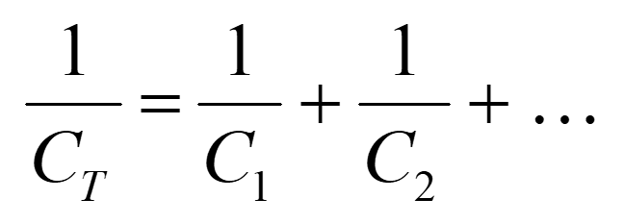
$E = \frac{1}{2}\text{QV}$ $Q = \text{CV}$ $C= \frac{ε_{o}ε_{r}A}{d}$ 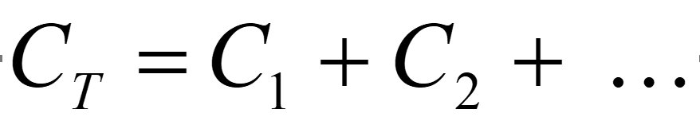 $τ = \text{RC}$
$φ = \text{BA}$ $ε = −L\frac{\text{ΔΙ}}{Δt}$ $ε = −\frac{Δφ}{Δt}$
$\frac{N_{p}}{N_{s}} = \frac{V_{p}}{V_{s}}$ $E = \frac{1}{2}L Ι^{2}$ $τ = \frac{L}{R}$
$Ι = Ι_{\text{MAX}}\text{sin}ωt$ $V = V_{\text{MAX}}\text{sin}ωt$ $Ι_{\text{MAX}} = \sqrt{2} Ι_{\text{rms}}$
$V_{\text{MAX}} = \sqrt{2} V_{\text{rms}}$ $X_{C} = \frac{1}{ωC}$
$X_{L} = ωL$ $V = ΙZ$ ω = 2π f

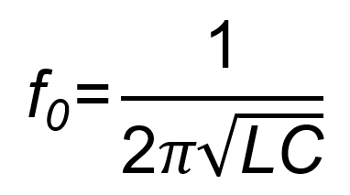

- Assessment Specifications for this achievement standard can be accessed through the Physics Resources page found at http://www.nzqa.govt.nz/qualifications-standards/qualifications/ncea/subjects/.

Replacement Information
This achievement standard replaced unit standard 6389, unit standard 6390, and AS90523.

Quality Assurance

- Providers and Industry Training Organisations must have been granted consent to assess by NZQA before they can register credits from assessment against achievement standards.

- Organisations with consent to assess and Industry Training Organisations assessing against achievement standards must engage with the moderation system that applies to those achievement standards.

Consent and Moderation Requirements (CMR) reference | 0233

