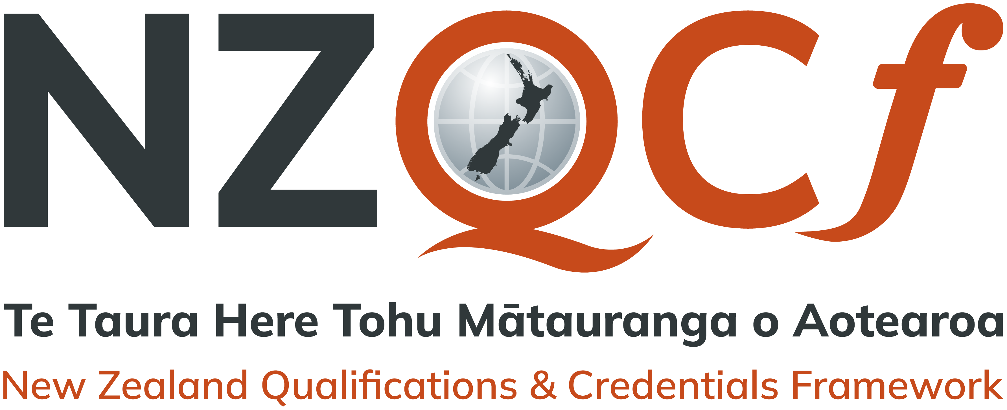

Qualification details
Te nama o te tohu mātauranga / Qualification number | 2346
Taitara / Title | Te Hiringa o te Taiao (Kaupae 4)
Taitara Ingarihi / English title | New Zealand Certificate in Māori Environment Practices (Kaupae 4)
Te putanga / Version number/ | 3 | Te momo tohu / Qualification type | Certificate
Te kaupae / Level/ | 4 | Ngā whiwhinga / Credits | 60
Whakaraupapa / NZSCED | 050999 Agriculture, Environmental and Related Studies > Environmental Studies > Environmental Studies not elsewhere classified
Te kaihanga tohu / Qualification developer | Māori Qualifications Services (NZQA)
Te rā arotake / Review Date | December 2025

Te tauāki ā-hua / Outcome statement
Te rautaki o te tohu / Strategic Purpose statement
This qualification is intended for whānau, hapū, iwi and others with some experience in mātauranga taiao, or those intending to work in the area of tiaki taiao, and who are seeking a formal qualification to work independently at an intermediate level.
The purpose of this qualification is to provide whānau, hapū, iwi, hapori and other entities with graduates who are able to fulfil kaupapa Māori based environmental roles and associated activities at an intermediate level. Te iwi Māori and Aotearoa will benefit from having graduates who are able to provide, from a te ao Māori perspective, skills grounded in mātauranga taiao to protect and enhance te taiao for current and future generations.
Graduates of this qualification will understand the value of mātauranga taiao and will be able to use their skills and knowledge based on whanaungatanga, kaitiakitanga, te pono me te tika, tūrangawaewae, pūkengatanga, and rangatiratanga to work independently to contribute to the future care and development of te taiao for whānau, hapū, iwi and hapori.

Ngā hua o te tohu / Graduate Profile
Graduates of this qualification will be able to:
- Communicate effectively with internal and external stakeholders, whānau, hapū, and iwi, and apply strategies to foster whanaungatanga and manage relationships in a taiao context.
- Explain the significance of important Māori concepts and their use by whānau, hapū and iwi to preserve, nurture, and manage te taiao as tūrangawaewae.
- Exercise kaitiakitanga in selected environmental resource management issues and to identify and manage the effects of the issues on whānau, hapū, iwi and hapori from local taiao perspectives.
- Apply pūkengatanga using both mātauranga Māori and contemporary research and project management methodologies to investigate kaitiakitanga related opportunities or issues.
- Exercise rangatiratanga to manage te taiao in accordance with local tikanga of whānau, hapū and iwi.
- Practice pono me te tika to assess the impact of relevant environmental resource management legislation on the roles and responsibilities of whānau, hapū and iwi in the management of te taiao.

Ngā kaupapa o te tohu / Guiding Principles
Whanaungatanga
Whanaungatanga embraces those skills and strategies that relate to communications and relationships, such as being able to understand different types of relationships and stakeholders, and knowing how to establish, maintain and enhance relationships, both internally and externally.

Te Pono me te Tika
Te Pono me te Tika encompasses important aspects of the protection and management of te taiao that relate to kawa and tikanga; legal obligations and compliance issues, systems and procedures and ethics, and acting in a way that is socially and culturally responsible. It also investigates how these protocols can be utilised to achieve the best outcomes for whānau, hapū and hapori.

Kaitiakitanga
Kaitiakitanga refers to the skills and knowledge needed to protect, retain and manage whānau, hapū and iwi interests in local, natural, physical and cultural taonga and resources. Graduates will be expected to understand how taonga and resources can be protected, managed and sustained in a way that aligns with legislation and the aspirations of whānau, hapū, iwi and hapori.

Tūrangawaewae
Tūrangawaewae affirms the mātauranga held amongst whānau, hapū and iwi about the environment and its cultural, spiritual and physical significance: the location, whakapapa, stories, and the kawa and tikanga practices associated with the local, natural and physical taiao.

Rangatiratanga
Rangatiratanga describes the skills, processes, kawa and tikanga that are utilised for protection and sustainable management of a healthy taiao. Including knowledge about unique taiao mātauranga and the roles and responsibilities of the whānau, hapū, iwi, and hapori.

Pūkengatanga
Pūkengatanga incorporates knowledge and skills required to effectively utilise modern technology and tools to restore, maintain and enhance the mātauranga Māori systems of our tūpuna.

Ngā huarahi mātauranga / Education Pathway
This qualification may lead to or further study at a higher level in:
- Rūmakihia te taiao (Kaupae 6) [Ref: 2347]
- New Zealand Diploma in Whānau Ora (Kaupae 5) [Ref:2879]
- New Zealand Certificate in Business (Māori Business and Management) (Level 5) [Ref:2712]
- Manu Taiko - Hoka Rangi (Kaupae 6) [Ref:2427]
- New Zealand Diploma in Tourism Māori (Kaupae 5) [Ref:2339]

Ko ngā huarahi ā-mahi, ā-ahurea, ā-whānau, ā-hapū, ā-iwi, ā-hapori anō hoki / Employment, Cultural, Community Pathway
Graduates of this certificate will have the transferable skills and knowledge to contribute to future taiao development of whānau, hapū, iwi and hapori, and to act effectively across a range of roles including the following:
- Hapū and iwi environmental and conservation roles
- Department of Conservation rangers, park and reserve rangers
- Ngā Whenua Rāhui Fund workers
- Nature guides, conservation and environmental educational roles
- Other conservation and environmental contracting, or consultancy roles
- Roles working within local and central government agencies
- Heritage New Zealand consultancy roles.

This qualification provides a pathway for graduates to support the development of whānau, hapū, iwi and hapori capability and capacity to preserve, nurture and enrich mātauranga taiao for current and future generations.
Contribution to community and cultural roles may include involvement as the following:
- Kaitiaki knowledge holders, and advisors of the local environment for whanau, hapū, and iwi
- Pouārahi and advisory environmental roles for local government, environmental, conservation, and community organisations.
- Tour guide

Ngā tauwhāititanga o te tohu / Qualification Specifications
Te whakawhiwhinga o te tohu / Qualification Award | This qualification may be awarded by any organisation that has an approved programme of study leading to the qualification.
Ngā taunaki hei whakaū i te tauritenga / Evidence requirements for assuring consistency | All tertiary education organisations (TEOs) accredited to deliver a programme leading to the award of this qualification are required to participate in consistency reviews. Programme providers at consistency reviews must provide relevant evidence of their graduates meeting the graduate outcomes. Programme providers should also be able to justify the nature, quality and integrity of the supporting evidence.  Evidence may include:  - internal and external moderation reports  - graduate feedback  - employer feedback  - whānau, hapū, iwi and hapori feedback  - end-user or destination data (including feedback from the providers of the graduates next level of study)  - programme completion data and course results  - external benchmarking activities or benchmarking across common programmes  - actions taken by the education organisation in response to feedback  - relevant external evaluation and review data where applicable  - programme evaluation reports or capstone event reports  - portfolios of learner work  - site visit reports, and  - any other relevant and reliable evidence.
Te pae o raro e tutuki ai, ngā paerewa hoki hei whakaatu i te taumata o te whakatutukinga / Minimum standard of achievement and standards for grade endorsements | Achieved.
Ko ētahi atu here o te tohu (tae atu hoki ki ngā here ā-hinonga whakamarumaru, ki ngā here ā-ture rānei) / Other requirements for the qualification (including regulatory body or legislative requirements) | There are no mandatory prerequisites to meet regulatory body, or legislative requirements for this qualification.
Ngā tikanga whānui o te hōtaka / General conditions for programme | Programme delivery and all assessments must actively support ways of teaching, learning, learning support, and pastoral care preferred by Māori.  Programmes should include mechanisms and protocols to engage, involve and consult tangata whenua and/or mana whenua with regard to local tikanga and kawa pertaining to the outcomes of the qualification.  All programmes leading to a qualification approved under Te Hono o Te Kahurangi and listed on the NZQF, will be evaluated under Te Hono o Te Kahurangi Quality Assurance.

Ngā tikanga e hāngai ana ki nga hua o te tohu / Conditions relating to the Graduate Profile
Ngā hua / Qualification outcomes |  | Ngā whiwhinga / Credits | Ngā Tikanga / Conditions
 | Communicate effectively with internal and external stakeholders, whānau, hapū, and iwi, and apply strategies to foster whanaungatanga and manage relationships in a taiao context. | 10 credits | Programme content and learning must:  - Explain whanaungatanga from the perspective of local whānau, hapū or iwi  - Demonstrate effective communication and relationship management skills when interacting with people of different age groups, ethnicities and interests  - Include local whānau, hapū and iwi accounts, customs and practices relating to the local taiao.
 | Explain the significance of important Māori concepts and their use by whānau, hapū and iwi to preserve, nurture, and manage te taiao as tūrangawaewae. | 10 credits | Programme content and learning must:  - Explain selected concepts relating to tūrangawaewae from the perspective of local whānau, hapū or iwi  - Demonstrate knowledge of selected mātauranga taiao concepts relevant to the local taiao context  - Demonstrate knowledge of selected whānau, hapū or iwi customs and practices relating to the management of the local taiao.
 | Exercise kaitiakitanga in selected environmental resource management issues and to identify and manage the effects of the issues on whānau, hapū, iwi and hapori from local taiao perspectives. | 10 credits | Programme content and learning must:  - Explain kaitiakitanga and other associated concepts from the perspective of local whānau, hapū or iwi  - Identify and explain provisions in selected legislation, which supports or creates barriers to whānau, hapū or iwi management of the local taiao  - Apply kaupapa Māori approaches to identify solutions regarding whānau, hapū or iwi management of the local taiao
 | Apply pūkengatanga using both mātauranga Māori and contemporary research and project management methodologies to investigate kaitiakitanga related opportunities or issues. | 10 credits | Programme content and learning must:  - Explain pūkengatanga from the perspective of local whānau, hapū or iwi  - Assess the effectiveness of modern technologies in preserving, nurturing and enhancing the local taiao  - Report on the state of selected traditional management practices of te taiao used by whānau, hapū or iwi.
 | Exercise rangatiratanga to manage te taiao in accordance with local tikanga of whānau, hapū and iwi. | 10 credits | Programme content and learning must:  - Include rangatiratanga from the perspective of local whānau, hapū and iwi  - Include knowledge of selected mātauranga taiao concepts within a taiao operational context for self and others.
 | Practice pono me te tika to assess the impact of relevant environmental resource management legislation on the roles and responsibilities of whānau, hapū and iwi in the management of te taiao. | 10 credits | Programme content and learning must:  - Analyse and report on the effects of proposed or current statutes and legislative mechanisms on whānau, hapū and iwi participation in an environmental resource management context  - Analyse and report on the extent to which local resource planning strategies, plans, policies and rules/regulations support whānau, hapū or iwi participation in an environmental resource management context.

He kōrero whakawhiti / Transition information
He kōrero mō te whakakapi / Replacement information | This qualification replaced the National Certificate in Māori Environmental Practices (Level 4) [Ref: 1296].  This has been discontinued.
Ko ētahi atu kōrero mō te whakakapi / Additional transition information | Version Information  Version 3 of this qualification was published following the review in November 2020. Please refer to Qualifications and Assessment Standards Approvals for further information.  Version 2 of this qualification was unpublished and sought an extension to the review date of the qualification, which was approved and applied to version 1.  The last date of assessment for version 1 is 31 December 2024.  It is not intended that anyone be disadvantaged by this review. Anyone who feels they have been disadvantaged can appeal to NZQA Māori Qualification Services at:  PO Box 160  Wellington 6140  Telephone: 04 463 3000  Email: mqs@nzqa.govt.nz  Website: https://www.nzqa.govt.nz/.  Republication information  Version 3 of this qualification was republished in August 2023 to extend the last date of assessment for the superseded version of this qualification from 31 December 2023 to 31 December 2024.  Please refer to Qualifications and Assessment Standards Approvals for further information.

