Field Community and Social Services

Registration of Youth Development unit standards

Subfield | Domain | ID
Social Services | Youth Development | 26124-26146

The Social Services Industry Training Organisation - Te Kaiawhina Ahumahi Inc. (SSITO) has requested the registration of the new unit standards listed above.

Date standards registered April 2011

Planned review date December 2013

Summary

Preparing people for youth development work requires education and training that develops competent practitioners able to work within the Youth Development Strategy Aotearoa (YDSA) developed by the Ministry of Youth Affairs, and to fulfil competencies and Code of Ethics requirements of the National Youth Workers Network Aotearoa (NYWNA) (now Ara Taiohi). The SSITO has been working with youth development practitioners to develop unit standards towards a degree level qualification.

These new unit standards will be registered within the new classification of Youth Development in the Social Services subfield. The unit standards were developed to define the requirements of the Youth Development sector of the social services industry in New Zealand, and will underpin a new degree level qualification. The unit standards represent the requirements for contemporary, professional level youth development practice as defined by the NYWNA (now Ara Taiohi). The unit standards were developed by an Industry Working Group, reviewed by an Industry Reference Group, and final sign off was agreed with a Degree Project Steering Group comprising key professional leaders from industry. The requirement for a new classification of Youth Development was advocated by industry leaders to ensure the unit standards reflect current industry best practice.

Philosophy underpinning unit standard development

The concept of professional competence as an integrated and holistic entity is the core philosophy underpinning the development of the unit standards.

Amanda Torr (Torr, 2005) developed this concept to address the concerns that unit standards are overly prescriptive, focus on the performance of tasks and ignore knowledge and that standards-based assessment deals only with the superficial aspects of professional practice while ignoring the holistic way in which knowledge and skill is integrated and coordinated in actual “real life”.

Addressing these concerns, Torr developed an integrated model of competence that identifies five domains of competence that, when fully integrated, describe the essential attributes, behaviours and characteristics that typify the competent professional.

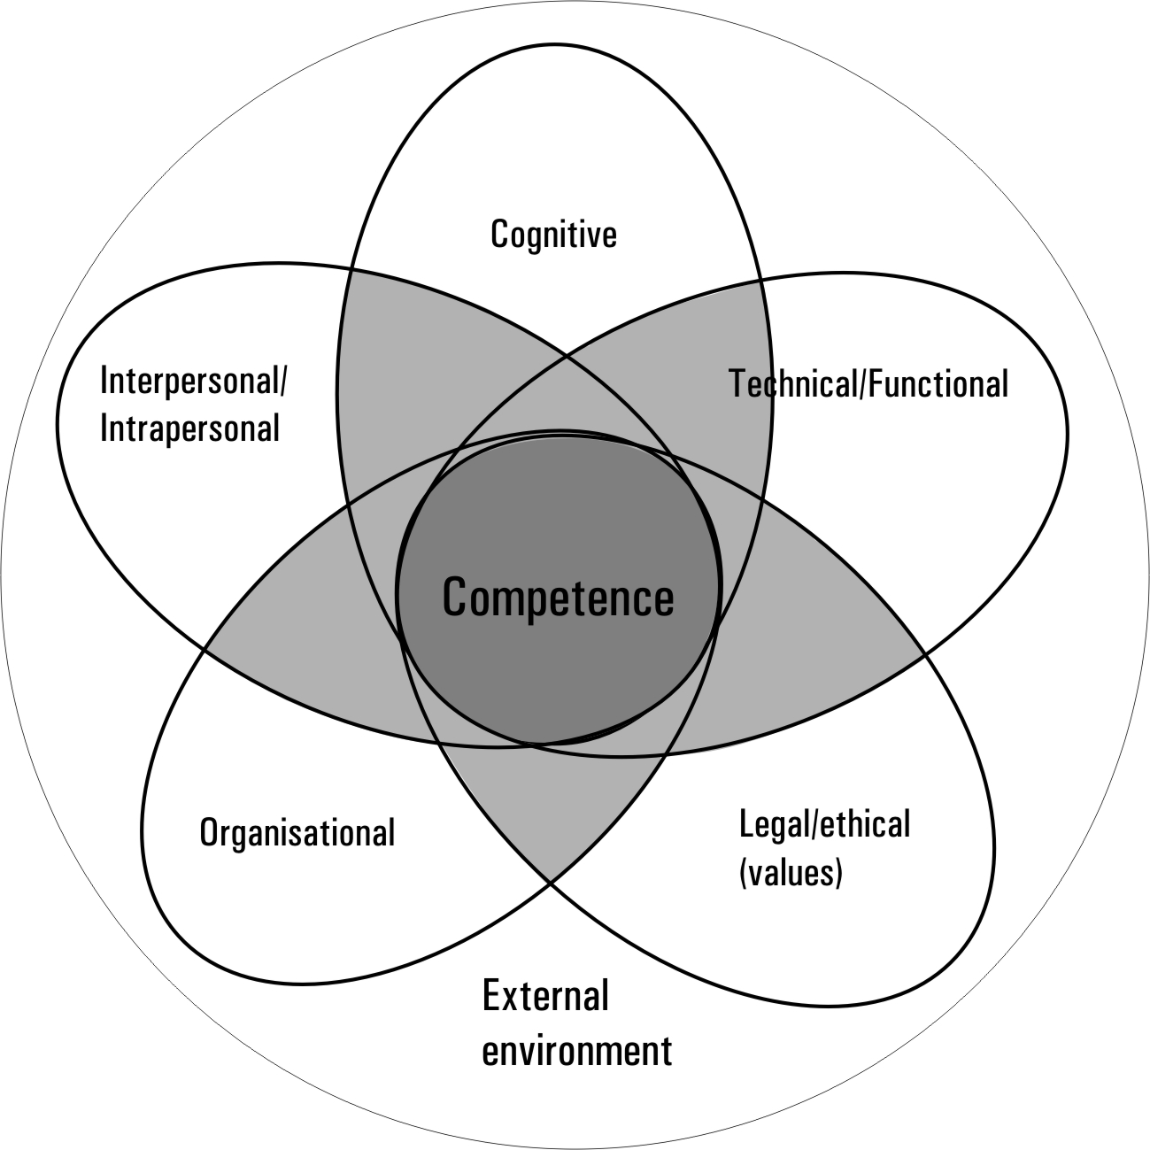

In Torr’s model, professional competence develops as practitioners build their capability to integrate the skills, knowledge, attributes and behaviours associated with each of the five domains to the point where the domains and their component parts are fully integrated. At this point, a practitioner is classed as professionally competent.

The domains of competence

The model proposes that each of the domains exists on a continuum ranging from the skills, knowledge and behaviours exhibited in isolation from the other domains to behaviours that fully integrate the skills, knowledge and behaviours from all other domains.

The cognitive domain encompasses:
- technical knowledge
- professional knowledge
- personal knowledge; and
- cognitive skills including problem solving.

The technical domain covers:
- psychomotor skills
- technical skills; and
- technical cognitive skills.

The legal/ethical domain covers:
- knowledge of the law
- morals
- the ability to work ethically by interpreting and applying the law and the profession’s code of ethics
- altruism; and
- the ability to work in socially and culturally appropriate ways.

The organisation domain encompasses the ability to:
- source information
- interpret new information
- manage the conflicting task required in professional practice
- organise own work; and
- manage others.

The intra/interpersonal domain covers:
- communication – verbal, non-verbal and written
- empathy
- self awareness and self confidence – the skills and attributes of knowing oneself, one’s strengths, weaknesses and limitations
- making decisions with confidence
- referring to others when necessary
- leadership; and
- working with others and as part of a team.

By integrating the skills and knowledge contained within these competency domains practitioners develop the ability to perform their professional roles and functions at the requisite level in situational and functional contexts appropriate to the profession.

Impact on Consent and Moderation Requirements (CMR)

CMR 0222 has been reviewed to meet the requirements for approving programmes of study leading to the award of a degree, and to set requirements for applicant organisations wishing to deliver or assess against the unit standards contained within degree programmes.

Detailed list of new unit standards – classification, title, level, and credits

Community and Social Services > Social Services > Youth Development
ID | Title | Level | Credit
26124 | Use understanding of the Treaty of Waitangi to propose a Treaty partnership approach to youth development | 5 | 15
26125 | Use knowledge of human development theory to develop positive youth development practice | 5 | 15
26126 | Use theory and knowledge of youth culture and identity formation to prepare for youth development work | 5 | 15
26127 | Assess risk, and work within risk management strategies, in youth development contexts | 5 | 15
26128 | Gather, analyse, and present information for youth development purposes | 5 | 15
26129 | Develop and maintain intentional relationships with young people in youth development settings | 5 | 15
26130 | Work with a young person to map and strengthen their connectedness with their key social environments | 5 | 15
26131 | Manage personal performance and actively engage in self care as a youth development worker | 5 | 15
26132 | Screen and conduct assessments of young people’s strengths, needs and context | 6 | 15
26133 | Design and plan a positive youth development initiative | 6 | 15
26134 | Integrate strengths-based practice and Treaty partnership approaches into delivery of youth development initiatives | 6 | 15
26135 | Facilitate group processes to support young people’s positive development | 6 | 15
26136 | Support team, multidisciplinary and cross cultural work in youth development | 6 | 15
26137 | Conduct a community needs analysis and support young people to participate in social change processes | 6 | 15
26138 | Evaluate positive youth development initiatives | 6 | 15
26139 | Integrate theories and procedures of a specialist practice into positive youth development practice models | 6 | 15
26140 | Carry out safe, ethical and professional youth development practice | 6 | 15
26141 | Support young people to influence regulatory processes to facilitate positive youth development | 7 | 15
26142 | Plan an organisation’s programme of youth development initiatives | 7 | 15
26143 | Manage crisis interventions in youth development settings | 7 | 15
26144 | Research a problem or issue impacting on youth in Aotearoa New Zealand | 7 | 30
26145 | Support ongoing development of professional practice in a youth development context | 7 | 15
26146 | Critically evaluate own capacity to integrate specialist practice to evolve positive youth development practice | 7 | 15

Torr, A. (2005). Professional Competence: Complexity, concepts and characteristics. A thesis published in completion with a PhD, Victoria University of Wellington: Wellington.

