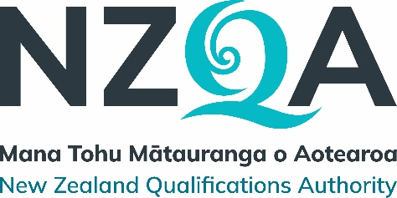

Field: Management and Commerce

Change report for the Republication of Personal Financial Capability New Zealand Certificates

Republished qualifications
Ref | Version | Qualification Title (Level) | Credits
2248 | 2 | New Zealand Certificate in Personal Financial Capability (Level 2) | 60
2249 | 2 | New Zealand Certificate in Personal Financial Capability (Level 3) | 60

Republication information
Qualification Developer | NZQA National Qualifications Services
Reason for the republication | Extension to the last dates of assessment for superseded version
Outcome date | November 2023
Next review date | November 2025

Summary
The retrospective extension of the last dates for assessment (LDA) of version 1 of the New Zealand Certificates in Personal Financial Capability (Level 2 and Level 3) has been undertaken following a request from and discussions with the principal provider Te Wananga o Aotearoa.
This extension of the last dates for assessment is to allow the provider time to update their existing programme, to lead to version 2 of the qualification.
The scheduled review of the qualifications was also deferred one year, from November 2024 to November 2025.

Main changes resulting from the republication process
The last dates for assessment of version 1 of the New Zealand Certificate in Personal Financial Capability (Level 2 and Level 3) were extended from 31 December 2022 to 30 June 2024.
The scheduled review of the qualifications is November 2025.

Transition information
Ref: | Version | Qualification Title (Level) | Last date of entry* | Last date of assessment
2248 | 1 | New Zealand Certificate in Personal Financial Capability (Level 2) | n/a | 30 June 2024
2249 | 1 | New Zealand Certificate in Personal Financial Capability (Level 3) | n/a | 30 June 2024
*only required for outcome category C or D

Any additional information
It is the intention of NZQA National Qualifications Services that no existing learner should be disadvantaged by these transition arrangements. Any person who considers they have been disadvantaged may contact the Qualification Developer:
NZQA National Qualifications Services
PO Box 160
Wellington 6140

Phone: 04 463 3000
Email: nqs@nzqa.govt.nz
Website: www.nzqa.govt.nz

