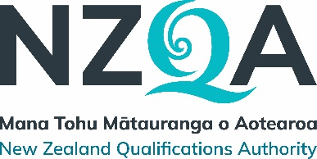

Field Engineering and Technology

Listing of Passenger Ropeways Maintenance Engineering New Zealand qualification

Listed qualification
[Ref] | Version | Qualification title | Level | Credits
5365 | 1 | New Zealand Certificate in Passenger Ropeways Maintenance Engineering (Level 4) with optional strand in Conveyor Systems | 4 | 100 - 115

Development information
Qualification Developer | Hanga-Aro-Rau Manufacturing, Engineering and Logistics Workforce Development Council
Reason for the development | New qualification
Review date | March 2023 – May 2025
Outcome date | July 2025
Next review date | July 2030

Summary of development and consultation process
Hanga-Aro-Rau Workforce Development Council developed this new qualification through extensive industry consultation with a diverse and representative group of stakeholders from across New Zealand’s passenger ropeway, ski tourism, engineering, and regulatory sectors.
This collaboration was driven by the need to address long-standing training gaps, improve safety assurance, and establish a formal pathway for workforce development in this high-risk, highly specialised sector.
The qualification is suitable for learners currently working in the passenger ropeway industry and who have relevant experience and skills in mechanical and/or electrical maintenance.

Main changes resulting from the development process
New qualification listed: New Zealand Certificate in Passenger Ropeways Maintenance Engineering (Level 4) with optional strand in Conveyor Systems [Ref: 5365]

Any additional information, including Qualification Developer contact details.
The qualification developer may be contacted at:
Hanga-Aro-Rau Manufacturing, Engineering and Logistics Workforce Development Council
PO Box 445
Wellington 6140

Phone: 04 909 0255
Email: qualifications@hangaarorau.nz
Website: www.hangaarorau.nz

